**Pilot Study to Demonstrate**

**the Use of GeoGebra Software**

**for Technology Enhanced Learning**

**in Mathematics**

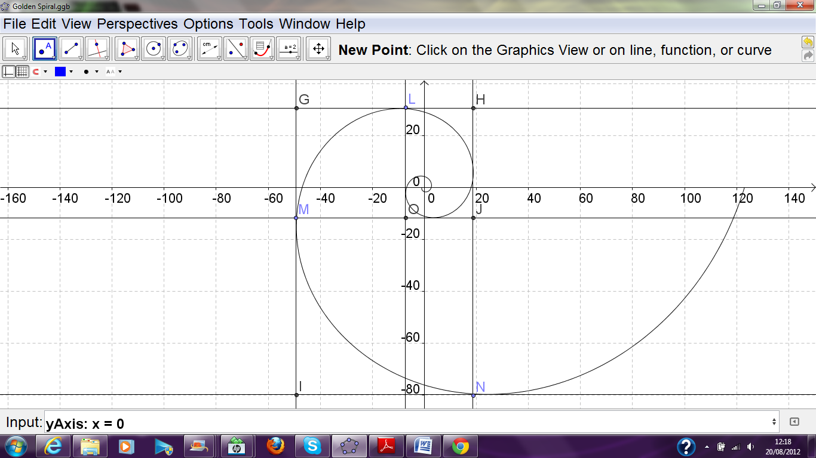

**Edwin Fennell**



Impington Village College

Abstract

The main aim of my project is use the geometry and algebra program GeoGebra to graphically illustrate mathematical concepts. This will be useful to children of 13-15 in introducing these otherwise fairly challenging topics, all of which are crucial in the development of further maths and physics skills. Visual and kinaesthetic aids have been shown to improve retention rates among this age group, and so my project should be beneficial to both teachers and students. I have also chosen my” mini-topics” for their interest value, as a secondary aim for my topic is to get students interested in the world of maths. Another secondary aim is to illustrate the utility of GeoGebra and the teaching possibilities it opens up.

Having downloaded the GeoGebra program, I devised brief investigations into four very distinct areas of maths. I created graphical representations and interactive tools for each. I attempted to make these tools as simple, accessible, and easy to use as possible. I then amalgamated these into presentation format, also designed for easy comprehension.

As the project has not yet reached its terminus, I cannot yet comment on its success.

About CCITE and GeoGebra

CCITE is an organisation that supports information technology needs among government and commercial enterprises in the Cambridge area. CCITE works in conjunction with STEM to provide the software and information technology for the GeoGebra project. GeoGebra itself is a geometry and algebra program intended for teachers and students. The program aims to make the teaching of maths and science topics easier through graphical material.

My Project

Topic 1: Faster-than-light travel

I open my investigations into GeoGebra with a topic which has fascinated the minds of science-fiction fans and science-fact scientists alike. However, conventional faster-than-light travel is, sadly, impossible. This is due to the Lorentz Factor, a feature of special relativity. The Lorentz factor is the formula for time dilation, which shows how time slows down as the speed of light is reached, and, due to the fact that space and time are one, we can incorporate this into an equation involving space as well. Newton’s second law of motion is not, therefore F=ma, but



Multiplying Newton’s second law by the Lorentz Factor gives us a slightly altered version of this law which barely seems different at all, because for all everyday cases of v, v2/c2 is almost zero, making the value of the Lorentz Factor very slightly more than 1. However, if v is significantly increased, the results are much more significant.

I decided to devise a theoretical experiment to see what would happen if mankind attempted to build a super-spaceship and flew it at very high speeds. I lent my theoretical spaceship a mass of 1,000,000kg, and a maximum thrust of 50,000,000N, which gives it a maximum acceleration of 50m/s2. I am also ignoring the loss of mass of fuel in my calculations, as this would add complexity unnecessary to demonstrate the concept. The spaceship is launched, and to escape Earth’s gravity and enter low orbit, the spaceship must travel at 7500m/s, which is 1/40000th the speed of light. To accelerate from this speed, as opposed to from rest, requires a tiny bit more force, which is equivalent to the ship gaining around 400mg. If, after leaving Earth’s atmosphere, the ship accelerates to half the speed of light, the effects of time dilation become a lot more dramatic. Upon attempting to accelerate from this speed, the ship would actually require an extra 8MN to achieve this, equivalent to an extra 155 tons. As the ship nears the speed of light, the effects become ever more marked. If, having reached 299,999,700m/s, 99.9999% the speed of light, the ship attempts to accelerate again, the actual force needed gives the ship an artificial mass of over 700,000 tons. Of course, the spaceship does not actually increase its thrust or mass. What I have here added on to the ship’s thrust is actually taken out of acceleration. This means that the ship, with constant thrust, accelerates less and less, until the acceleration is negligible, at which point the ship reaches terminal velocity.

To aid comprehension of the exponential increase of the value of the Lorentz Function, I have constructed a handy graph showing this clearly. On the x-axis is the speed in m/s of the spaceship and on the y-axis is the force in N required to accelerate it by 50m/s2.

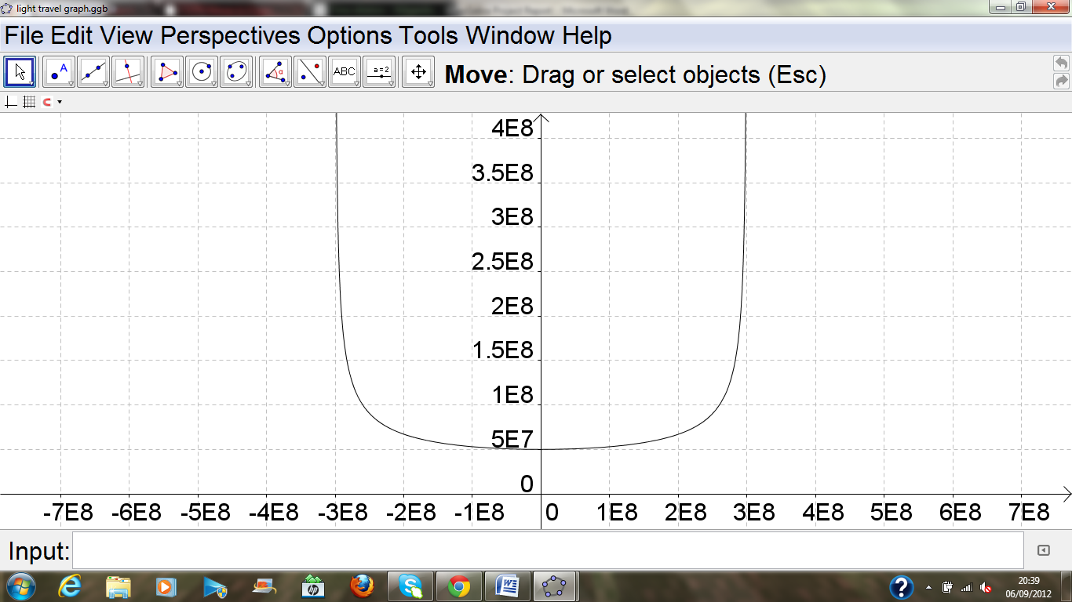

The main intention of this particular piece is not to attempt to teach young people a particularly deep understanding of special relativity, but rather to pique their interest in maths and physics. This particular topic is one encountered in many books and films, and so some students may have encountered the concept before, if only in a science fiction context. There is also the possibility of including the anecdote about the spaceship when explaining this, which means the explanation, is not just full of formulae and abstractions. There is a considerable amount of maths, but this can be left out of the explanation until the students have grasped the concept and examined the graph. I will by no means suggest that the topic is taught as I have presented it above. I have only presented it in this way as this is a factual report, and I am providing background information about my investigation.

Topic 2: Why the golden spiral is so special

My second topic is about one of the most famous mathematical shapes: the golden spiral. This spiral is known as the golden spiral because it seems so perfect. The spiral has a growth rate of phi, a number known as the golden ratio. This number appears in many seemingly unrelated places in maths and the sciences, from the growth rate of plants to the spaces between molecules. This could be because phi has one special property which makes it very special indeed, and that is



My investigation is going to be why this special property ties into the Golden Spiral’s special property, which is as follows: if each quarter turn is circumscribed by a square, the squares tessellate perfectly. To examine why these properties are related, I have drawn the graph of a golden spiral. It is enclosed below.



I have drawn lines around and through the spiral. Now for the proof that the squares circumscribing the quarter circle do in fact tessellate. The quadrilaterals in the diagram, GMOL and MINJ, along with the corresponding quadrilaterals circumscribing each quarter turn, tessellate perfectly. These are clearly rectangles, but it has to be proved that these quadrilaterals are squares. Now, assume that line segment LH has a length of 1 unit. As this is part of the square circumscribing one quarter turn of the spiral, the length of the corresponding length for the next quarter turn, line segment GM, will be phi times longer, due to the growth rate of phi. Thus GM has a length of phi units. The next corresponding line segment, IN has a length of phi*phi, or phi^2. GH and IN are equal in length, so GH=IN=phi^2. It is known that LH is 1 unit long, so we have the formula phi^2=1+GL. Due to the fact that phi^2=phi+1, we know that GL=phi. GL therefore=GM, and so GMOL is a square. As all the quadrilaterals are similar, all are squares. The theory is proved.

I hope that this proof will help to introduce students to the weird and wonderful world of phi. However, aside from showing of a numerical quirk, I think that this investigation has other use. It will help to introduce students to serious proof, as well as an introduction to spiral graphs. It also, hopefully, gets some students interested in maths. As with the previous example, I am aware that the topic should not be broached as I have broached it.

Topic 3: Pythagoras’ proof

My third topic is one which my target audience would certainly have come across before: Pythagoras’ theorem. However, many students may be wondering why Pythagoras’ theorem is true. The standard “three squares” explanation, depicted below, is long and tedious.

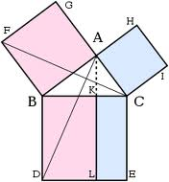

There is, however, another proof, which is seldom taught in school. This is what I call the “one square” proof. I find that it is a lot simpler. I have made a interactive version using GeoGebra, the link to which is here: <http://www.geogebratube.org/material/show/id/16010>. Point E can be manipulated using the mouse to show all possible right-angled triangles, showing visually that the theorem always works. The proof states that the area of the big square can be represented in two ways. The first is the square of the sum of the shorter two sides of a triangle: (xy) ^2 or x^2+2xy+y^2. The second way is the sum of the four triangles and the smaller square: 4(xy/2)+z^2 or 2xy+z^2. By subtracting 2xy from both sides of the equation we can derive the famous theorem. I have also included in my applet a measure of sides and angles.

I think that this proof and my interactive applet would be quite useful in explaining why Pythagoras’ theorem works. Unlike the previous two topics, this is not an introduction; this is a continuation of an already known topic. This applet also demonstrates the power of the GeoGebra tool, and displays its ability to create interactive diagrams rather than just graphs.

Topic 4: Differential Tool

This final topic represents an area of maths that has a fearsome reputation for being difficult to understand. I have therefore designed a tool that can help introduce the nuances of differentiation: <http://www.geogebratube.org/material/show/id/16356>. The tool allows students to investigate the gradient of a curve at different points of the curve. This tool is designed to be used in conjunction with teaching on the subject: i.e., the teacher should, while the students are exploring the tool, explain that the gradient of curve axb=abx(b-1).

On my tool, there are six sliders. The top slider controls the number of x5, the second controls the number of x4, etc. This allows students to see that differentiating works for any curve.

The aim of this tool is also to demonstrate that, with GeoGebra, some quite sophisticated gadgets can be made. The interactivity of the tool, like my Pythagoras tool, shows that kinaesthetic aids can easily be created.

Differentiating, with the knowledge, is easy to do. However, understanding why it works is a different matter. For the sake of completeness, I will outline the explanation here. If we have, for example, the function y=x2, the gradient can be worked out by differentiation. The long and formalised derivation runs as follows: the point (x, x2) lies on this graph, as does the point (x+h, (x+h)2). By drawing a line between these points, we have a rough approximation of the gradient of the cure; if h is smaller, the line is more accurate. This line is known as the secant line, and, in this case, has a gradient of



Opening the brackets and simplifying yields



Dividing everything in the numerator by h gives 2x+h. This is the gradient of the secant line. As I said before, the accuracy increases as h gets smaller. This means that the line is absolutely accurate if h is infinitely small, that is, if h=0. As h=0, we can just ignore it, and therefore the gradient of the line is 2x.

There is also the short way of derivation, which is, for each term, to multiply the coefficient by the index and then subtract one from the index. This works for our example thusly: 1 is the coefficient of x, 2 is the index. 1×2=2, and 2-1=1, so the derivative of x2 is 2x, which is the same answer as given by the other method.

There is something missing here, and that is why these two expressions are equal. This is something that I have never heard before, and, despite looking on the internet, have never seen. I also do not think it is taught at sixth form, as I have searched the curriculum and have not found it. This is why I have decided to outline it here. Imagine differentiating the graph axb. (x, axb) lies on this graph, as does (x+h, a(x+h)b). The gradient of the secant line is



This simplifies as



The first term of the a(x+h)b is just axb, and axb-axb is 0. Dividing the numerator by the denominator leaves us one term without any form of h in it: the second term, abxb-1 (formerly abxb-1h). As the derivative can only be found using the secant line if h is effectively 0, all terms with some form of h in it are discounted, leaving only abxb-1. The two expressions are equivalent.

In my opinion, this is an incredibly useful proof, as it is important to understand why something is so, as well as just that it is so. I think it should be more widely taught in schools, as well as more widely displayed on the internet.

Conclusion: GeoGebra as a teaching resource

In the main body of my essay, I have talked mainly about the fields of my investigation, and not very much about the actual essay topic: the GeoGebra program itself. Here I am going to take the opportunity to do just that. GeoGebra seems to me to have great potential as a teaching resource. The diverse and various tools enable the user to create a wide range of tools and gadgetry for nearly all basic mathematical applications. Tools can be created which the user can interact with and explore. The logic on this program is good as well (despite I myself not knowing how to use it properly). Both of these features can be clearly seen from just one of the many “applets” I have selected from the GeoGebra website: <http://www.geogebratube.org/student/m3022>. This brings me onto my next point, which is that there is a thriving GeoGebra community. It may be true that it takes too long for a busy teacher to spend over an hour making and troubleshooting an applet, but this is not an issue when you can simply search for whatever you wanted on “GeoGebra Tube”, a gallery for GeoGebra materials. With almost 15000 gadgets on the site, there is a fair chance whatever you’re looking for is there somewhere. If you want to learn how to improve your “GeoGebra literacy”, there are many helpful tutorials on the site itself. There is a beta test version of GeoGebra with 3D capabilities, so in the future, GeoGebra could be used to create an even wider range of gadgetry. GeoGebra is also a free teaching resource, so it can be used in all schools with computers. School education is getting ever-more “technology-centric”, meaning that there is an open niche for a comprehensive maths computer program, which GeoGebra fits nicely.