ADE EARTH & BEYOND
MODULE: RESEARCH

Template for Module
PART 1: EXPLORE AND PLAN
1.1 Exploration (Teacher explores their own practise)
1.2 Stimulus (OER’s or videos/resources)
1.3 Reflection (What did I learn)
1.4 Subject-pedagogy (Methods/activities)
1.5 Development of a classroom activity (for learners)
1.6 Subject curriculum content (Concrete ideas)
1.7 Technology-applications (OER’s, activity sheets)
PART 2: TEACH USING THE CLASSROOM ACTIVITY PLAN (Teachers tries out new ideas)
PART 3: REFLECTION (Did it work, how can it be improved?)
3.1 Assessment based on experience/Assessment activity for teacher

Outcomes of unit
To assist teachers to:
- Teach learners how to do research
- To illustrate to learners how to apply the knowledge they gained in class with what they researched.
- Guide learners in their presentation of the data they researched.

Introduction
- The unit contains the following type of activities:
- Teacher activities that you have to complete individually and with peers or fellow students.
- Learner activities where you will apply what you have learned in the form of a teaching and learning activity or lesson.
- Reflection where you will record your experiences of the application, will reflect on it and will report on it in your portfolio.

PART 1: EXPLORE AND PLAN
  - Exploration (Teacher explores their own practise)

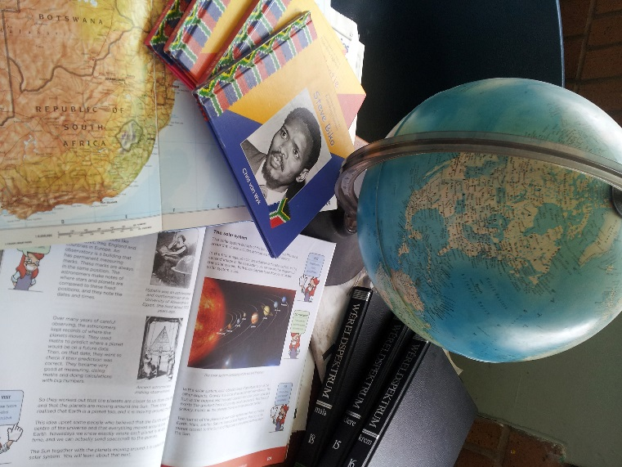
Activity 1: Learner Activity: Give learners a resource to summarize. If you give learners the instruction to summarize something, you will realise that learners cannot summarize and most of them cannot lift out the real important facts. If you reflect on how successful the learners were you will see that this is a skill that they need to be taught.

Activity 2: Teacher activity: Explain to learners how to prepare for a research project. Teach them what the basic items are to have in any project. Guide them on how to lift out the most important relevant facts and how to choose good headings. Teach them how to use the rubric and interpret it optimally and how to present the final product. When the learners know these basic research skills, they can tackle their own research project.

Activity 3: Learner activity: Study different resources.
Learn how to work with resources when doing research and how to correctly reference them. Divide into groups and work with 3 different resources on a theme.

Example: A significant discovery in astronomy. Do research on any significant discovery in astronomy. Use at least 3 different types of resources. Make a poster of your findings.
Each group must use a book, a newspaper article and an internet resource to do their research. Let the learners bring their resources to class and let them work in class. Follow these steps.
Step by step: Step 1: Read articles/resources
Step 2: Highlight the most important facts
Step 3: Decide on your headings
Step 4: Group your information under the different headings
Step 5: Rewrite the sentences in your own words
Step 6: Choose relevant pictures/photo’s and cite them correctly
Step 6: Cite your references

  - Stimulus (OER’s or videos/resources)

Look at the following OER sources and use them to improve your learners skills and knowledge:

Types of resources: Primary, secondary and Tertiary.

Citing resources:
http://www.oerafrica.org/resource/citing-sources

Rocks: What are rocks and how are they formed?
http://www.oercommons.org/courses/rock-solid

Students learn about fossils what they are, how they are formed, and why scientists and engineers care about them.
http://www.oercommons.org/courses/fantastic-fossils

This OLogy activity serves as a kid-friendly how-to manual about searching for fossils
http://www.oercommons.org/courses/finding-fossils.

Interactive resource on types of fossils:
http://www.oercommons.org/courses/types-of-fossils

Identifying and classifying rocks:
http://www.oercommons.org/courses/rock-identification

To introduce students to the basic elements of our Earth's crust: rocks, soils and minerals
http://www.oercommons.org/courses/earth-rocks

Students test rocks to identify their physical properties (such as luster, hardness, color, etc.) and classify them as igneous, metamorphic or sedimentary:
http://www.oercommons.org/courses/rocks-rocks-rocks-activity

Explains the differences between the three rock groups (igneous, sedimentary, metamorphic)
http://www.oercommons.org/courses/if-rocks-could-talk

How to do research on Internet:
http://www.oerafrica.org/resource/research-internet

Earth’ structure: Activity on building an earth to show the structure of the earth. Gr 5
http://www.oercommons.org/courses/let-s-build-the-earth-the-structure-of-the-earth-s-crust-and-interior

Erosion: Look at the following activity for Gr 5 learners about erosion and how ti identify it in their own school ground. Try this activity.
http://www.oercommons.org/courses/erosion-in-our-world-2

Citation:
http://www.oerafrica.org/resource/copyright-electronic-publishing-citation

How to summarize a paragraph: http://www.oerafrica.org/ResourceResults/tabid/1562/mctl/Details/id/37428/Default.aspx

How to cite electronic resources: http://www.oerafrica.org/ResourceResults/tabid/1562/mctl/Details/id/36472/Default.aspx

Reading and note taking:
http://www.open.edu/openlearn/society/politics-policy-people/sociology/reading-and-note-taking-preparation-study/content-section-0

1.3 Reflection (What did I learn)

- Can learners summarize a resource? What did you do to help them to do this effectively?
- Do learners know about different types of resources (primary, secondary and tertiary), and how they can use it?
- Did your learners choose good headings in their research? How can you assist them?
- Do your learners know how to cite a resource? What guidelines did you give them on citation of resources?
- Did you develop a good rubric that guided them in their project? How can you improve?

1.4 Subject-pedagogy (Methods/activities)
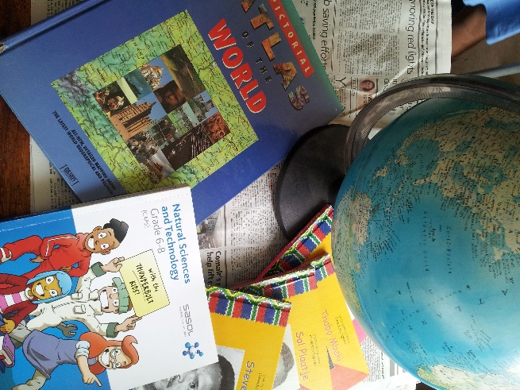
Learners are expected to do a few projects in the school curriculum. Projects are tasks in which learners illustrate or apply knowledge that they have gained in class. Projects may involve aspects of investigation and/or research. Learners may collect data to understand a particular set of circumstances and/or phenomena. In doing this, they can build models, compile reports, essays or posters and even give presentations.
Learners need some support and guidance from the teacher. The teacher directs the choice of the project, usually by providing the learners with a topic or brief for the investigation.

Basic skills in research
- Use as many resources as possible. At least 3. The more information you can gather, the better.
- Read through your sources and summarize the most important facts under relevanr headings.
- Make sure you cite your resource correctly.
- Know about Plagiarism and how to avoid it.
- Rewrite the sentences in your own words and make the sentences simple.
- Do not use words if you do not know the meaning of them.
- If you use pictures, photo’s or diagrams, make sure you have subheadings with descriptions and cite the source.
- Take your own photo’s and draw your own pictures if you can.
- How to reference:
  - Give information about the type of item, the name or title of the item, who produced it, the date it was produced and where you found it.
  - Harvard style: Author, A. A. and Other-Author, B. B. (Date) ‘Title of item’, Title of Overall Work [Item type/information], Publisher information/location from which accessed.

Source: The Open University

Why you should cite references
When writing a piece of work, it's important to give complete, accurate references. Here are some reasons why:
- Your references show you have read around the subject;
- Your argument will be stronger if supported by evidence from others' research;
- You enable others to find and use the sources that informed your work;
- If you don't include references, you will be guilty of plagiarism, i.e. passing off someone else's work as your own.

1.5 Development of a classroom activity (for learners)

Develop a classroom activity for your learners and use a rubric like the Example, and assess the learners.

Possible projects:
The planets
Astronomical discoveries

Rubric: Research project
Choose one of the planets. Do research about the planet. Use the rubric as indicator of what information you need to research.
Format:
- Book
- Smaller than A4 (must be pasted in books)
- Typed or written

Date of submission: ______________________________________________
Research: Planets | Possible | Self | Teacher
1. Front page  - Your name and surname  - Your grade and class  - Planets name | 3
2. Basic statistics of planet  - Distance from sun  - Time to make 1 revolution  - Moons?  - Atmosphere  - Can humans live there? | 5
5. Other information | 4
6. Pictures with headings | 5
7. Punctuality | 2
8. Rubric pasted in | 1
9. Neatness | 2
10. Resources used: At least two (correctly referenced) | 2
TOTAL | 24
Date handed in:

1.6 Subject curriculum content (Concrete ideas)

Curriculum content
Curriculum and Assessment Policy Statement (CAPS): Natural Science & Technology
Strand: Planet Earth & Beyond
Gr 6:
- The Solar system: The Sun, Planets and Asteroids
Researching/reading information about the planets focusing on size, distance from the Sun, average temperature, number of moons and any other features

- Systems to explore the Moon and Mars
Researching the key features and purposes of the Mars or Moon Rovers including wheels and axles, cameras, mechanical arms, and systems for using solar energy and communications

Gr 7:
Researching and writing about a significant discovery in astronomy

1.7 Technology-applications (OER’s, activity sheets)

PART 2: TEACH USING THE CLASSROOM ACTIVITY PLAN (Teachers tries out new ideas)

PART 3: REFLECTION (Did it work, how can it be improved?)
3.1 Assessment based on experience/Assessment activity for teacher

Portfolio assessment
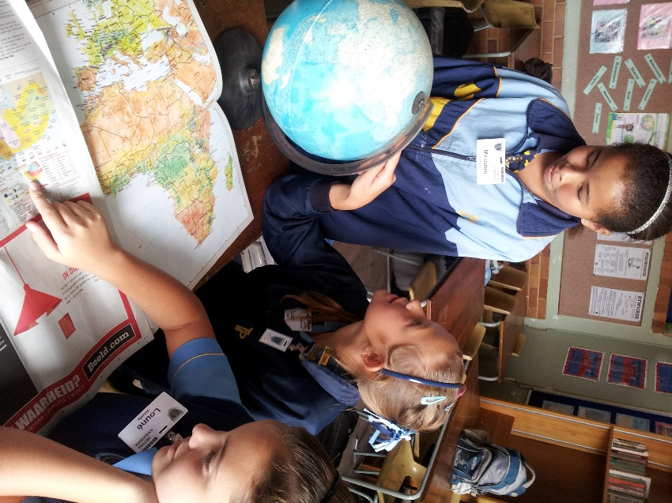
- Develop a lesson plan on the content covered in this unit. Planning is the most important tool for a teacher.
- Write down what your experiences were. Did it go well? Did the learners participate? What strategies did you follow to improve the activity? What will you do different?
- Annotate your lesson plan:
  - Mark the section you would do differently. Write how you would change them.
  - List the problems that occurred. What can you do differently to solve the problems?
- Make a list of the resources you used and developed. Take photographs or include them in your portfolio.

Misconceptions
- Children can summarize: Learners do not know how to summarize. You need to show them or you will get exact copies of the resources they used.

Possible OER Resources:
http://www.oerafrica.org/ResourceResults/tabid/1562/mctl/Details/id/39305/Default.aspx
Secondary school level: http://www.oerafrica.org/ResourceResults/tabid/1562/mctl/Details/id/37028/Default.aspx

