**W3 Sperm whale scientific article**

The following article is an extract from the One World Wildlife website a charity based in the UK. It records a study of Sperm Whales.

[**http://www.oneworldwildlife.org/what\_we\_do/projects/current/mediterranean**](http://www.oneworldwildlife.org/what_we_do/projects/current/mediterranean)

[](http://www.oneworldwildlife.org/)

monitoring whales, dolphins and turtles in the Mediterranean

**The search for a population of sperm whales began in 2003 after visitors and locals reported various sightings around the Balearic islands of Mallorca and Menorca. Sadly, dead calves and adults indicate all might not be well. As of 2009, five full field seasons were completed.**

One World Wildlife initiated the sperm-whale-monitoring project inthe Mediterranean in 2003 along with Dr Luke Rendell from the Universityof St Andrews. In addition, the team of researchers is monitoring the numbers of other species in the region. Initial sightings indicated cetaceans were predominantly of striped dolphins (*S.coeruleoalba*), Risso's dolphins (*G.griseus*), long-finned pilotwhales (*G.melaena*) and bottlenose dolphins (*T.truncates)*. Relative to other cetacean species, the bottlenose dolphins had a markedly coastal distribution and data from this project now indicates there may be far fewer pods than previously reported.

With the support of the Nando Peretti Foundation, five years' field seasons have been completed. The sperm whale photo ID data thus far is indicating a population very likely to be more than 40 individuals, and the awareness of the importance of this area grows with each further year of study. Long-lived slow reproducing species such as the sperm whale require long-term monitoring and continued vigilance regarding their conservation.

The projcet will also continue to monitor populations of the sea turtle (*Caretta caretta)*, which like the dolphins is vulnerable to boat strikes, nets, plastic jetsam, and in partiular, to the destruction of beach nesting sites through tourist development and pollution.

Over the last five years, we have managed to identify in the order of about 50 individual sperm whales by “photo-tagging”, a process that identifies each whale by its unique tail fluke, similar to the use of fingerprinting in people, but this can be done from a distance before each feeding dive.

The monitoring team searches for sperm whales with the aid of hydrophones, focusing on areas around the islands where the sea is one kilometre deep or so. This is the depth at which sperm whales typically feed. In the complete darkness, they locate and catch their prey, mainly squid. The whales use clicks to navigate and probably to find and stun prey. The males make what could be the loudest noise in the animal kingdom – a very loud click thought to demonstrate size and location of prey to other males. It is these noises that the dual hydrophones pick up, thus enabling the team of researchers to locate the whales.

A dual hydrophone is used to allow the team to track individuals, acting like antennae. The team tracks them until they come to the surface, at which point they fall silent. This is when the team has to work quickly: the whales are spotted by their plume, and the research vessel attempts to move close enough to take a photo before they dive once more. Other information is taken when possible, such as skin and faecal samples to help understand the ecology of these whales and possible relationship to populations of sperm whales elsewhere in the world.

The project has been building a picture not just of how many whales there are, but also of how many males, females and young.

The team has built up a good relationship with the Spanish fisheries' authority in Palma, which is now helping with some of the survey work under the guidance of Dr Txema Brotons. This cooperation helps ensure communication with fishermen on which areas they should be extra vigilant in avoiding contact with whales. A major threat to the whales is the incidence of boat strikes, but they can also become entangled in fishing nets, which results in a long and painful death.

Sperm whales are a keystone species in many deep ocean ecosystems. Hunted almost to extinction (in 1964, 29,255 sperm whales were killed), there has been a significant disruption to the male-to-female ratio and a heavily reduced birth rate. In recent years, the increased number of strandings, thought to be due to the use of drift nets and military sonar, is causing grave concern within the conservation community. Developed by fishermen out of a desire to secure ever-increasing profit margins, drift nets have proved to be one of the most destructive fishing practices of all time. Drift nets (often referred to as "the wall of death") catch everything in their path, playing havoc with the ocean's ecology and natural harmony.

Military sonar has recently been linked with the multiple strandings of sperm whales and other cetacean species in the Mediterranean, and in the United States a court has ruled that the US Navy must negotiate with concerned organisations before deployment.

Whales breed very slowly, so it doesn't take a high rate of fatalities before the population goes into terminal decline and the whales become extinct in the region. The work is difficult and intensive: it is hard to know if the 50 or so already identified are most of the Mediterranean population or only a small fraction. We estimate that the population could be in the 100s, but if two or three individuals are lost to ship strikes each year, the population may dissapear. In 2007, there were five deaths including two juveniles. If this continues, it could mean the extinction of sperm whales in the Mediterranean. Under the ACCOBAMS treaty, national authorities agree to investigate and attempt to determine the cause of death of whales and dolphins (cetaceans).

Most damage is done accidentally, but in the Mediterranean there is still illegal drift-net fishing. The nets hang from buoys and can be hundreds of metres long. They kill everything in their path. It is a very damaging form of fishing, which countries have agreed to ban, but fishing is poorly policed. In addition to ship strikes and pollution, the other threat to the whales is the military and commercial use of sonar: there are reports of cetaceans being killed or injured from the shockwaves of a sonar burst, which can also cause deep tissue damage.

One World Wildlife made an initial investment of €45,000 in the project, which has paid for 5 years of research, the commissioning of boats and equipment and victuals. The crew is typically on board for two weeks at a time with one stop at port, tracking as many whales at a time as possible. They spend four weeks at sea over each field season (usually July-August).  A further £1,610was spent in 2008 supporting the ongoing monitoring programme.

The crew consists of team leader Dr Rendell mainly assisted by MSc postgraduate students from a relevant biological sciences degree who volunteer to work in the field. They benefit from training on how to track whales and how to collect and process various data. Recent graduate work by Anna Nuutilla has gone on to be presented at an international conference and yet another, Suzannah Buchan, has gone on to work on another One World Wildlife project in Chile on blue whale conservation.

In total to date, 15 MSc students have benefited from the intensive training on board.

For 2010, we are looking to raise a further €8,000. Three more field seasons would need €16,000. Initially OWW received around £35,000, largely from the [Nando Peretti](http://www.nandoperettifound.org/" \t "_blank) Foundation, but we also received private donations and are increasingly funding the project through the Adopt Wildlife scheme.

By gathering sound scientific evidence on the sperm whales' population trends and status, One World Wildlife, with the support of the Foundation, will influence the creation of a protected area around the Balearic Islands. Not only could this ensure the sperm whales' survival in the region, but it would also preserve the biological integrity of many deep ocean ecosystems and guarantee the survival of other species that depend upon them.

The objectives of this project are to:

* Establish and maintain a comprehensive photo identification catalogue of sperm whales around the Balearics;
* Collect ancillary genetic samples and acoustic data for analysis of social structure;
* Use photo-identification and the ancillary genetic and acoustic data to attempt estimates of sperm whale population size and trends in the area;
* Identify areas of critical habitat for sperm whales and the size and health of the dependent population.

Using established research techniques, the waters are surveyed using a hydrophone to detect sperm whale vocalization. Once a whale is detected, it is followed with a directional hydrophone. Photographs of the tails form the ID database, containing any relevant information about the individual whale to allow individual identification at a later date. At the same time, naturally sloughed skin samples will be collected for later date. This information will allow the social structure to be determined. The database is submitted to two European databases – [Europhlukes](http://www.europhlukes.net/" \t "_blank) and [NAMSC](http://www.leidenuniv.nl/interfac/cml/ssp/projects/namsc/). It is imperative that this research is continued, as establishing population status and trends of cetaceans takes several years.

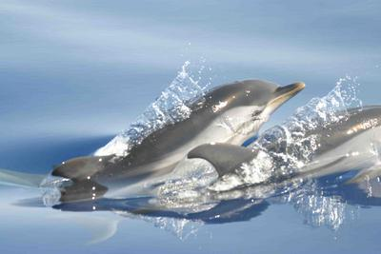 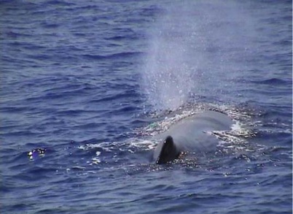

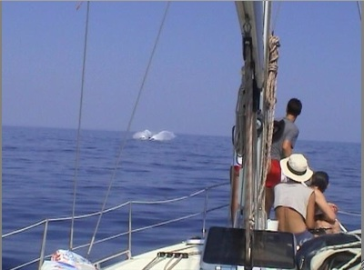 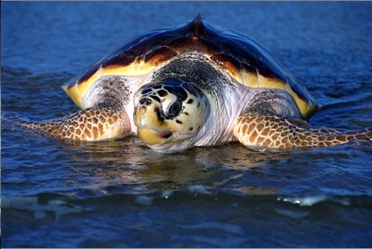

Images courtesy of Dennis Buurman



© One World Wildlife 2012 | Email: [myrddin@oneworldwildlife.org](mailto:myrddin@oneworldwildlife.org) | UK registered charity number 1099353 | site by [Circle Interactive](http://www.circle-interactive.co.uk/) | [Terms & Conditions](http://www.oneworldwildlife.org/terms-and-conditions) |[Sitemap](http://www.oneworldwildlife.org/sitemap.xml)