**GeoGebra STEM Extension**

##### Summary 15-year-old students were asked to develop ‘real life’ GeoGebra mathematical software applications of their choice for a *wide range of users (both other students and teachers) of varying technical ability and confidence*. The month-long activity consisted of 3 four-hour workshops interspersed with home-working and on-line collaboration. In addition to excellent GeoGebra applications per se, the students developed their *communication and collaboration skills and enhanced their (measured) perception of the importance of technological education*.

##### The project also demonstrated a successful approach featuring *collaboration between students, schools and four organisations,* and the respective roles of *‘teacher as expert educator/facilitator’* working and learning (CPD) with the (often scarce) technology specialist teacherand/or supporting an industry expert.

**1 Background**

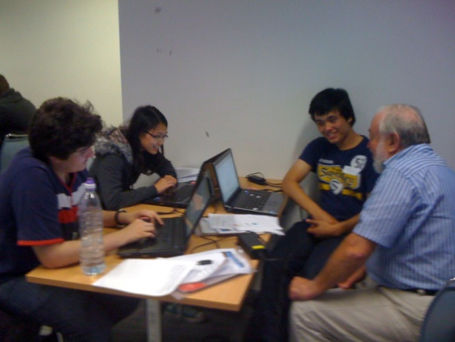GeoGebra is free, open-source software for mathematics, science and technology which has a rapidly growing international user base. It is the STEM equivalent of “Office" style software for business. It has very many powerful features to support interactive use, which can pose a challenge for many to get started.

The challenge for students was to contribute to its adoption in UK education by developing 'real world' applications for use by students and teachers with a wide range of technical ability. In addition to responding to the technical challenge, students were asked to demonstrate communication and collaboration skills including on-line interaction, team-working and face-to-face presentation.

**2 Approach**

The activity consisted of 3 half-day workshops interspersed with home-working and on-line collaboration.  Because GeoGebra, and indeed STEM teachers are relatively thin on the ground, the approach taken was for the teacher to facilitate the workshops working economically with the technology (GeoGebra) expert. The three half-day sessions became gradually less structured as the students became more confident:

**Session 1**

The first session featured a hands-on GeoGebra tutorial and discussion of on-line communication possibilities. The initial GeoGebra tutorial session featured ‘real life’ examples such as mathematical modelingand visualizationfrom photographs of patterns and structure in flowers and architecture; exercises such as “math aerobics” where students model algebraic functions kinesthetically; and data analysis and exploration such as from astronomy (Kepler's 3rd law) and athletic performance (Usain Bolt’s 100m sprints) [3,4,5].

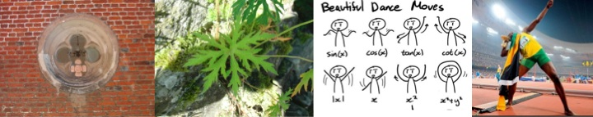

Realistic examples such as these, or from students’ previous work, are essential to get the ball rolling. Following this, the onus is very much on the student’s own initiative.

The students then had a one-hour activity to come up with their own applications and, were asked to prepare and then present their ideas receiving feedback from both fellow students and teacher. This first agenda was:

* Welcome and Project Objectives
* Hands-on GeoGebra tutorial example
* Communications on-line discussion
* 'Do your own' activity - students develop their own ideas with help as/if requested
* Presentation preparation
* 60-seconds Presentation: YOUR activity, ideas and next steps

**Session 2**

This session featured a full team plenary start and finish, with the major part devoted to individual one-to-one sessions making and discussing progress:

* Welcome and individual project presentation update - feedback and suggestions from pupils and experts.
* 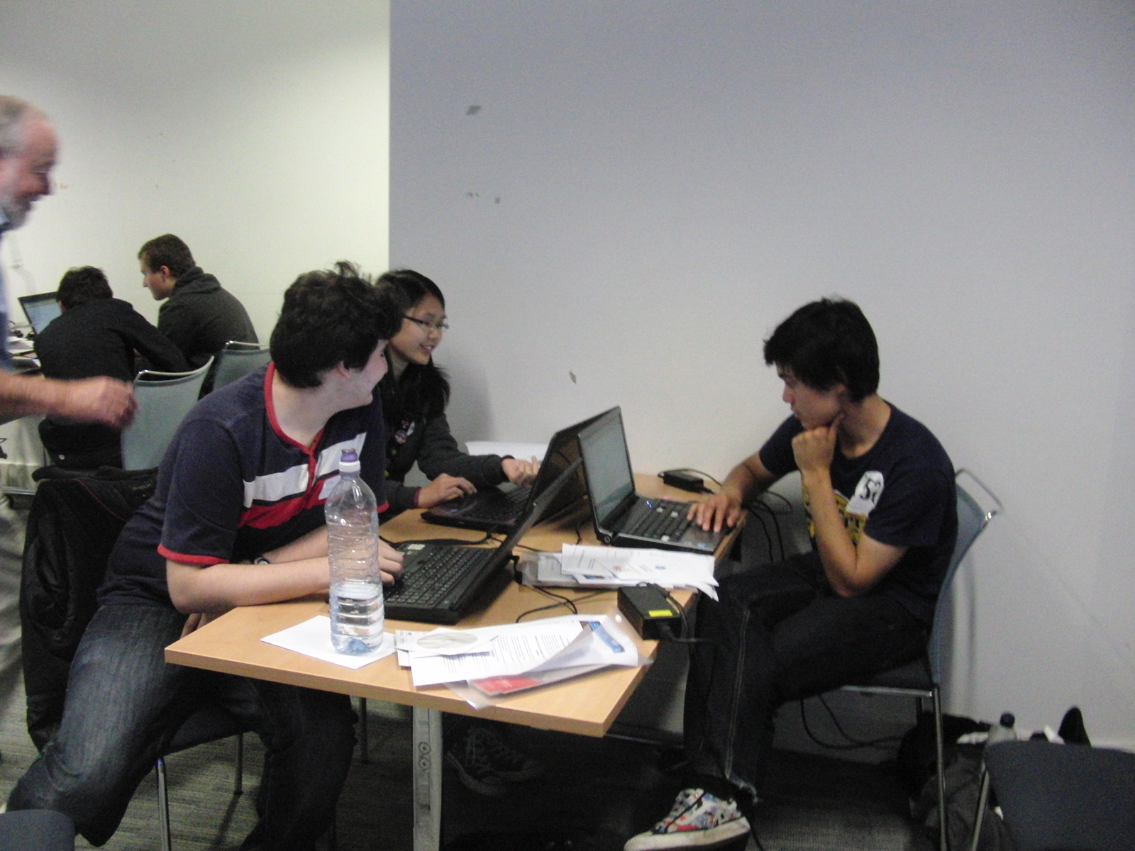Pupils work on their individual projects and are visited by our various experts receiving support as and when needed:
  + GeoGebra Help in developing project  - from GeoGebra experts
  + GeoGebra on-line communication and collaboration inc getting content on GeoGebra during the day
  + Meeting the requirement 'Addressing both technical and non-technical students and teachers' - CCITE
  + Usain Bolt and GeoGebra!
* Individual project presentation update and agreement on next steps and meeting

**Session 3**

Students presented their work. This consisted of project description and demonstration.

**4 Student Project Outcomes**

Excellent projects and presentations were demonstrated. Each project has an associated GeoGebra application file available from the ORBIT project database (see [http://orbit.educ.cam.ac.uk/wiki/GeoGebraSTEM\_exploration\_day](http://orbit.educ.cam.ac.uk/wiki/GeoGebraSTEM_exploration_day" \t "_blank)). The projects may be used in their on right or to generate ideas for new students to develop their own projects. The individual projects are described in the students' own words. It will be noted that the target user age ranges vary from 5 to 9 years of age to upper 6th plus teachers.

**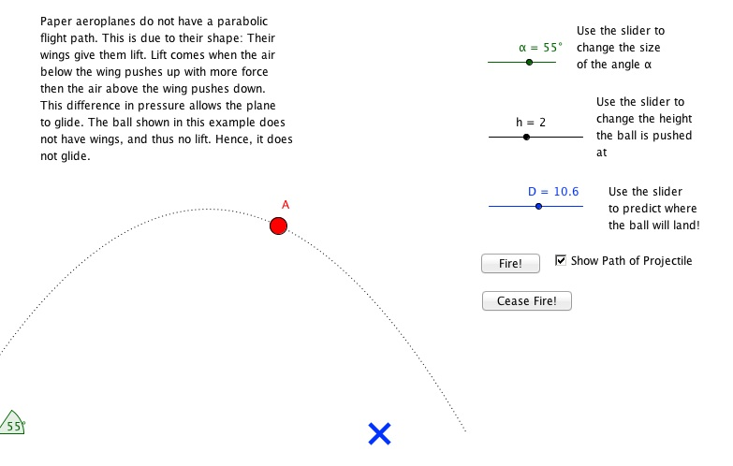Flying paper planes** Age group years 5-9, it’s not too technical, and it is very visual and interactive and simple to understand

I used Geogebra to produce an animated tutorial of an origami piece (such as a paper aeroplane). Once the plane has been made, experiments with throwing the plane show that it does not fly in a parabolic curve, as a ball would. I have produced an interactive geogebra spreadsheet to show how a ball would fall. Another geogebra spreadsheet demonstrates the flight trajectory of the plane. I have also produced a word document describing very simply, how the plane flies.

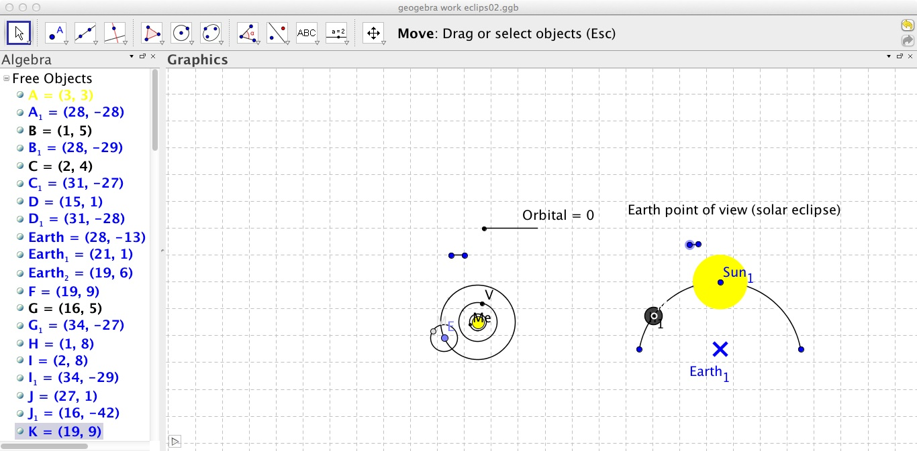

**To show and explain how a Solar and Lunar eclipse occurs.** For GCSE year 7 students and teachers who can use it as an example or a visual aid to teach their lessons.

Researching and creating a simulation of an eclipse from two points of view, with sliders that enable the users to interact with the simulation.

**Visualisation of maths and science concepts** 14-15 year olds, who are at the right age to begin grasping the things in my project and help teachers to introduce these concepts.

My project takes some of the concepts from maths and the sciences and uses graphical representations to help explain them. I think this could potentially be useful to 11-14 year-olds, who would be about the right age level to be to understand this, and who could also benefit very well from the visualisations. Below are two examples:

*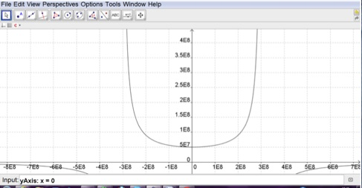The impossibility of faster-than-light travel >*

The graph shows that, as the speed of the object increases, F increases asymptotically to x=300,000,000, effectively increasing the object’s mass to infinity. The graph also shows that travelling faster than the speed of light gives a negative value of F, which is impossible.

*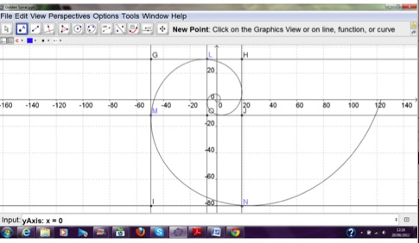< Golden spirals and why they work*

The Fibonacci sequence is the most famous sequence in which terms in the sequence refer to previous terms. The limiting ratio for the Fibonacci sequence is phi, the golden ratio. Phi can be visualised in the “golden spiral”, which is a spiral with a growth rate of phi for every quarter turn. Each quarter turn of the spiral can be inscribed within squares, which then fit together without gaps.

**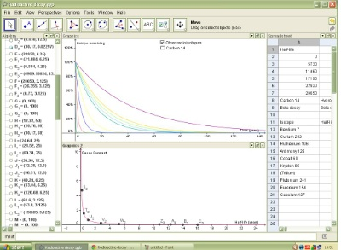Radioactive Decay & Carbon Dating** for GCSE A-level students teaching GCSE science

This project explores exponential graphs and how these are applied in radioactive decay, including carbon dating.

**5 Evaluation**

Various evaluation possibilities offer themselves

**Existing in-house evaluation methods**

In this case the [STEMNET CREST Award](http://www.stemteameast.org.uk/secondary/crest-awards/) provided both an incentive for students and an evaluation. CREST is Britain’s largest national award scheme for project work in the STEM subjects.  It is designed for secondary aged students and has three levels – Bronze, Silver and Gold. The projects were all deemed on course for the CREST Gold award.

**Qualitative evidence**

A wide range of collaborative face-to-face and on-line learning took place:

* *Fun and exciting using the GeoGebra software. Have learnt many new skills and facts whilst participating in this project. This project has allowed me to create and present my ideas to others.*
* *This project has helped me experience of doing a project individually, a lot about my topic and extending topics, GeoGebra is really useful! The project was interesting and taught me how to facilitate a long-term project. Sharing ideas was very helpful in generating concepts for my project. This project has helped me to learn how to put ideas together into one coherent project*
* *It has allowed me to research areas of interest independently. Even if subjects are of interest to me, I probably wouldn’t have looked them up in my free time, so this project has been interesting for me to research into things I enjoy.*
* *I developed my understanding of how planes fly, as well as how to present it in a way suitable for young people to use and interact with.*
* *I enjoyed the independency of the project and he introduced us to each other to ensure we were comfortable with each other.*
* *I have seen how a simple idea has evolved into something much larger. Normally, ideas tend to be too optimistic, and have to be shrunk or held back. However, my initial idea was much smaller than what I have been able to achieve. I found asking others very helpful, as they share ideas with me, which I would not have previously thought of.*

**Quantitative Evaluation**

The Expectation Shock evaluation methodology compares user/customer/student perception pre and post activity. In this project, pupils were asked five technology perception questions on a five-point scale (1-low, 5-high) of type: *To what extent do you feel that you have the technology skills to succeed in your career? To what extent do you feel that teamworking is important in technological activities?*

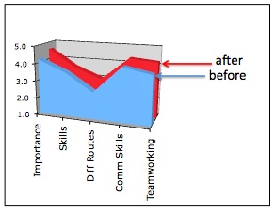The chart shows the group profile before (blue) and after (red) the programme. As a whole, the pre-programme group perception was that technology was quite important (mostly 4’s), that they had the requisite skills (mostly 3’s and 4’s), were to a certain extent aware that there were different routes to technology (3’s), and that communication and team-working skills are quite important (mostly 3’s and 4’s).

The after-programme scores (red) shows clear enhancements in their perception, particularly of the importance of technology, and the associated necessary communication and teamworking skills.

**6 Conclusion and Next Steps**

The project successfully explored a technology activity widened cross-curriculum and requiring communication and collaboration skills.

On an individual level, students achieved successful technology projects and also enhanced perception of the importance of technology and the essential technology related skills of communication and collaboration.

Regarding the educational process, the project demonstrated the feasibility of splitting the ‘teacher as expert facilitator/educator’ from that of ‘teacher as expert’. With the dearth of technology teachers, this could be used to spread them around and also support the use of industry experts by expert non-technology teachers. This would also provide a powerful continuing professional development opportunity (CPD).

This GeoGebra project is the first CCITE\* exemplar activity of a proposed three-year development of 20 such authentic learning activities each covering an extended STEM curriculum for key stages 2 and 3. Each activity will take half a term. The objective is to extend technology learning to cross-curricular, ‘real life’ activities reaching a wide audience with students, teachers and organisations working together. More generally, the activity could be a term, year or longer programme engaging a large number of schools.

\* CCITE is the umbrella organisation providing a Cambridge Centre for Innovation in Technological Education. STEM Team East provides expert engagement with schools and the CREST award. The University of Cambridge Faculty of Education project ORBIT provides research expertise, teacher education expertise and the ORBIT database (Open Resource Bank for Interactive Teaching). GeoGebra is a worldwide community developing and using the GeoGebra software.