**Kepler’s Third Law from Planetary data with GeoGebra** Adrian Oldknow [adrian@ccite.org](mailto:adrian@ccite.org) 7th Aug 2012

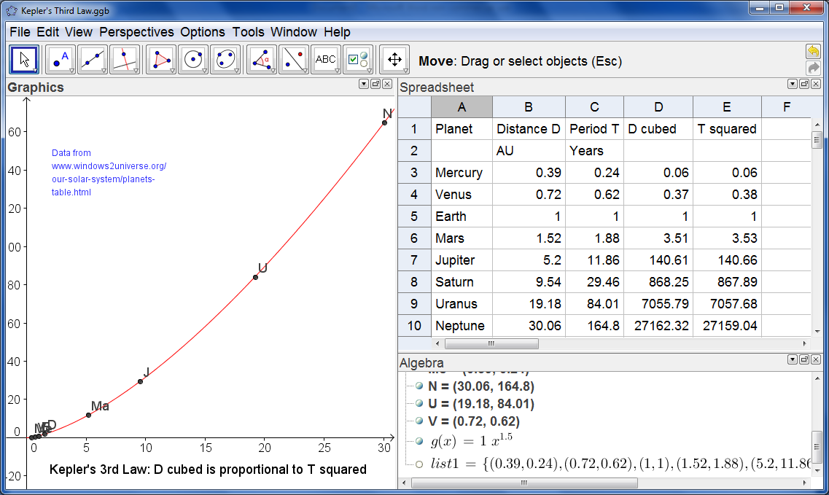Johannes Kepler (1571-1630) was a German astronomer who studied the motion of the planets in the solar system. Based on experimental data he proposed three “laws” – or hypotheses – about the way the planets orbit the sun. Later, Isaac Newton produced mathematical proofs of these laws under the assumption that the force of attraction between the Sun and a planet at any time is proportional to the reciprocal of the square of their distances apart at that time. His third law expresses the relationship between the period of a planet’s orbit (T) and its mean distance from the Sun (D). A table of planetary data can be found at the National Earth Science Teachers Association (USA) website: Windows To The Universe:

<http://www.windows2universe.org/our_solar_system/planets_table.html>

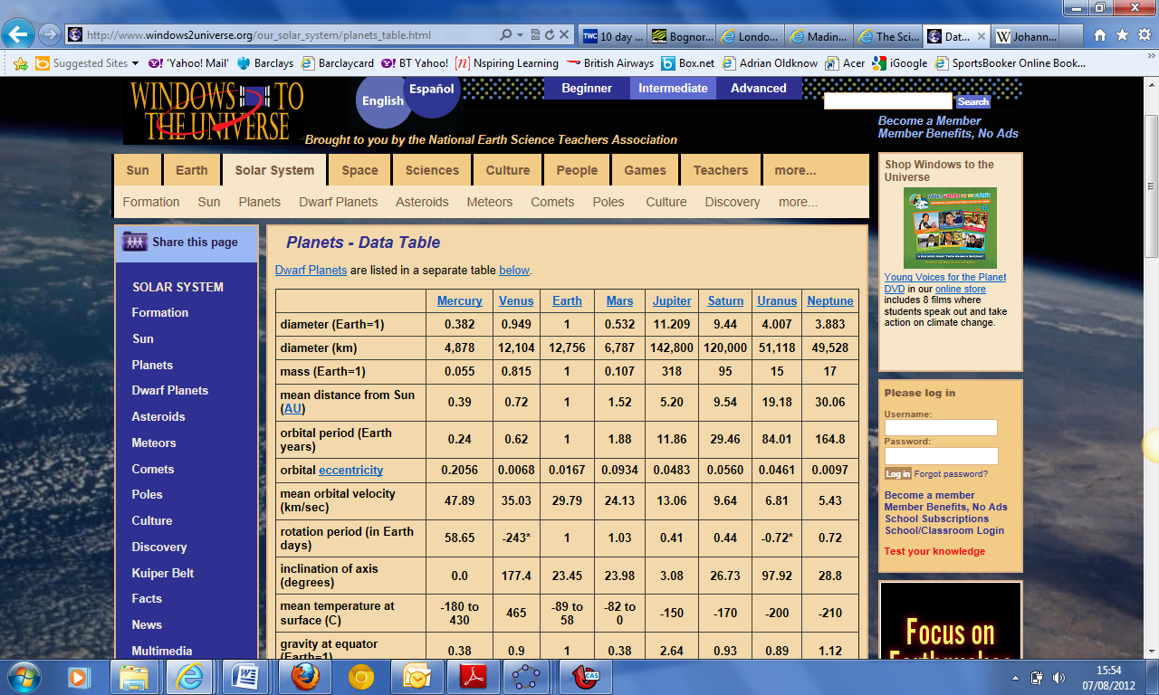

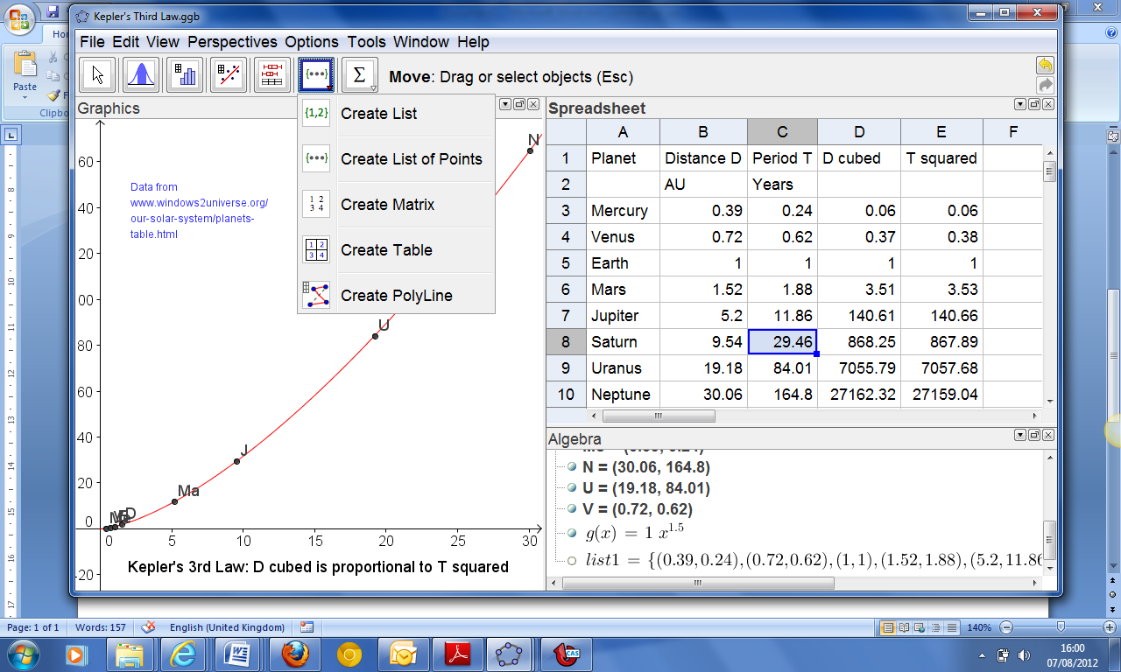The data from the fourth and fifth rows of the table can be entered into the Spreadsheet View of GeoGebra.

In order to produce the scatter-plot of T against D you highlight the block of data in the 2x8 rectangle B3:C10, drop down the menu from the 6th icon and select the “Create List of Points” option. In the Dialog box you can give this list a name, such as DT.

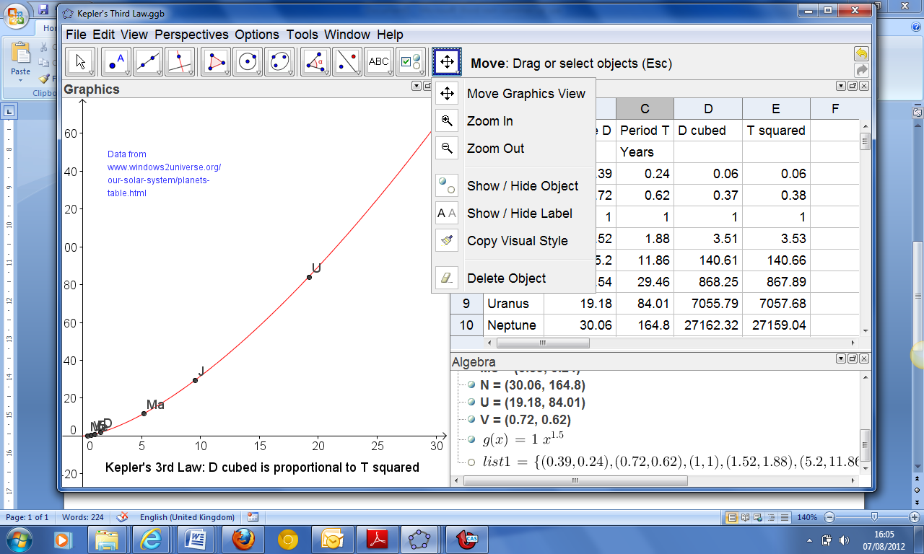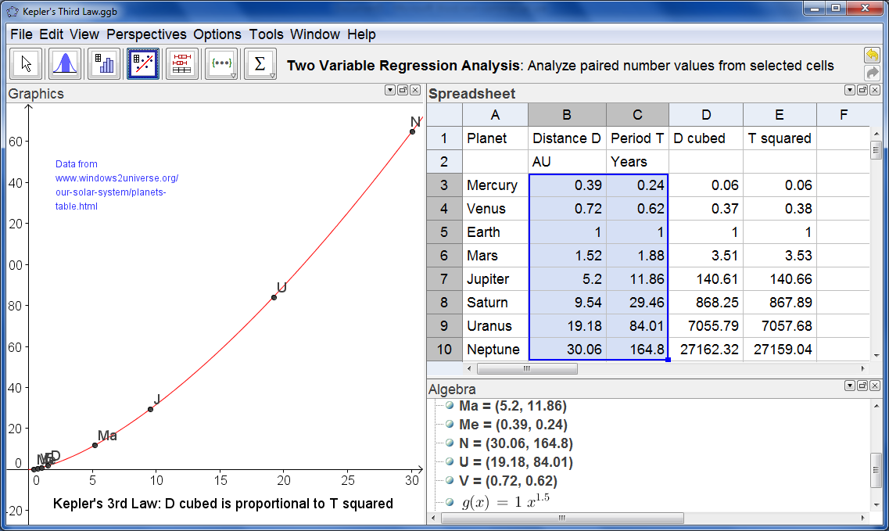In order for the plotted points to be visible in the Graphics View you will need to rescale the x- and y-axis e.g. from -5 to 35 and -10 to 170. In the Graphics View you will need to select the Move option from the rightmost icon. Then click on one of the axes and drag it to change the scale. Repeat for the other axis. Then click anywhere away from the axes and drag the whole sheet of graph paper to a suitable place in the Graphics View. Now we are ready to carry out some analysis on the data. In the Spreadsheet View make sure the same rectangle of cells is highlit and then click on the fourth icon to perform a “Two Variable Regression Analysis”. Our two variables are the mean distance D and the period of orbit T, and we are looking for a formula which could find T as a function of D. In the Regression Analysis window you will see the scatter-plot – and you can select a function from the drop down menu for the Regression Model. In this case try “Power” and you should see a pretty good fit. In this case *y* represents T and *x* represents D.

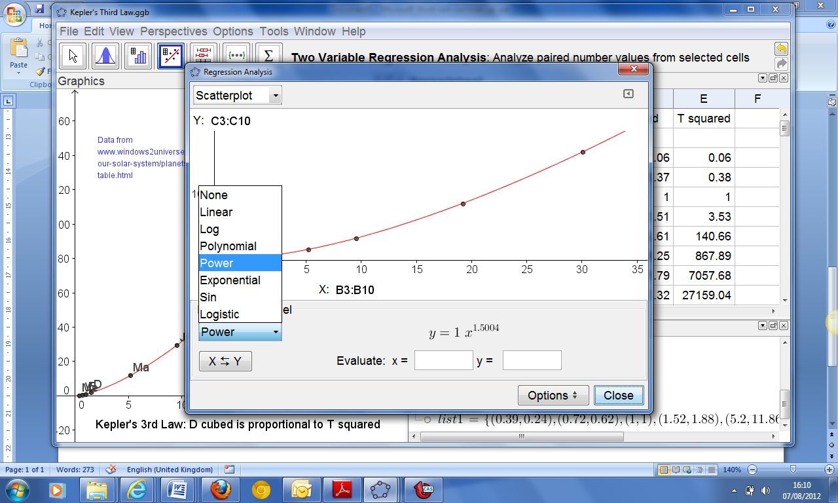If you right click on the red graph you can select the option to Copy to Graphics View.

Now we have a good model in the form of the equation T = D1.5. If we write 1.5 as the fraction 3/2 then the model is that T is given by the square root of the cube of D. Or that T squared is equal to D cubed. You can check these by adding columns to the Spreadsheet to show T^2 and D^3. All that remains now is to tidy up the final screen layout in GeoGebra and you are ready to publish your results!

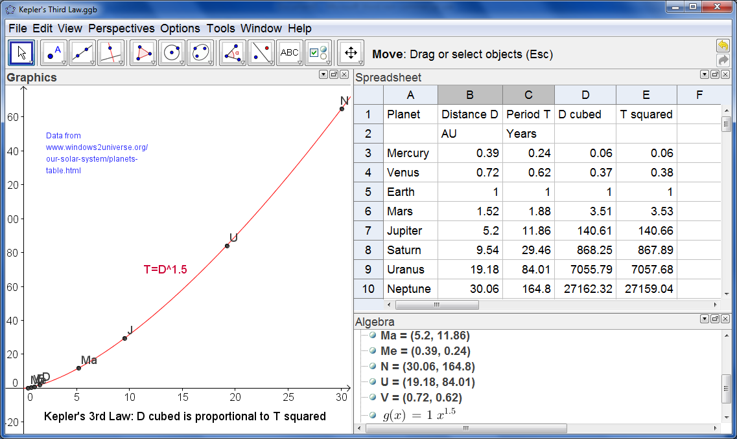

Here we have three views selected – and the Algebra View has been dragged to lie below the Spreadsheet View. The 10th icon has been used to enter text on the Graphics View. The points have been renamed according to the planet each represents. Once you have produced a display you are happy with, you can save you work using the File menu. You can also export it as an interactive Web Page in html format.

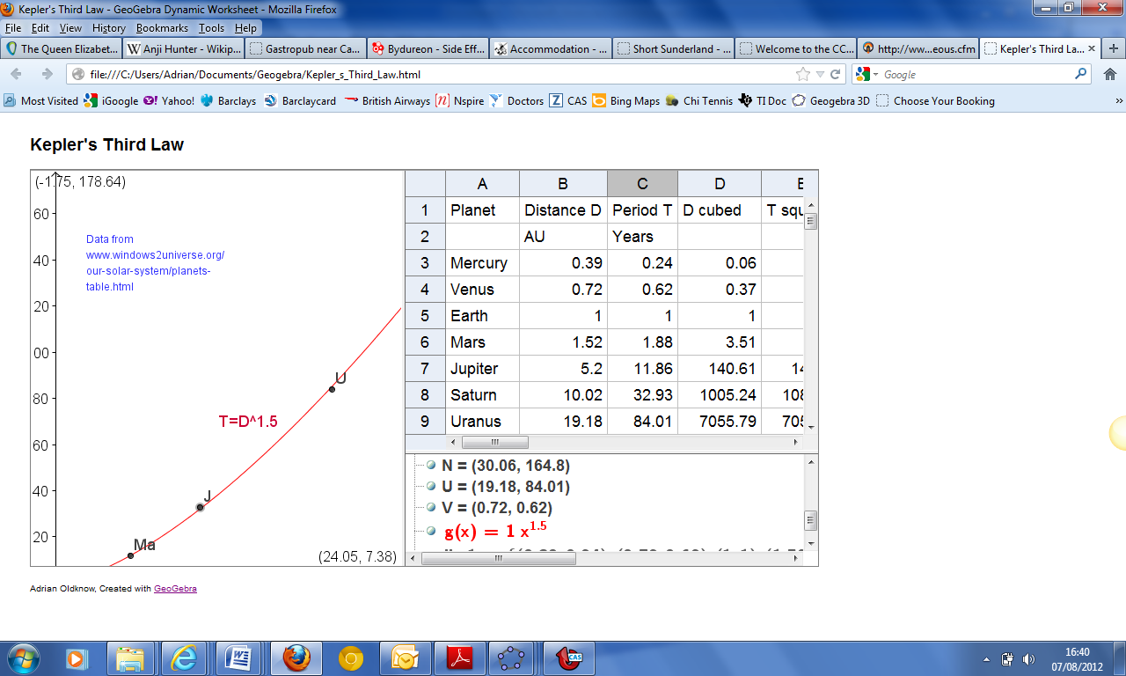However you will need to experiment with the best window size to use before publishing. If in doubt search the GeoGebra Wiki for information on the best screen dimensions to use.

You can also export the Graphics View as an interactive display for others to use by publishing your work to GeoGebraTube – also using the File menu. You will need to register on the GeoGebra site to use this feature.

Can you illustrate Kepler’s other laws using GeoGebra? What can you find out about ellipses?

Have a look at the TI-Nspire STEM booklets (Galloway, Oldknow & Tetlow), such as “Using Real World Data” <http://www.nationalstemcentre.org.uk/elibrary/resource/715/stem-activities-with-ti-nspire> for other ideas for modelling using these techniques.