**GeoGebra STEM Exploration - an intensive summer project at Cambridge University**

Input your inspiration and perspiration to enhance STEM learning

##### Summary Nine 15-year-old students developed ‘real life’ GeoGebra mathematical software applications for a range of users of varying technical ability and confidence. The month-long activity consisted of 3 four-hour workshops interspersed with home-working and on-line collaboration. In addition to excellent GeoGebra applications per se, the students also demonstrated target user awareness, communication and collaboration, and learning insights.

##### The GeoGebra project is the first CCITE exemplar activity of a proposed three-year development of 20 such authentic learning activities covering an extended STEM curriculum for key stages 2,3 and 4. The objective is to extend technology learning to cross-curricular, ‘real life’ activities reaching a wide audience with students, teachers and organisations working together.

1 Background

GeoGebra is a mathematics software and community of users that is going viral globally. See (<http://geogebra.org/cms/>) It has many similarities to Excel, is free and highly interactive yet remains a challenge for many to get started.

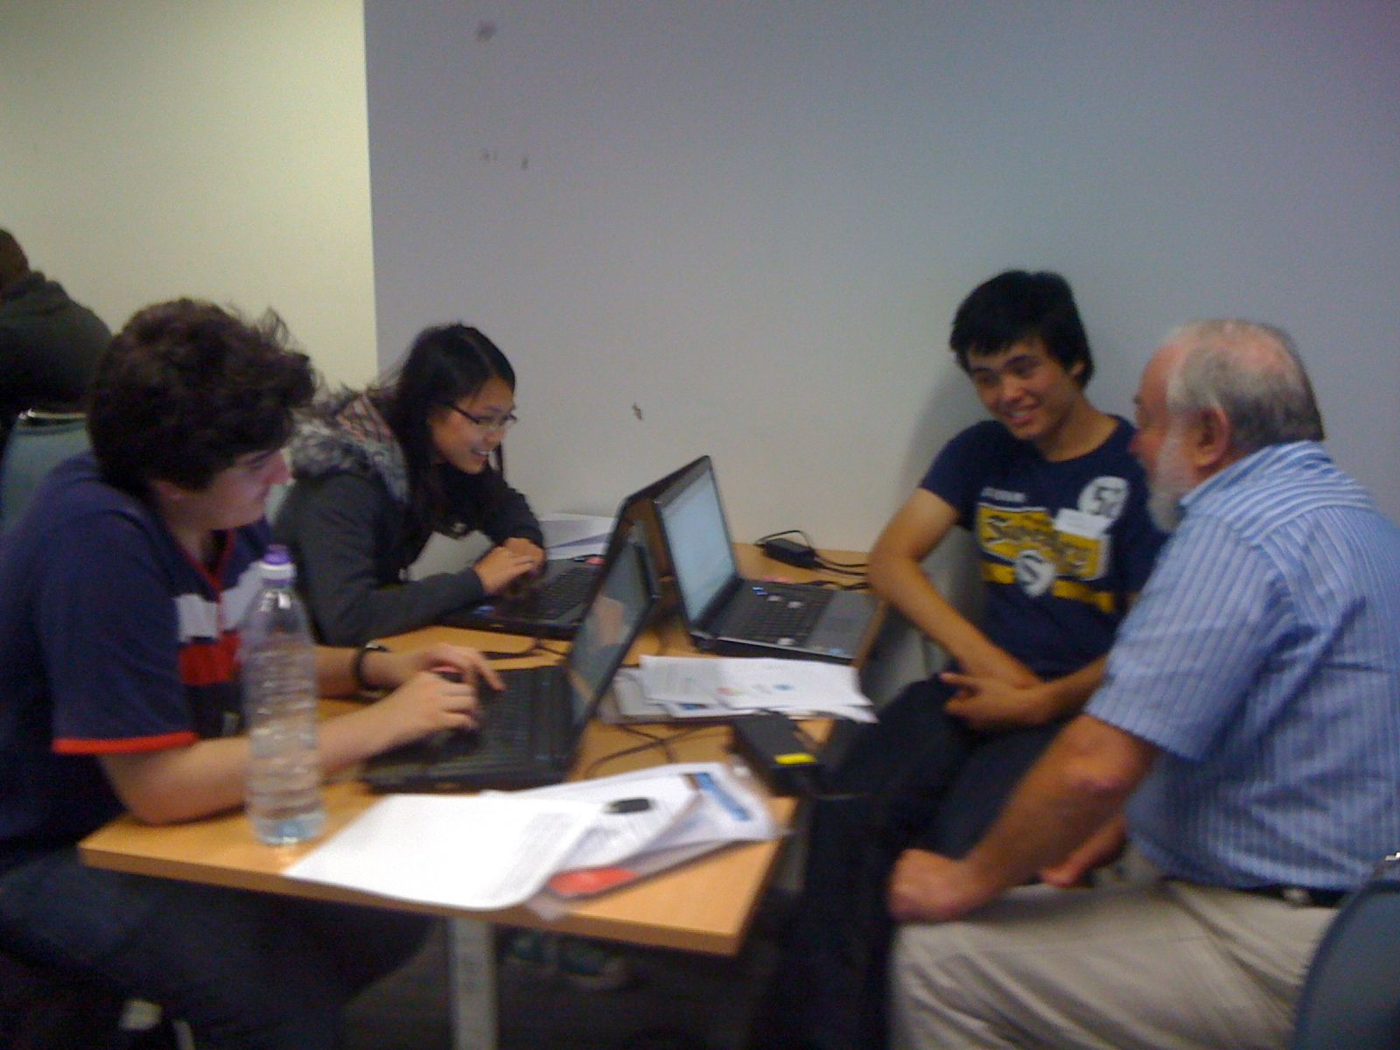Nine male and female 15-year-old male and female students were offered a unique opportunity to contribute to its deployment in the UK by developing***'real life' applications*** of their choice for use with a ***wide range of students and teachers***. In addition to the technical challenge, all students were asked to demonstrate ***communication and collaboration skills*** including team-working, face-to-face presentations and on-line. The resultant student projects suggested that the activity would be of considerable benefit to other students as a half-term extended STEM activity for 15-year-olds.

The activity consisted of 3 half-day workshops interspersed with home-working and on-line collaboration.  Each workshop was part tutorial and help in GeoGebra, part development, presentation and feedback on their emerging work, and periodic injections of ‘real life’ STEM discussions featuring discussions of maths in buildings (using the picture below), plants (using the picture below), math aerobics (see <http://mathaerobics4samvedna.wikidot.com>/) and Usain Bolt (download [Taking a closer look at Usain Bolt](http://www.ccite.org/Analysing%20men%20100m%20GeoGebra.pdf)).



2 Pedagogic Rationale and Approach

The Pedagogic rationale was to apply, understand and appreciate mathematics in real-life, to communicate and collaborate for learning, and to undertake interactive, affective learning. Also it was to encourage pupils to develop ‘real life’ mathematical applications of their choice which take into account a wide variety of users, to think about and meet user requirements, and to experience individual ownership of their project yet communicate and collaborate to achieve their objective. The focus on ‘real life’ and student ownership of their idea and project was expected to increase student motivation. The challenges and opportunities for learning are many, and include:

* Open ended and closed questioning - to and by pupils and teachers
* Teamworking - inclusion of ALL members, listening to others, respect for different and complementary strengths of team members
* Leadership - assertive, appropriate behaviour, discipline and negotiation
* Presentation - making physical face-to-face and on-line communication appropriate to a given audience, giving and receiving feedback
* Plenary - teams present to class and receive feedback

The onus is very much on students' own initiative.

3 Lesson Plan/Agendas

The three half-day sessions became gradually less structured as students become more confident:

Session 1

The first session featured a hands-on GeoGebra tutorial and discussion of on-line communication possibilities. The students then had a one-hour activity to come up with their own applications and, were asked to prepare and then present their ideas receiving feedback from both fellow students and teacher:

* Welcome and Project Objectives
* Hands-on GeoGebra tutorial example
* Communications on-line discussion
* 'Do your own' activity - students develop their own ideas with help as/if requested
* Presentation preparation
* 60-seconds Presentation: YOUR activity, ideas and next steps including communications and collaboration

Session 2

This session featured a full team plenary start and finish, with the major part devoted to individual one-to-one sessions making and discussing progress:

* Welcome and individual project presentation update - feedback and suggestions from pupils and experts.
* 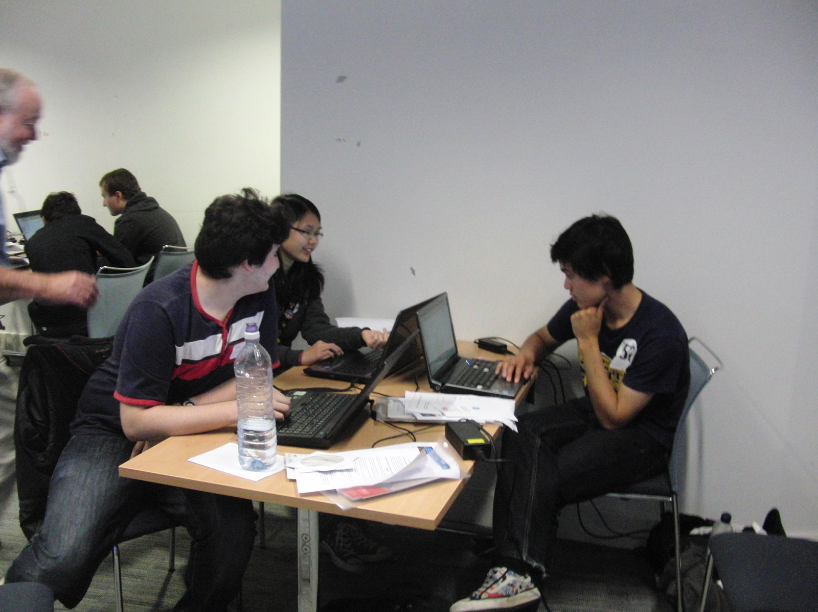Pupils work on their individual projects and are visited by our various experts receiving support as and when needed:
  + GeoGebra Help in developing project  - from GeoGebra experts
  + GeoGebra on-line communication and collaboration inc getting content on GeoGebra during the day
  + Meeting the requirement 'Addressing both technical and non-technical students and teachers' - CCITE
  + Usain Bolt and GeoGebra!
* Individual project presentation update and agreement on next steps and meeting

Session 3

Students presented their work. This consisted of project description and demonstration.

4 Student Project Outcomes

Five excellent projects and presentations were demonstrated. Each project has an associated GeoGebra application file available from the ORBIT project database (see [http://orbit.educ.cam.ac.uk/wiki/GeoGebraSTEM\_exploration\_day](http://orbit.educ.cam.ac.uk/wiki/GeoGebraSTEM_exploration_day" \t "_blank)). The projects may generate ideas for students to develop their own projects.

**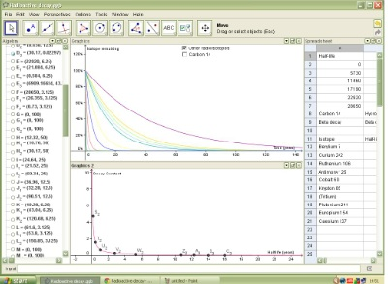Radioactive Decay & Carbon Dating** for GCSE A-level students teaching GCSE science

This project explores exponential graphs and how these are applied in radioactive decay, including carbon dating. For those studying for their GCSEs, it would be appropriate to explore radioactive decay theory and how this forms the basis of carbon dating, including topics such as half-lives and what radioactivity is. This knowledge can be further applied into the processes inside a nuclear reactor; perhaps a student could develop this project by drawing graphs of the amounts of energy released by different radioisotopes when bombarded with a neutron in a nuclear reactor. Learning about exponential graphs would also deepen a student’s understanding of compound interest, which is part of the Maths curriculum and in preparation for A-level Maths.

**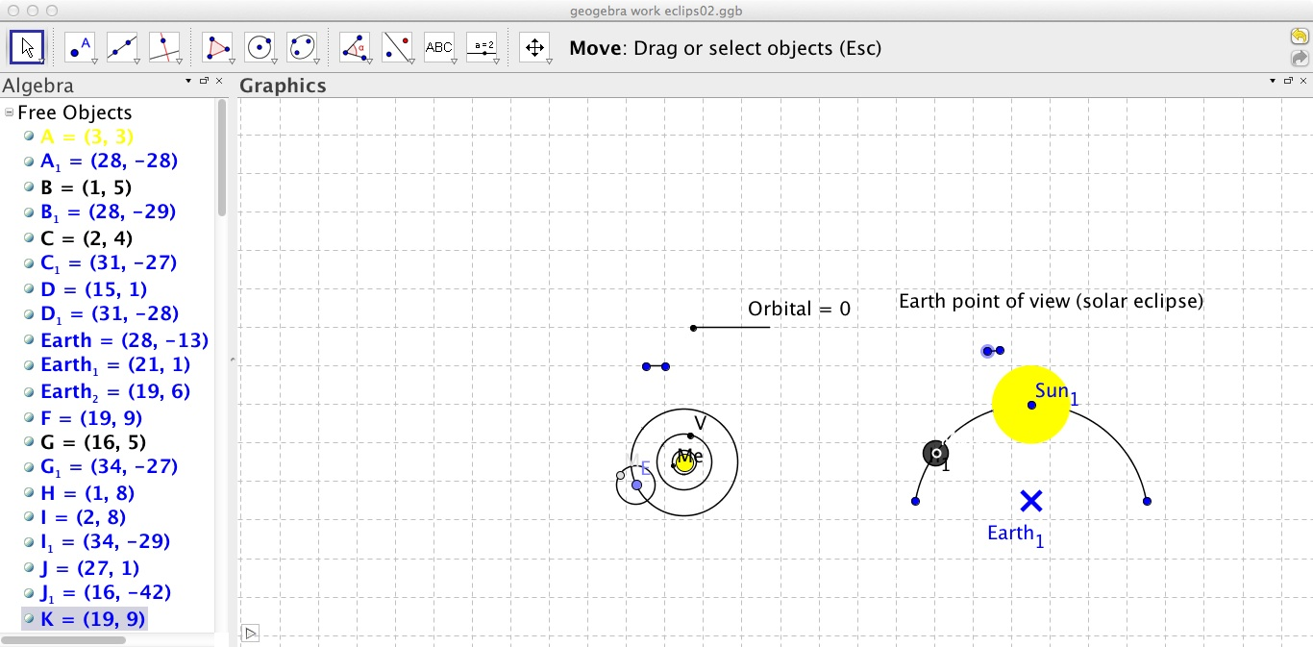To show and explain how a Solar and Lunar eclipse occurs.** For GCSE year 7 science students, teachers can use it as an example or a visual aid to teach their lessons.

Researching and creating a simulation of an eclipse from two points of view, with sliders that enable the users to interact with the simulation. As seen from the surface of the Earth, a solar eclipse occurs when the Moon passes between the Sun and the Earth, and the Moon either funnels, or partially blocks, the Sun. During total eclipses, the disk of the sun is fully blocked out by the Moon. If the Moon were in a circular orbit close enough to the Earth and in the same orbital plane (path), there would be total solar eclipses every month. However as a matter of fact the Moon's orbit is inclined at more than 5 degrees to the Earth's orbit around the Sun. Thus the Moon's shadow at a new moon usually misses the Earth. The Earth's orbit around the sun is called the ecliptic plane as the Moon's orbit must cross this plane in order for an eclipse (both solar and lunar eclipse) to occur. Furthermore the Moon's actual orbit is also elliptical, taking it far away from the Earth that its apparent size is not large enough to fully obscure the Sun. These orbital planes cross each year at a line of nodes, this results in at least 2 and up to 5 solar eclipses occurring each year, two of which will be the only total solar eclipses in that year. In the GeoGebra project I will label all the variables that will affect the eclipse, e.g the inclined angle of the Moon's orbit etc.

The target age group for this project is students that are in year seven and year eight. Projects like this one will appeal to students of this age group because at this age the students are very inquisitive and they will be interested to learn about the solar system and how eclipses occur. Further more eclipses are rear natural phenomenon thus students will be interested to learn about it and see how they can be predicted.

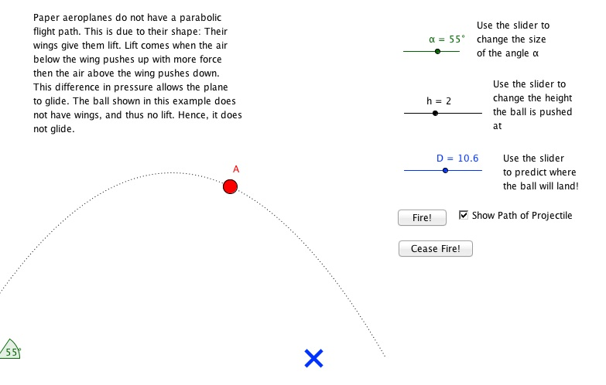Flying paper planes Age group years 5-9, it’s not too technical, and it is very visual and interactive and simple to understand

I used Geogebra to produce an animated tutorial of an origami piece (such as a paper aeroplane). Once the plane has been made, experiments with throwing the plane show that it does not fly in a parabolic curve, as a ball would. I have produced an interactive geogebra spreadsheet to show how a ball would fall. Another geogebra spreadsheet demonstrates the flight trajectory of the plane. I have also produced a word document describing very simply, how the plane flies. I have seen how a simple idea has evolved into something much larger.

Normally, ideas tend to be too optimistic, and have to be shrunk or held back. However, my initial idea was much smaller than what I have been able to achieve. I found asking others very helpful, as they share ideas with me, which I would not have previously thought of.

Visualisation of maths and science concepts 14-15 year olds, who are at the right age to begin grasping the things in my project and help teachers to introduce these concepts.

My project takes some of the concepts from maths and the sciences and uses graphical representations to help explain them. I think this could potentially be useful to 11-14 year-olds, who would be about the right age level to be to understand this, and who could also benefit very well from the visualisations. Below are two examples:

**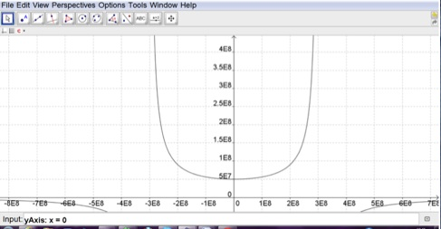The impossibility of faster-than-light travel >**

The graph shows that, as the speed of the object increases, F increases asymptotically to x=300,000,000, effectively increasing the object’s mass to infinity. The graph also shows that travelling faster than the speed of light gives a negative value of F, which is impossible.

**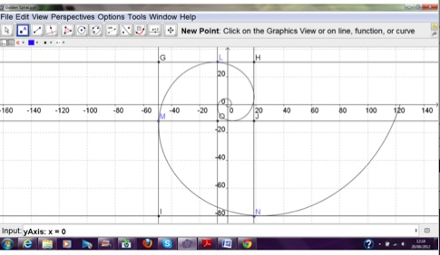< Golden spirals and why they work**

The Fibonacci sequence is the most famous sequence in which terms in the sequence refer to previous terms. The limiting ratio for the Fibonacci sequence is phi, the golden ratio. Phi can be visualised in the “golden spiral”, which is a spiral with a growth rate of phi for every quarter turn. Each quarter turn of the spiral can be inscribed within squares, which then fit together without gaps.

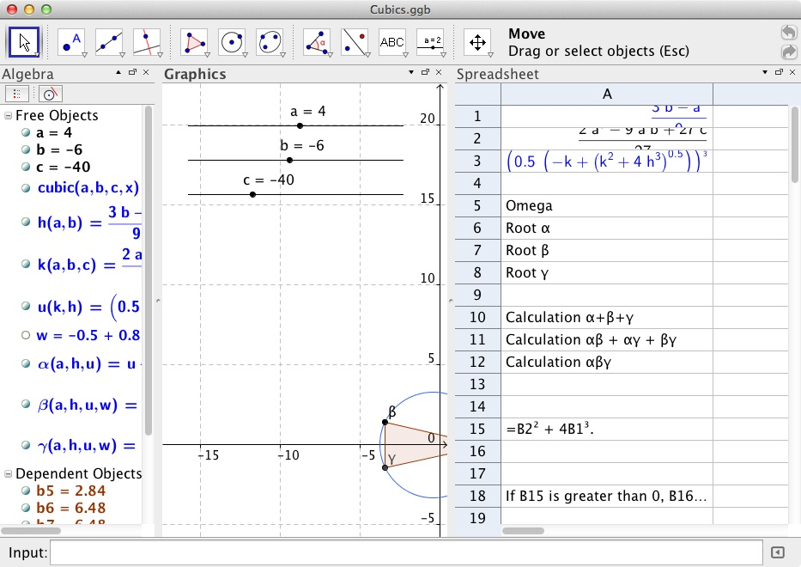Cubic equations and their roots for lower and upper 6th students

I recalled some mathematical reading I had done about cubic equations and their complex roots, and decided that I would try to discover more about them for myself. I would then try to use Geogebra to find the solution to any cubic equation, given its coefficients, and plot the real and complex roots on an Argand diagram so that as the user changed the coefficients, they could see how that affected the roots of the cubic equation.

The potential age group that I am targeting is for students around my age – so, for Lower 6th students who are interested and want to learn something outside of their syllabus, and for Upper 6th students for whom it may be relevant to their studies on complex numbers and the relationships between roots of equations. I think my project would appeal to them as it is expanding on the syllabus that is taught

5 Evaluation

Many evaluation possibilities offer themselves:

Existing in-house evaluation methods can be used.

In this case the [STEMNET CREST Award](http://www.stemteameast.org.uk/secondary/crest-awards/) provided both an incentive for students and an evaluation. CREST is Britain’s largest national award scheme for project work in the STEM subjects.  It is designed for secondary aged students and has three levels – Bronze, Silver and Gold. The projects were all deemed on course for the CREST Gold award.

Qualitative evidence

A wide range of collaborative face-to-face and on-line learning took place, including also the frequently cited freedom to work on a project individually.

* *Fun and exciting using the GeoGebra software. Have learnt many new skills and facts whilst participating in this project. This project has allowed me to create and present my ideas to others.*
* *This project has helped me experience of doing a project individually, a lot about my topic and extending topics, GeoGebra is really useful! The project was interesting and taught me how to facilitate a long-term project. Sharing ideas was very helpful in generating concepts for my project. This project has helped me to learn how to put ideas together into one coherent project*
* *It has allowed me to research areas of interest independently. Even if subjects are of interest to me, I probably wouldn’t have looked them up in my free time, so this project has been interesting for me to research into things I enjoy.*
* *I developed my understanding of how planes fly, as well as how to present it in a way suitable for young people to use and interact with.*
* *I enjoyed the independency of the project and he introduced us to each other to ensure we were comfortable with each other.*
* *We communicated via online on Facebook and email (most students noted this).*

The one-liner responses from the pupils reflect an extremely challenging but successful project:

* *Thanks a lot, I've learnt a lot today!*
* *Fantastic experience, great software enjoyed the day*
* *Really enjoyable day. A lot easier after getting to know the software*
* *Cheers - enjoyed the day even though it was tough*
* *Awesome experience, very nice software to work with Thanks!*
* *Tough to start with but got progressively more enjoyable*
* *Very enjoyable and challenging. I needed this to stop my brain going to mush over summer from disuse!*
* *Though I struggled to come up with an idea at first, I thoroughly enjoyed learning about time dilation and using the GeoGebra software*

Quantitative Evaluation

Evidence was found for enhanced technology perception:

The pupils were asked five technology perception questions on a five-point scale (1-low, 5-high) of type: *To what extent do you feel that you have the technology skills to succeed in your career? To what extent do you feel that teamworking is important in technological activities?*

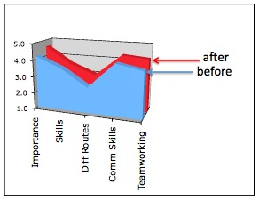The chart shows the group profile before (blue) and after (red) the programme. As a whole, the pre-programme group perception was that technology was quite important (mostly 4’s), that they had the requisite skills (mostly 3’s and 4’s), were to a certain extent aware that there were different routes to technology (3’s), and that communication and team working skills are quite important (mostly 3’s and 4’s).

The after-programme scores (red) shows enhancements in their perception, particularly of the importance of technology, communication and teamworking skills.

Conclusion and Next Steps

This GeoGebra project is the first CCITE exemplar activity of a proposed three-year development of 20 such authentic learning activities covering an extended STEM curriculum for key stages 2,3 and 4. Each activity will take half a term. The objective is to extend technology learning to cross-curricular, ‘real life’ activities reaching a wide audience with students, teachers and organisations working together. We invite collaboration.