SC0032 - Teacher's Notes
Working with discussion: rationale
This resource is aimed at developing student teachers’ skills in working with discussion. Its main focus is on managing and organising discussion-based activities. It provides guidance on:

- Starting a discussion
- Structuring discussions
- Organising group talk
- Role Play
- Ground Rules for Discussion
- Difficult Discussions

Objectives are that student teachers learn a range of pedagogical techniques for promoting and managing discussion and about some of the issues relevant to teaching in this way. It can be presented to the students as a hand-out accompanying class practice of some of the ideas in it or read online on the BEEP website as background reference material.

Working with discussion as a science teaching strategy
Science teachers are often encouraged to rush from one topic to another delivering science content and explanation without giving students the opportunity to consider why they are believed to be true. To step back and give students an opportunity to reflect on and discuss their ideas can be hard, however it is part and parcel of teaching nature of science and about controversial issues in science.

- Starting a Discussion
Students often find it difficult to swap into discussion mode when their science lessons are more usually teacher-led, changing the lab for a classroom or using pictures or short activities as starters can help. Suggested starters include


Headlines
Cut out or photocopy stories from the daily papers - a collection soon builds up. Laminate any particularly good ones for future use. NB write the paper and date in the margin first. Metro is a particularly good source as you can pick up a dozen copies at a time for free.

Many websites now supply newsfeeds which will keep you up to date with topical stories. Details about the BBC's service which includes science-specific items are available here.

Hands and Hearts
This is a quick exercise designed to enable students to consider the different parts that emotional reaction and logical thinking play in making difficult decisions.

A controversial question such as whether genetic screening should be made freely available is read out and students asked to move to nominated spaces in the room. If they agree say ‘yes, without reservation’, ‘yes, but only for those with disabling inherited disorders’ or ‘no, never’. The students are then asked to place their hands on their head if they made their decision through logical decision making – weighing up the pros and cons – or through an emotional reaction. Both are allowed.
This can be a good starter to use before a more thorough risk-benefit analysis to get students thinking about the pros and cons of a situation. It can also be used with subtly changing situations to illustrate the complexity of ethical questions.

Cartoons
Ever since Concept cartoons (see www.conceptcartoons.com) became famous science teachers have come to realise the value of cartoons for initiating a discussion. There is a wide range available on the internet - type the topic name e.g. "cloning" and "cartoons" into Google and click on the Images tab. We cannot include these here because of copyright issues but there are a couple of copyright-free ones below to start you off.
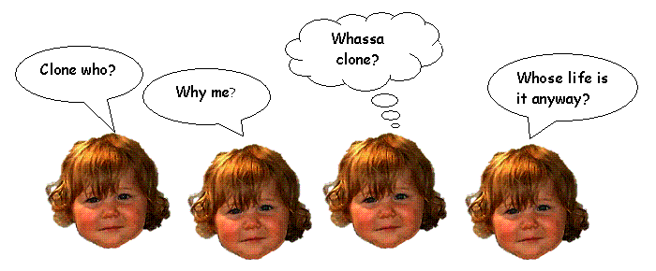
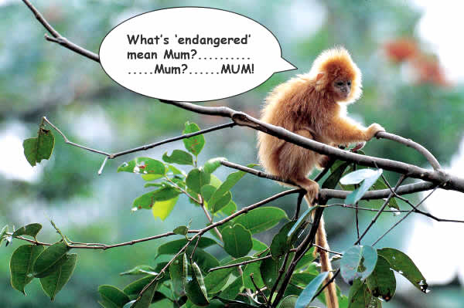

There is an article by Tom Kempton in December 2004’s School Science Review (Vol. 86 no 315) on using cartoons and paintings to stimulate discussion if you want to follow this up further.

- Structuring discussions

Writing frames
These can be based around some prompts to keep discussion flowing. For example:

- Why do you think that?
- What is your reason for that?
- Can you think of another argument for your view?
- Can you think of an argument against your view?
- How do you know?
- What is your evidence?
- Is there another argument for what you believe?
Another example is the use of questions to evaluate the scientific evidence presented in an article or piece of work.

- What scientific evidence is included?
- Who collected the scientific evidence?
- How was the scientific evidence collected?
- What does the scientific evidence tell us?
- What are the limitations of the scientific evidence?

Using different perspectives

Goals, rights and responsibilities
While not actually going so far as to develop a role play students can be encouraged to think through ethical questions from different perspectives.

It is often useful to make a table with the different actors in the ethical dilemma as rows and for each their goals, rights and responsibilities. Goals are things we aim for, rights are things that are due to us and responsibilities are the things we owe others. For example, the ‘saviour sibling’ scenario can be broken into:

 | Goals | Rights | Responsibilities
Father | Healthy sibling | Freedom to reproduce
Mother | Healthy sibling. Baby without inherited disorder | Freedom to reproduce | To both her children
Unborn Baby |  | To life without assault
Sibling | To become well
The trick is to make sure you have a sensible balance covering enough of the main actors in the scenario. For instance in the case of reproductive cloning, the parents and the unborn baby are essential but what about any siblings, the doctor performing the procedure or the baby's grandparents for example?

- Managing Discussions

Organising Group Talk
Relying on friendship groups to support discussion doesn’t work very well: the students are comfortable with each other but also know each other’s opinions well so discussion doesn’t necessarily ‘take off’. Mixed pace groups that you set up yourself work best. It helps to plan the groups and to give out roles.

Pairs
Easy to organise and high participation, very useful for planning but will take a long time if each pair is expected to feed back to the class.

Triads
Again easy to organise but care needed to prevent 'lurking'. Best to assign each group member a role eg. talker, questioner and recorder. The talker presents their case, the questioner seeks clarification and the recorder takes notes and reports on discussion.

Pairs to Fours
Useful to compare and explain ideas before generating feedback for the rest of the class.

Envoys
Once a group has carried out a task, one person from each group moves to another to report on their group's conclusions and to find out what the other group decided and achieved. The envoy then returns to their original group to feed back the new information. This effectively avoids repetitive feedback to the whole class.

Report Back
Choosing a group representative at random after they have completed the discussion helps to ensures that everyone participates! For example, you can ask them to number themselves 1, 2, 3, 4 initially without you knowing which is which, then at the end ask all the number 2s to report back.

Role Play
It is often easier to run discussions by having the students prepare for playing different roles; students may have little or no experience of thinking about moral issues, or of debating them with others or may know each other too well to generate open discussion.

Role play has long been used in schools for teaching in two areas; the first where there is an intention for the pupils to experience their learning in order to understand and change their attitudes and behaviour and the second, where development of interpersonal and communication skills are involved.

Many of the case studies on the BEEP website can be adapted for role play by asking students to debate as if they were one of the key players in the scenario. Or the goals, rights and responsibilities teaching activity can be carried out in role.

When using role play don’t forget to allow time for students to wind down and come out of role before leaving class.

Ground rules for discussion
You, as the teacher, will need to establish rules or guidelines on appropriate and inappropriate modes of argument and self-expression. The goal is a general atmosphere of mutual respect and tolerance but is more readily stated than achieved.

In defining the rules or framework for discussion, attention should be paid to both cultural and religious sensitivity as well as maintaining a balance between objectivity and emotional engagement. Try not to allow students to personalise the issues under discussion as this may arouse feelings of guilt and a need for self-justification.

Multiple perspectives can arise from differences of culture, religion, social class, gender or academic discipline. When several students within the group share a perspective the discussion can possibly break down into a contest between rival ‘factions’.

A clear framework suggested by Susan Illingworth for students in Higher Education can be helpful here. Teachers should ensure that:

- Every member of the group has an opportunity to speak.
- Views can be expressed without interruption.
- Criticisms are aimed at arguments and not individuals.
- There are mechanisms for defusing heated situations.
- Participants are encouraged to apply constructive criticism to their own beliefs
- Participants are encouraged to look for common ground between opposing views
- Teaching materials are selected for their accessibility to a range of viewpoints.

Students are used to being asked for the correct answer, so it will take them a while to come to terms with the fact that when discussing controversial issues as opposed to science concepts there will not always be correct answers. This needs to be made clear to them.

Students should feel safe in the classroom environment. As private individuals they could refuse to participate in a debate if it distressed them either by remaining silent or by walking away but in school students are expected to remain in class.

Difficult discussions
Sometimes discussions won’t take off, students might need help in order to realise that they already have opinions on moral issues. Emotive starters for discussion may help.

A teacher working with possibly contentious moral issues needs to have ‘emotional
intelligence’, i.e. the ability to recognise the way in which some students can be affected, especially when the topic impinges on some aspect of personal experience.

It is worth considering whether students can be given the right to opt out from topics that they find distressing. ‘Opt-out’ can mean that students simply leave out that portion of the course but more usually in the school situation they will need to be guided in the selection of an alternative topic that will meet the course learning and teaching objectives.

Forewarned is forearmed: a difficult topic that is introduced clearly at the end of an earlier lesson with an invitation to approach you before the next session will allow you to deal with concerns beforehand. Also approach any individual known to be suffering from an inherited condition such as cystic fibrosis, as they may wish to contribute offering a valuable perspective or request that the topic be changed.

It may be useful to make sure you are clear on how to refer students to the school counselling service or school nurse, especially if issues are likely to crop up that they may wish to discuss in confidence.

The Teacher's role
Teachers need to take care in discussion for students may look to them to seek direction and it is easy to let slip a remark that sways students' viewpoints. You can take various roles such as neutral chair or devil's advocate but these have implications. Students know you probably have your own point of view and may not be convinced by these approaches, selecting only what they wish to hear from what you say.

Advice from the DfEE Advisory Group on Citizenship suggests adopting a common sense approach, telling the students that there are other viewpoints that you would like to share with the class. It is also advocated by some educationists that in order to be believable and enable open discussion you need to make your views known in the same way as you are encouraging your pupils to but teachers are still worried about possibly being accused of indoctrination. You will need to find out which approach you are most comfortable with.

