O3 Black Oak scientific article
The following article is an extract from the US National Parks Service Yosemite website. It is a study of the Black Oak trees a native species of the USA. This tree is not normally found in the UK.
http://www.nps.gov/yose/naturescience/black-oaks.htm

Black Oaks
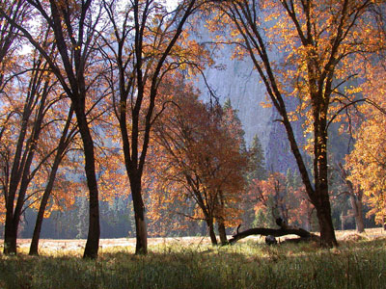
Black oaks grow in the open meadows of Yosemite Valley. A study seeks to determine if the oaks are declining in Yosemite National Park.

Why Is the Park Studying Black Oaks?
The black oak trees in Yosemite Valley have been recognized as a valued cultural, scenic, and biological resource. Black oak acorns used to be a major part of American Indian diets, and traditional acorn collection still occurs today. Acorns also are important to the diets of various animals, including bears, deer, woodpeckers, and squirrels. Additionally, oak groves in the Valley are an iconic scenic feature. However, there has been a long-time perception that black oaks have been declining in Yosemite Valley and perhaps throughout the park. Because of this perception, the park has begun studying the oaks to determine if the populations are actually declining.
How Did Scientists Study the Oaks and What Did the Studies Show?
Historical Aerial Photography: The first study used historical aerial photographs taken in 1944 and compared them to photographs taken in 2005 in 18 locations to determine if the extent of black oaks was decreasing. An analysis of the photos found that, in places where black oaks dominated, the canopy extent of the woodlands examined remained unchanged between 1944 and 2005. In locations where individual tree canopies could be discerned in the photos, it was found that more trees died than were added to the populations through new germination. Since the total canopy cover did not change, the conclusion is that the net loss of trees was offset by the continued growth of surviving trees—there are fewer oaks today than in 1944, but they are larger.

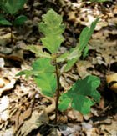
In a healthy population, there should be many oak tree seedlings.
Recruitment Rate Study: Another study looked at the recruitment rate—essentially the “birth” and retention rate—for oak seedlings and saplings. In a set of randomly located plots within areas where black oaks were known to occur in the Valley, all black oaks were inventoried, and assigned to one of several size classes. Researchers also recorded various environmental site conditions that may influence the recruitment rate. Within a healthy tree population, there are many seedlings, fewer saplings, and even fewer adults. In the oak tree populations studied in the Valley—regardless of elevation, soil type, vegetation community, and distance from roads and trails—the expected population structure was not found. The populations were mostly mature adult trees with a fair number of seedlings but few saplings or young adults.

A factor that is operating Valley-wide seems to be preventing seedlings and saplings from surviving. Because some sites surveyed had few conifers, this would seem to question the hypothesis that conifers are shading out and killing oaks due to a previous policy of fire suppression—although that may still turn out to be a factor. Oak core samples showing the age of oaks indicates that oak populations were healthy until about 1920, when the populations started to decline. It appears that something began happening at that time that reduced the survival rates of seedlings and saplings, leading to a population structure found today that is skewed in favour of mature, adult trees.
One hypothesis that might explain the decline in black oaks is that the formerly common practice of fire suppression reduced the overall relative dominance of black oaks. Most oak species are adapted to survive fire and may even need fire to persist. Prior to the era of fire suppression, American Indians used fire as a management tool to favor oaks and maximize annual acorn crops.
A second hypothesis for current oak decline is that American Indians intensively managed them in Yosemite Valley and may have actively protected young oak saplings. Written accounts from the first Euro-American settlers to the Valley indicate that centuries of active American Indian land management had produced an open oak woodland with few conifers. Today, there are fewer oaks and many more conifers. Perhaps the oak populations we see today are returning to a state that existed prior to intensive Native American land management.
A third hypothesis for black oak decline is a change in deer population size and behaviour. Factors affecting these may include: a decline in American Indian use of deer; changes in deer hunting regulations and practice both inside and outside the park; changes in deer predator management, particularly outside the park; and, changes in development, both inside and outside the park. An increase in deer populations may lead to increased deer browsing on certain plants, including oak seedlings and saplings.
There may also be other factors to consider in oak population declines such as changes in hydrology, acorns and seedlings being eaten by rodents, disease and insects attacking acorns, climate change, or some other, as yet unconsidered, factor.
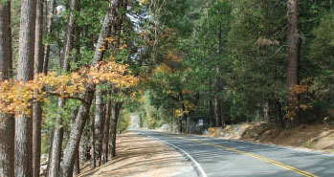
Several scientific theories explain why oak saplings survive close to roadsides.
Oaks Along Roadsides: A third study examined what effect roads might be having on oaks. Scientific study of “road ecology” has documented that most animals avoid roads, creating a buffer zone around roads where animals don’t often venture. These buffer zones may then act as refuges for plants that would otherwise be browsed by animals. Researchers surveyed oak populations next to the roads and 10 meters farther away to see if the population structure differed. While the scientists found the same number of seedlings and young adults regardless of their locations, there were more saplings next to the road. This result is consistent with road ecology theory and findings; animals are reluctant to forage close to the roads, increasing seedling survival. More study would be necessary to test that hypothesis. Oaks near roadsides may also be affected by factors such as a fertilization effect from car emissions or additional water from roadside water runoff.
What Are the Next Steps?
These studies represent a first step in establishing a knowledge baseline for Yosemite Valley’s black oaks, pointing the way for future research to help answer questions about what is causing the decline and what may need to be done to conserve them. Future research may look at the potential role of animal foraging and other factors in suppressing oak recruitment.
Sources
Angress, E.E. (1985). The Decline of Quercus kelloggii in Yosemite Valley: An Evaluation of Fire and Moisture Regimes. San Francisco, San Francisco State University.
Kuhn, B. (2007, Summer). Yosemite’s Black Oaks, Yosemite, 69(3): 7-8 pp. [326 kb PDF]
Kuhn, B. & Johnson, B. (2008, July). Status and Trends of Black Oak (Quercus kelloggii) Populations and Recruitment in Yosemite Valley (a.k.a. Preserving Yosemite's Oaks). Final report prepared for the Yosemite Fund. 50 pp. [330 kb PDF].
Ripple, W.J. & Beschta, R.L. (2008). Tropic Cascades Involving Cougar, Mule Deer, and Black Oaks in Yosemite National Park, Biological Conservation 141: 1249-1256 pp. [602 kb PDF]
Winter Factoid: Snow from winter storms can weigh down trees, especially with the Sierra’s heavy snows. California black oaks are winter deciduous, but they do tend to retain the dead leaves on the branches—offering a large surface area for snow to accumulate. Oaks and other broadleaf trees and plants are not well adapted to shedding snow like most conifers are that have a conical shape with branches that bend downward to slough off accumulating snow.

