O4 Black Oaks scientific article (shorter version)
The following article is an extract from the US National Parks Service Yosemite website. It is a study of the Black Oak trees a native species of the USA. This tree is not normally found in the UK.
http://www.nps.gov/yose/naturescience/black-oaks.htm

Black Oaks
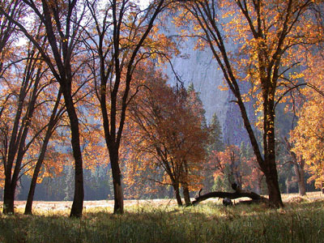
Black oaks grow in the open meadows of Yosemite Valley. A study seeks to determine if the oaks are declining in Yosemite National Park.
Why Is the Park Studying Black Oaks?
The black oak trees in Yosemite Valley have been recognized as a valued cultural, scenic, and biological resource. Black oak acorns used to be a major part of American Indian diets, and traditional acorn collection still occurs today. Acorns also are important to the diets of various animals, including bears, deer, woodpeckers, and squirrels. Additionally, oak groves in the Valley are an iconic scenic feature. However, there has been a long-time perception that black oaks have been declining in Yosemite Valley and perhaps throughout the park. Because of this perception, the park has begun studying the oaks to determine if the populations are actually declining.

How Did Scientists Study the Oaks and What Did the Studies Show?
Historical Aerial Photography: The first study used historical aerial photographs taken in 1944 and compared them to photographs taken in 2005 in 18 locations to determine if the extent of black oaks was decreasing. An analysis of the photos found that, in places where black oaks dominated, the canopy extent of the woodlands examined remained unchanged between 1944 and 2005. In locations where individual tree canopies could be discerned in the photos, it was found that more trees died than were added to the populations through new germination. Since the total canopy cover did not change, the conclusion is that the net loss of trees was offset by the continued growth of surviving trees—there are fewer oaks today than in 1944, but they are larger.

