

|  |
| --- |
| Stephen Perse Sixth Form College | Chung Man |

Flying Paper Aeroplanes

An investigation using GeoGebra Software

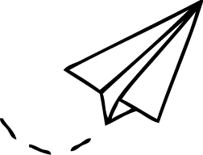

**Flying Paper Planes: An Investigation using GeoGebra**

Contents

GeoGebra Project 2012 3

GeoGebra Tutorial 4

Using GeoGebra 7

Conclusion and Evaluation 10

Acknowledgements 10

Bibliography 10

Aim

This project was part of a pilot scheme to examine ways in which the mathematics software GeoGebra could be introduced into schools in the UK. The project was one of a number by A level students, in which each student chose a topic or topics of interest to them and then explored them using the software. Having explored and researched the topic of interest, students needed to consider how this would be used in schools to demonstrate the use of GeoGebra and so encourage uptake.

In this project the topic of Origami was explored with GeoGebra to produce templates for paper Aeroplanes. A tutorial was produced which would serve as a good learning tool for studying symmetry at Key Stage 2 and 3 in mathematics. Using the aeroplanes produced, their flight path was studied in a practical investigation. The parabolic flight path could then be described and examined by producing an interactive model with GeoGebra software. This model could be used at Key Stage 3 and 4 Mathematics

Background

The Japanese art of paper folding is called Origami. Origami is of great interest and fascination for many people, young and old. Therefore it was considered that if we could use this attraction of Origami as a topic with which to teach the use of the mathematics software GeoGebra, it would appeal to a large group of people.

Folded paper aeroplanes, or aerogamis, are a favourite child’s toy for children across the World – but they have more significance in the history of heavier-than-air flight. The most significant use of such plane designs were by the Wright Brothers, who used a wind tunnel and paper models to observe the forces on the plane. This was very important in the progress of creating larger models, gliders and eventually, a controllable aeroplane.

In present day, paper planes can be much more sophisticated than the simple one created in this tutorial. They can be made using Computer Aided Designs, kirigami (where paper is cut into components of a larger design), or made from other materials such as soft woods. These improvements have enabled paper planes to fly further, faster and for longer than ever before, with the longest flight time being 27.6 seconds.

The Project

With GeoGebra, moving lines can be created and so it would be fitting to produce a tutorial to show how to fold something, in this case a paper plane and so the following tutorial was produced as a means of introducing GeoGebra.

Following this, the trajectory of the plane flight (a parabola) could be shown and made interactive so pupils may learn how the parabola changes as parameters change. Expanding on this, the physics of flight was introduced to demonstrate the idea of air resistance and lift. Furthermore, the flight of a plane was compared to the flight of a ball, as they differ due to the plane wings and therefore have lift and can fly. Finally GeoGebra was used to create an interactive ‘game’ to follow on the practical ball trajectory work, with guessing where a ball will land when thrown as a mathematical exercise on the parabola study.

# GeoGebra Tutorial

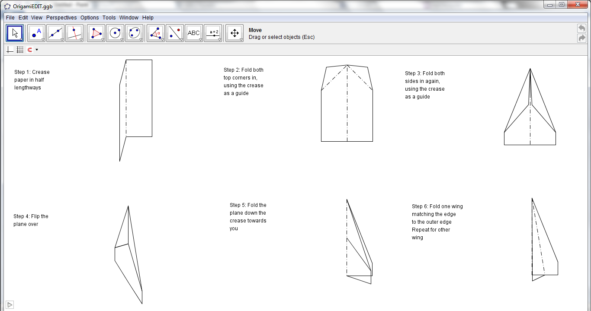

This tutorial is animated, and shows and explains the method of which to fold the plane. The objective of the tutorial is to show how a plane would fly. It starts with simple model to show how an object would fly - the simplest object would be a ball, and that would fly in a parabola.

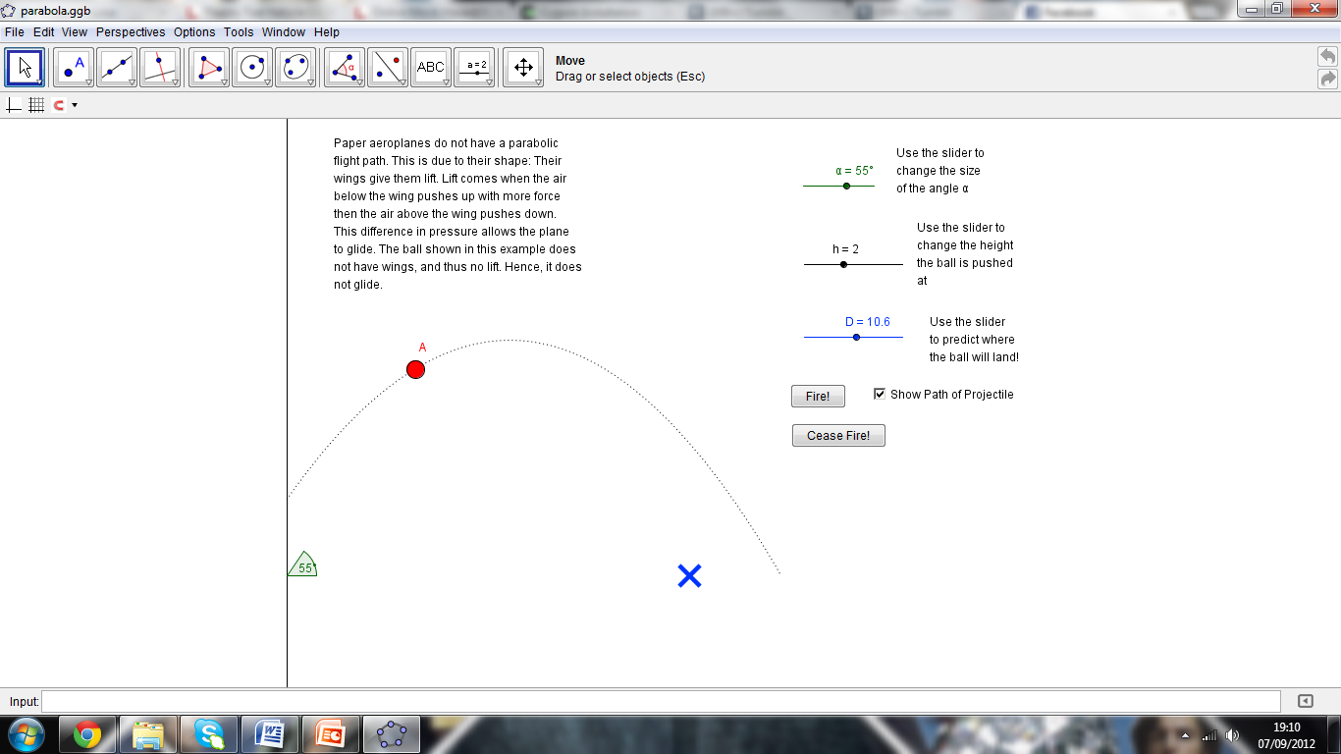

This ‘ball game’ tutorial is an interactive game demonstrating the trajectory of a ball, and how the angle at which it is thrust and the height at which it starts affects the distance the ball has travelled.

However, planes *do not* fly in parabolic curves.

The white line shows the curve of a ball thrown at the same angle as the plane. As we can see (and probably expect) the plane flies much further and in a much shallower curve compared to the ball.

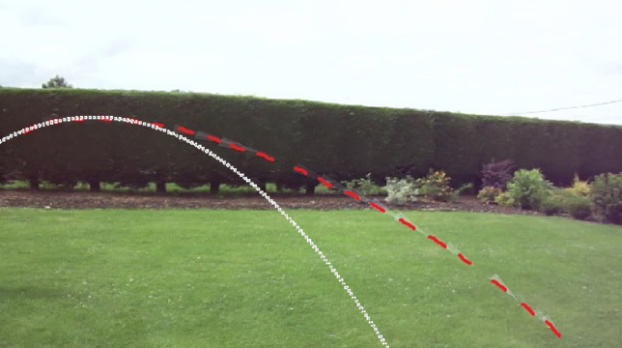

In the most basic terms, there are four main forces working on an aeroplane. Although the paper plane is not quite the same as a real plane, for explanation purposes it is easier to see how our plane flies by understanding the way a real plane flies. Should the plane be thrown at an angle, these forces are found by resolving the horizontal and vertical forces.

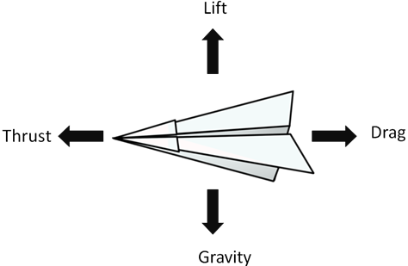

Air resistance is the ‘drag’ force, and limits the distance the plane can fly. If there was too much drag, the plane wouldn’t fly – similar to flying a paper aeroplane under water. The drag on the plane depends on its shape. The smaller the cross sectional area of the plane, the lesser the area perpendicular to the horizontal path of the plane and the less drag is experienced.

Gravity is the acceleration force which causes the plane to fall to the ground. To counteract gravity, the mass of the plane should be kept to a minimum. If there was no gravity (e.g. in space) the plane would fly on forever.

Thrust is what you provide to the plane when you throw it. In order to make a plane fly, there are two factors to consider: the lift must be greater than the acceleration due to gravity, and the lift is dependent on the thrust. If thrust = drag, the object won’t move. Unlike a real plane, the thrust on our paper plane can’t be maintained and they will eventually fall to the ground due to gravity. Similarly, a real plane uses fuel to thrust it through the air – and must come down to refuel. You may notice when throwing the plane, it is much easier to throw the plane at an angle, than it is to throw it straight ahead. The angle at which it is thrown is called the angle of attack, and is the angle that the wing presents to the oncoming air. The smaller the angle and the more parallel the plane is to the ground, the less lift. The more angled the plane is, the greater the lift. Too angled, and the plane has too much lift and the forces are not in equilibrium. The angle the plane is thrown at is important – it determines whether a plane flies, or dives.

Another factor is Bernoulli’s effect, which has less of an effect on the paper plane then a real plane.

Bernoulli’s Effect: In any fluid, an increase in velocity equals a decrease in pressure. On a real aeroplane, the shape of the wings are catered to enhance the Bernoulli’s effect. The aeroplane’s wings are curved on top, meaning there is a longer distance the air has to travel. The wings on a plane cut through the air as it flies, splitting the air. The air moving over the top of the wing travels faster and creates a lower pressure than the air moving under the wing, which pushes up to equalize the low pressure. Lift is generated.

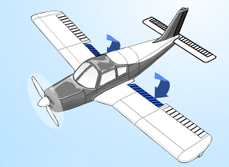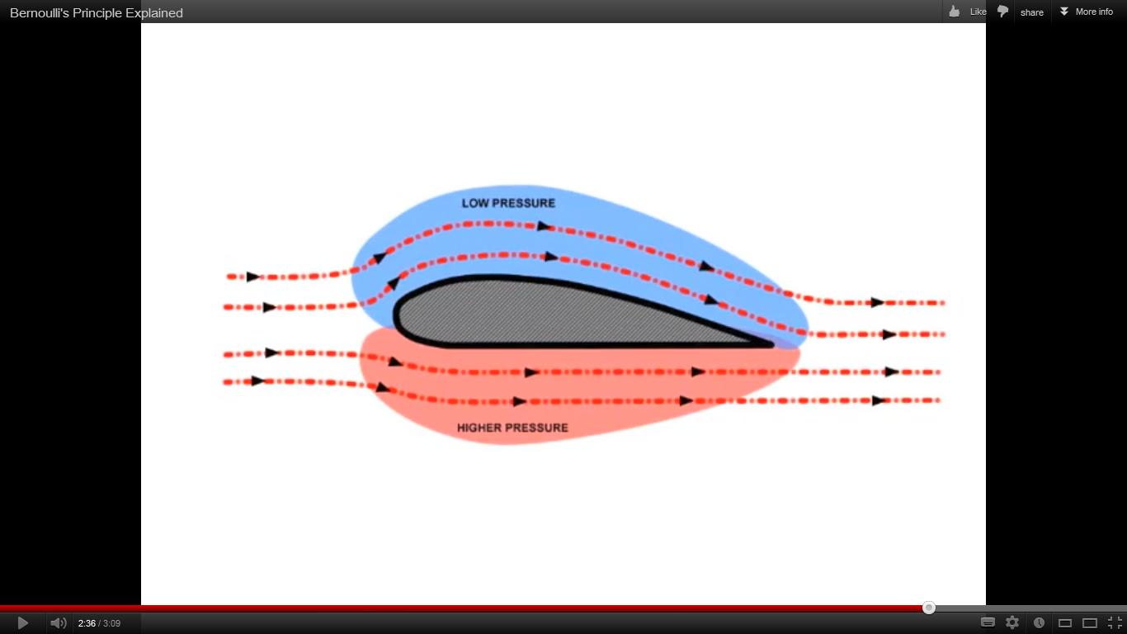

During the take-off and landing of a real plane, there are flaps on the wings which open out to face towards the ground. This changes the shape of the wing, diverting the air on top even further, and creating more lift. This also creates drag, so when landing it helps the aeroplane to slow down (however, this means at lift off, more thrust is required).

Bullet

To maximise the length of flight, the four forces must be balanced. Long thin planes such as the dart or the bullet do not have a lot of drag or lift, so in order to overcome gravity, they must be thrown with a lot of force to provide extra thrust. These are long distance fliers.

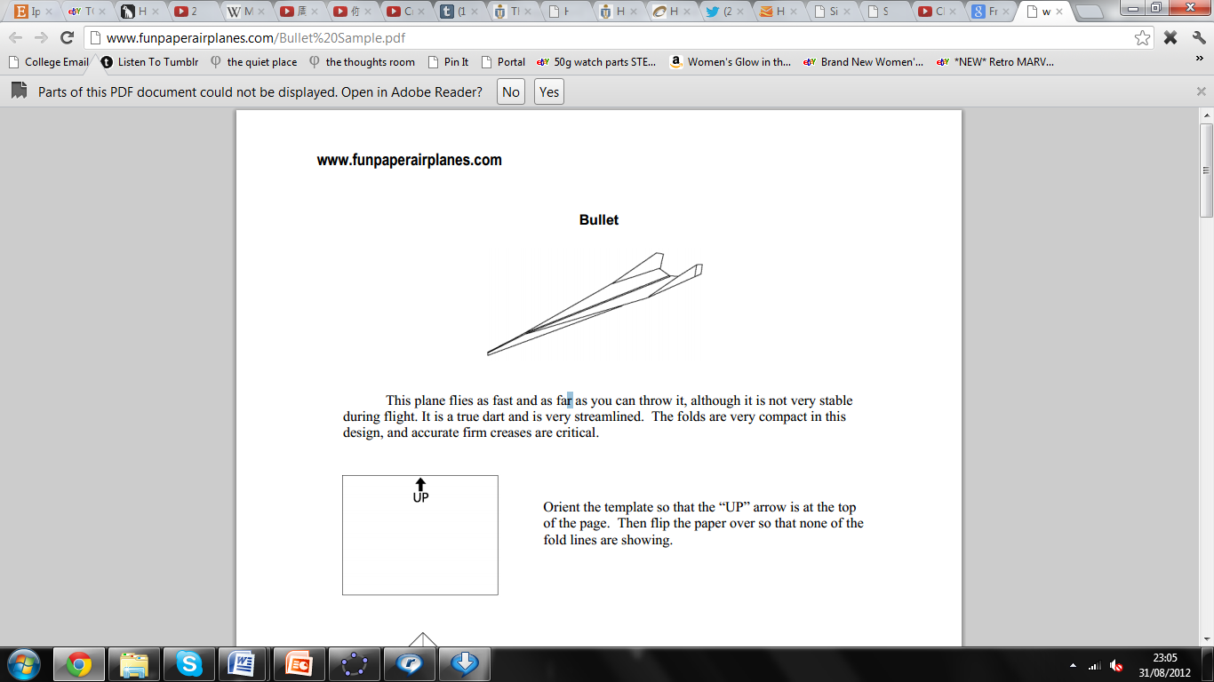

Other planes such as this condor are folded to spend more time in the air usually have broad, curved wings to provide lots of lift – but need little thrust. These planes fly slowly and gently.

Condor

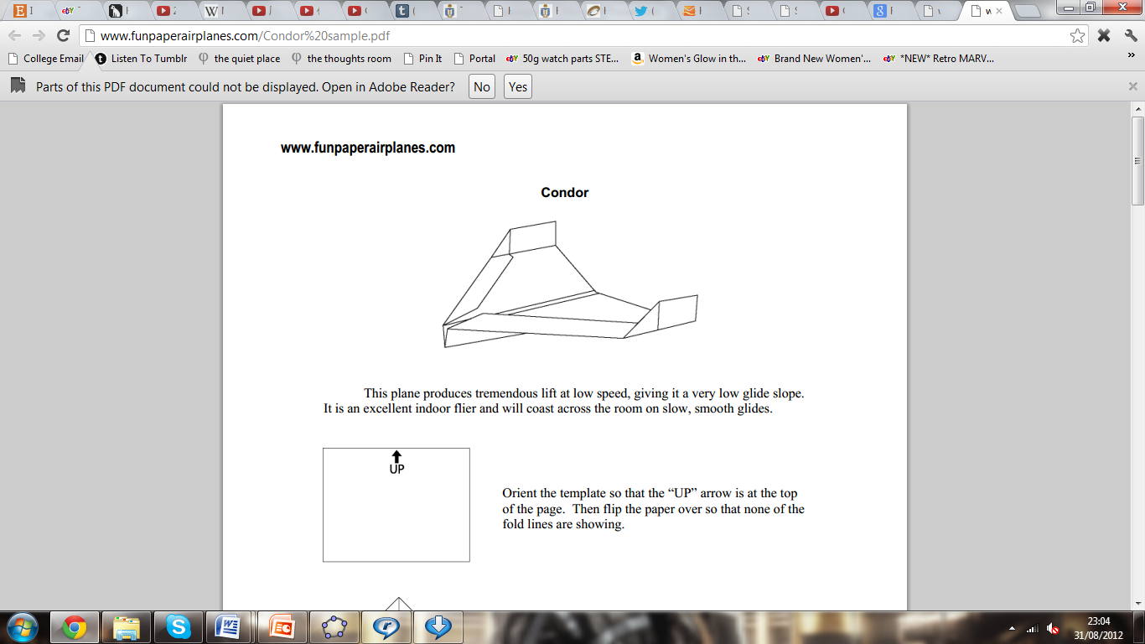

# Using GeoGebra

GeoGebra was introduced at a workshop and students were required to learn by trial and error. After trial with the software, origami as a tutorial seems a useful application on making the planes pupils may fly them and study the trajectory

Using GeoGebtra to investigate the parabola flight path, an interactive game was designed in which you could throw a ball, choosing the angle and height it starts at, and guess where it might land. A PowerPoint presentation, explaining how a plane is different to a ball, was produced see Appendix 1.

|  |  |
| --- | --- |
| **Problems** | **Solutions** |
| When an object has been animated, the conditions of when it is displayed depending on the motion of a line or point were unable to be altered. | This was simple to solve. Right click on the object in question > Object Properties > Advanced > Condition to show object. For example, if a line was to appear when a point V_5 had an x coordinate greater than 10, the conditions chosen to show the line would be when X(V_5) > 10. |
| When an object appears at the wrong time due to incorrect condition choices, it took a long time to go through all the possible points under the Algebra column. This was due to the removal of all the unnecessary points from view. | In the future, the program would be checked to ensure it is working correctly before all the points would be removed from view, as this would save a lot of time in the long run. Fewer unnecessary objects should also be created.  This was how my tutorial appeared before removing all the ‘objects’ – the blue dots. |
| **Problems**  Difficulties in using a slider to move an object manually. A frustratingly easy concept, but as it is so easy, searches on the GeoGebra forum and Google proved futile. | This was how my tutorial appeared after removing all the ‘objects’ – the blue dots.  The final tutorial  **Solutions**  A slider was finally programmed to change the size of an angle, Alpha. |
| Difficulties on how to have a ball moving on the parabola, with the ability to edit the height and angle. | Extremely helpful answers were provided on GeoGebratube.org which were edited to fit the needs of the parabola. |
| With my parabola complete, a button to turn the animation of the ball on and off was to be created. | Create a button and have StartAnimation [A] to begin the animation of the ball (named [A]). Similarly, to stop the animation of the ball, create another button with StartAnimation [A, False] |

Once the bulk of the GeoGebra tutorial was complete, the flight of a plane had to be filmed. It was difficult to find a calm enough day to film on, and the grass was wet so there were only had a few opportunities to film. Attempts were made to create a plane launcher, but this kept ripping the crease on the underneath of the plane, so instead the plane was thrown by hand instead of with a launcher. A plane launcher was eventually acquired (courtesy of Professor Oldknow) a week later, which made the plane fly much more consistently. This was where the project idea was changed from comparing the plane’s flight pattern to the theoretical trajectory, to comparing the plane’s flight pattern to an object’s flight pattern. They would be different as the plane has lift under the wings, whereas an object such as a ball only has the initial thrust. Thus, the plane glides through the air before landing, and the ball flies in a parabolic curve before hitting the ground.

Once the video had been taken, different video editing software including AVS and online Youtube editor were used. Other methods were also tried, such as producing a gif and a merged image. These steps were time consuming, and in the end they were unfortunately incompatible with the Powerpoint presentation.

Images appearing one on top of another after a certain amount of time had elapsed (similar to a gif) were produced on GeoGebra, and the effect was the same as that of a gif. These are used on one of the GeoGebra tutorials.

The parabola ‘ball game’ tutorial was extremely enjoyable to make. The parabola is defined parametrically by using equations for the displacements horizontally and vertically:

Horizontal displacement: where = initial velocity (and in this case, 0)



Vertical displacement: where = -9.8, or the acceleration due to gravity.



To define the parabola, the curve command was used. The ‘help’ section of GeoGebra was helpful, and I found what had to be input:

Curve[<Expression>,<Expression>,<ParameterVariable>,<StartValue>,<EndValue>]

Or in my case, the parabola was of the form:

Curve[x(t),y(t),t,starting value of t, final value of t]

The final parabola was of this form:

Curve[, , t,0,tmax]



Since the values of v0 were not to be shown, the slider was hidden.

# Conclusion and Evaluation

This tutorial has achieved its aims – it is simple to use whilst informative. In order to improve this work and expand the project further, some physics was researched -- how lift affects the flight path of the plane. However, the maths required to understand the process is at a higher level of maths than the students this tutorial is aimed for would understand..

# Acknowledgements

I would like to thank the education charity STEM East, the ORBIT Project, Cambridge University and the Faculty of Education for the opportunity to be part of such a fantastic project, I have thoroughly enjoyed the experience of working independently. I would never have come across the GeoGebra mathematics software, but I firmly believe it would be a brilliant classroom tool for teaching, and for students to explore themselves, too.

Thank you also to E. Crilly, Professor. A. Oldknow and T. Houghton for organising regular meetings, and for mentoring me, helping us when I wase unsure, and for ensuring I was on the right course. Their enthusiasm for this project has helped me progress further than I would have imagined. Collaboration and communication between other students was also useful, to find out how others felt about the course, and ideas about how to solve problems, or just general improvements with the projects.

# Bibliography

GeoGebratube.org

GeoGebra.org

Wikipedia.org

Google.co.uk

10paperairplanes.com

Paperairplaneshq.com

Amazingpaperairplanes.com

Ehow.com

Wikihow.com

Youtube.org (orchestrastudio)

Gimp.com

Science.howstuffworks.com