An evening with the stars
One school’s attempt to inspire girls to take up Physics through the use of extracurricular engagement

Across the curriculum there are many subjects that cannot be taught properly within the confines of the school day. For example Geography is greatly enhanced by a visit to the features seen in a text book and an exchange visit to France is very useful for a linguist. As a Physicist I have long found that Astronomy is a topic area that also fits into this bracket; without the ability to personally see and experience the vastness of space, even the most able students cannot fully grasp just how massive and complex the universe is.
From this starting point in 2005 the physics department at Hitchin Girls School coordinated an after school master class over the winter for able and interested students in year 10. We ran a series of 6, two hour sessions from 7pm to 9pm every week from January through to early March. In this first year we invited many local amateur astronomers and experts in to give short talks on their work, and were also lucky enough to have several nights of good weather to allow us outside to view the stars.
We chose year 10 students as a focus for two main reasons. Firstly that they are old enough to have encountered some of the basics of the subject in their normal lessons, however secondly they are still young enough for us to have an impact on their future subject and career choices. Whilst the small group of students we had in our first year is not a statistically significant sample, many of those students did go on to choose sciences at A-Level and 2 eventually chose astronomy related degrees.

Beyond the first year
As always when something new is tried for the first time vast improvements are often made when you repeat it. So in the years that followed we made significant changes to the structure of the course.

- We did not ask the local experts back. Whilst they did a very good job of demonstrating their enthusiasm for the subject and did bring some interesting ideas and content to the course, unfortunately the majority of them could not approach a topic from the level at which the students could understand it. We were unintentionally reinforcing the perception that physics is impossible to comprehend!
- We deliberately styled future sessions as “not school” – we affirmatively dispensed with many of the regular school rules and treated the students as adults for the night. They were allowed to interrupt to ask questions rather than put a hand up and wait, they didn’t have to wear uniform and there was a free to use hot chocolate machine placed in the corner (very important when you planning to go outside in winter).
- We formulated a definitive structure to the evenings. Of the two hour slot, the first hour would always be an interactive presentation based on a theme. Again we styled this very differently to a normal lesson – there were no learning objectives, there was no writing things down or exercises to complete. Instead we engaged them with the content through the use of lots of video material, interactive simulations on PC’s and very well written and rehearsed presentations. The second hour of each session is then either a time for practical astronomy outside or in the likelihood of cloudy weather (we do live in the UK!) a creative or challenging task based on the material in the first half.
- Most importantly we sat down and designed a scheme of work that would engage the students and stretch them beyond their comfort zone but would not double up on anything they would study in their GCSE’s. We felt this was important so that it was then “OK” for them to leave at the end of an evening with a sense of confusion and wanting to know more, rather than feeling they had to understand everything for an exam.

This structure has remained largely unchanged in the subsequent 6 years and has been hugely successful. In our first year we had a handful of students from our own school, topped up with some keen and interested pupils from other schools in our local consortium; a class size of 12. By the winter of 2011 we had a class of 29 girls, all from our own school, and to limit it to that number we only made the class available to the 70 students who had opted for triple science at GCSE. If we had opened the class to the remainder of the year group we certainly could have filled it at least twice over. A common question by year 11 students remains “can we come back and do this again next year!”

Impact
We have also seen a significant impact in our uptake at of physics at A Level which can be directly traced back to engaging the students in year 10. We have found the largest increase to be amongst the less able girls who now choose physics because they “enjoy” and “love” it rather than because they are amazingly good at it. As a result whilst we have seen many more students tackling A Level Physics we have not seen an increase in grade As at AS and A2 level but rather many more students achieving grade C and D. This is obviously our next target for improvement.

Over the last year I have had to opportunity to publish our entire master class online to allow other schools and institutions the chance to use a pre-built package with their own students. It is published on the web under a creative commons licence for anybody to use. When writing it I deliberately wanted to avoid using traditional tools such as PowerPoint to stitch together these sessions and so the bulk of the presentation resources are written in Prezi.
Prezi is a relatively new piece of software which allows you to have an entire presentation on a single “canvas” and then to zoom in and around the screen following a pre-defined path. It is ideal for a master class environment as right from the very first session the students can see everything that they are going to do as a massive mind map. Prezi allows me as a presenter to jump and skip around to other points in the presentation with ease just by clicking on them. Also once published online it can be embedded in any webpage, which has allowed me to place a copy on our school’s learning platform for students to browse and explore at their leisure. Many students have used this embedded version to explain concepts from the classes to fellow students and their parents!
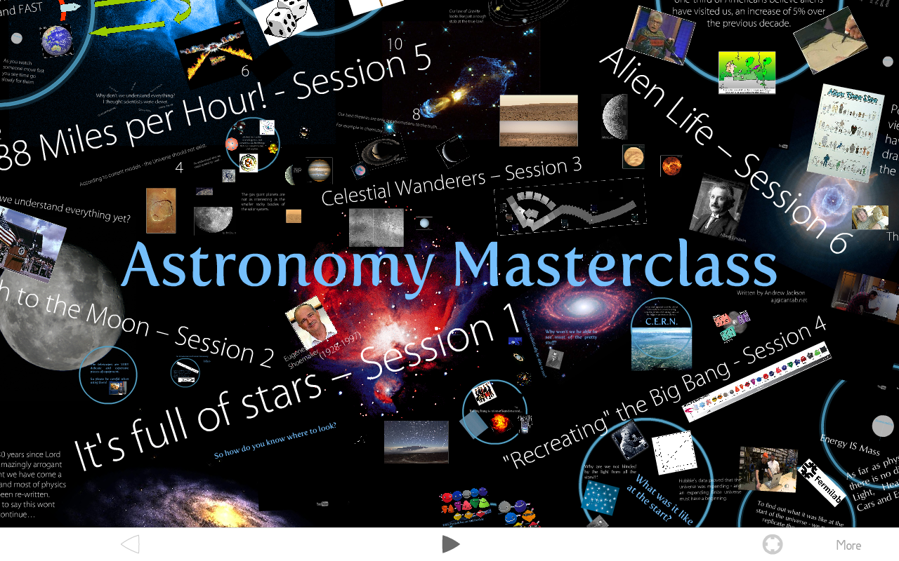
One of the best activities we have run during the second hour is that on sessions 4 and 5 (depending on the weather) I have placed the students in groups of 6, given them a digital camera (or asked them to bring in one of their own) and allowed them time to create a short film explaining one of the concepts they have learnt about in a fun and interactive way. The students have then edited these videos using simple video editing software that ships on every modern PC and we have shown them in a cinematic experience in session 6. Over the past 3 years I have been blown away by their creativity as students have produced a vast array of different short films, ranging from a vision of the first manned flight to Mars to a dramatised recreation of the entirety of the history of the universe. I routinely keep a copy of all the videos produced and play them back to students when they leave in year 13.

The impact of this master class within our own school has been huge, ranging from measurable factors such as the increased take up of the subject at AS level through to an unquantifiable increase in enthusiasm and participation in GCSE physics lessons. Our plan for the future is to continue to develop and update this resource and to try to continue to inspire the next generation of astrophysicists.
Andrew Jackson – April 2011
Andrew is a Teacher of Physics at Hitchin Girls School with a special interest in using new technologies to engage with students
andrew.jackson@hgs.herts.sch.uk

The Master class Prezi can be viewed online @ http://prezi.com/2hk390sfkqjh or the full set of resources can be downloaded from the TES resource exchange @
http://www.tes.co.uk/teaching-resource/The-Astronomy-Masterclass-6070303/

Side boxes

Don’t I need an expensive telescope to run an astronomy class?
Whilst it is true that a bigger and better scope does make astronomy easier, at a basic level it really doesn’t matter. From a security light lit school field in the middle of a town we found that an expensive £5000 Meade scope and a cheap scope we picked up from a charity shop for £20 performed about the same. As long as you are looking at bright objects (such as major planets and/or the moon) there is no real need for expensive equipment. In fact it is often better to have a few cheap scopes as students can then have a much more hands on experience without the fear that they will damage expensive equipment.

The published version of our master class consists of 6 x 1 hour speaker lead sessions along with suggestions and plans for cloudy weather activities.
- It’s full of stars – How to use a telescope, how to navigate by the nights sky and how modern technology aids an astronomer.
- From the Earth to the Moon – The story landing a man on the moon. From the inception of an idea during the cold war through to modern proposals to send men to Mars.
- Celestial Wanderers – The exploration of the planets by robotic spacecraft and a brief introduction to the geology of the rocky bodies.
- Recreating the Big Bang – An introduction to cosmology and the evidence of the origin of the universe leading to a look at modern particle physics experiments, and the hunt for the Higgs Boson at CERN
- 88 Miles per Hour – A look at the frontiers of physics through time travel, special relativity, quantum mechanics and the search for unified theories of everything.
- Alien Life – From the logistics of abducting someone from another planet, to modern programs such as SETI – an objective look at the possibilities of life beyond the Earth.

A selection of quotes from the feedback from this year’s class.

‘Really enjoyed the non school environment. Felt able to ask questions and I loved every minute of it. Thanks to all the staff for making it so much fun …… while learning.’

‘I really enjoyed making the film and learning about Space. My family have been constantly regaled by crazy Space facts by me.’

‘It was EPIC.’

‘They are awesome, interesting and informative.’

‘I learnt loads. It was so much fun. It was ‘OUT OF THIS WORLD’ but please don’t leave the weather up to Quantum Mechanics.’

‘It was amazing – best club ever. I learnt a lot and enjoyed it. Thank you.’

