
Vu eBook

.
The activities have been organised by age suitability. The exercises sometimes repeat over age bands to take into
account the learning that takes place.
Section one are outlines of exercises that match specific learning objectives or targets.
Section two are activities that have been expanded to work over a set of lessons or for a project.
Section three includes some resources that have come to our attention and may be useful in planning science
investigations or Datalogging activities.
Section one.

1. 2. 3. 4.
5.
6. 7. 8. 9.
Exploring numbers.
Does light shine through everything?
How much?
How dark is a shadow?
Noise, more or less?
Noise, making it quiet
Noise or sounds
What changes when we exercise?
What's different?
17. Light, dark and somewhere in between.
18. Why is it different over here?
19. What happens when I am not there?
20. How does heat move around?
21. Conduction of heat
22. Speedy cars, what stops them going faster?
23. How does exercise change us?
24. Pulse, what is normal?
25. Pulse, who is fit?

10. How many?
11. Light and dark
12. Cold and Hot
13. Where is it cold and hot?
14. Speedy cars
15. How many?
16. What are shadows?

Section two.
26. How does temperature change as you heat water
27. Reducing noise - distance
28. Reducing noise - muffles 29. Decay.
30. Reactions.
31. Long wires less light. 32. Light to electric.

1. 2. 3.
4.
5. 6. 7.
Hops and jumps.
What shall I wear today?
Are your hands warmer than mine?
Making ears.
Goldilocks.
Keeping warm.
Fruity electric

Section 3
1. My planning sheet - early primary. 2. Our planning sheet - early primary.

Acknowledgments.
Dyan Hewett, Rosemary Feasey, Keith Helmsley and Barabara Higginbotham who created the original activities that
form the basis of much of this work.
Shelagh MacKenzie for critical comment.
DO240 version 1, issue 1 2012

1

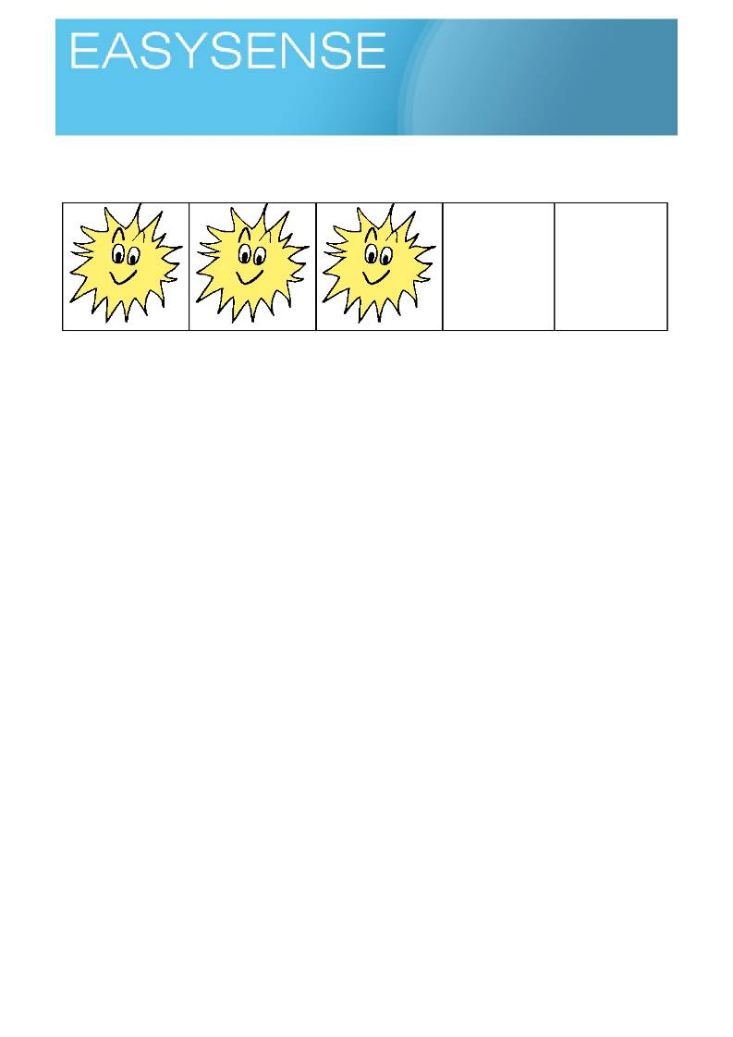
Age 4 - 6
Activities
Sensors: Light Logging mode: Snapshot

.
Exploring numbers
= ?

Learning experiences covered.
• Number and counting.
• Quantity.
• Graphing.
• Describing and comparing.
You will need.
• A datalogger with a light sensor (attached to the computer linked to your interactive whiteboard,
projector or other large display)
• Software showing the product of the logger as pictograms and bar charts.
Suggested method.
• Connect the datalogger, open the software and select the Pictogram option. As we are using light,
set the pictogram to suns or similar.
• Set the datalogger running and ask the children to watch the graph and tell you what they think the
datalogger is doing. While they are watching, put the datalogger near a source of bright light, in a
box, under the table etc. Get children to talk to their learning partners and share ideas.
• Invite questions and ideas around what the bar on the screen shows, how the suns tell us how
much, count up the suns (good link to number line work).
• Show the children a new location for the logger - eg. in a drawer, in a plastic box. Get the children to
try and predict how many suns will show on the pictogram.
• While looking at the pictogram build in questions related to highest number, lowest number, how
many more or less, how many altogether etc
This is such a simple activity it should not be though of as a one off, use it over several days / lessons.
Involve the class in choosing the light and dark areas, Develop counting games around the light, Consider labelling different areas of the class (1 sun, 2 suns to show the light level. Printout and display the relevant pictogram or bar chart.
Develop this activity by thinking about whether the light level changes at different times of the day and talk
about why this could be.
Link to shadow puppets activity - how many suns do we need to make a good shadow puppet?

1

Logging time:
Loggers

Teacher's notes
Quantity is the indication of how much, without a mathematical value e.g. there is a lot of water in the glass.
Number is the numerical value given to a quantity e.g. 2 is an alternative representation of the word two or
there are 2 glasses of water on the table.
Quantity is almost an instinctive value, we differentiate quantity quite well before we have had any
mathematical education. Some cultures have no indication of number using a, many and lots to describe quantity.
In this exercise the learning outcome is for students to recognise difference in quantity and for some to give
a number value to the quantity.
You can decide to describe what the logger is doing to the level you feel you and the class are comfortable
with. Initially there is nothing wrong with describing it as something that tells / shows us how much (quantity) light there is.

2
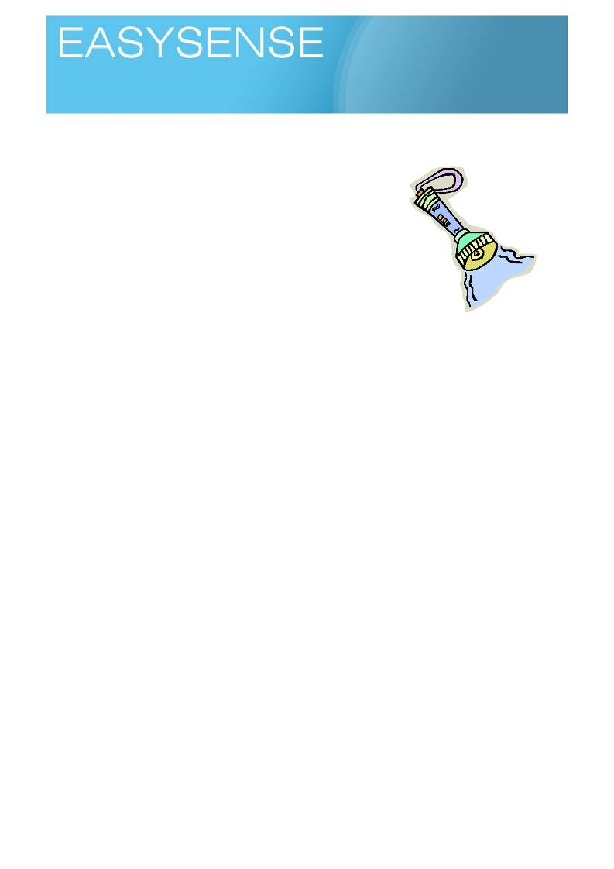
Age 4 - 6
Activities
Sensors: Light Logging mode: EasyLog

Does light shine through everything?
Learning experiences covered.
• Science activities and methods.
• Number and counting.
• Quantity.
• Graphing.
• Describing and comparing.

You will need.
• A datalogger with a light sensor (attached to the computer linked
to your interactive whiteboard, projector or other large display)
• Software that shows the product of the datalogger as pictograms and bar charts
• A good light source (class lights, well lit window, torch).
• A s e l e c t i o n o f o b je c t s t h a t :
1. block light
2. let light through clearly
3. let light through to some extent
4. let light through but colour it (e.g. A4 sheets of card, paper, plain and coloured translucent
film, different fabrics etc)

Suggested method.
Pass the objects around the class and ask the children to work with their talk partners to think about how
light proof each object might be. Get them to give each a score, 1-4 according to whether/how it lets light through. Discuss and record the scores on the board or a flip chart.
• Connect the datalogger to the computer and show the software on the screen / whiteboard.
• Use the horizontal bars or pictograms. If using pictograms use a symbol to match the activity e.g.
suns for light.
• Review the light and bars activity by pointing the datalogger to a bright light and then to a dark light
and then something in between, to check the children understand that big? long? bars mean more
light, short? bars less light. Relate the bars to the graph axes, or count the pictograms with the children. (numeracy link).
• Place the datalogger next to the bright light source. Discuss the graph/pictogram displayed and
agree with the children that this is a bright light. Take a snapshot.
• Get one of the children to choose one of the objects which everyone thought might block the light
and put it between the light and the datalogger. Snapshot the data.
• Discuss the graph/pictogram displayed and compare it to the one captured. Introduce a describing
word to label on object which blocks light e.g. light proof and relate to the science word opaque
• Ask the children to think about why we need light proof materials and to think of examples and where
they are used.

1
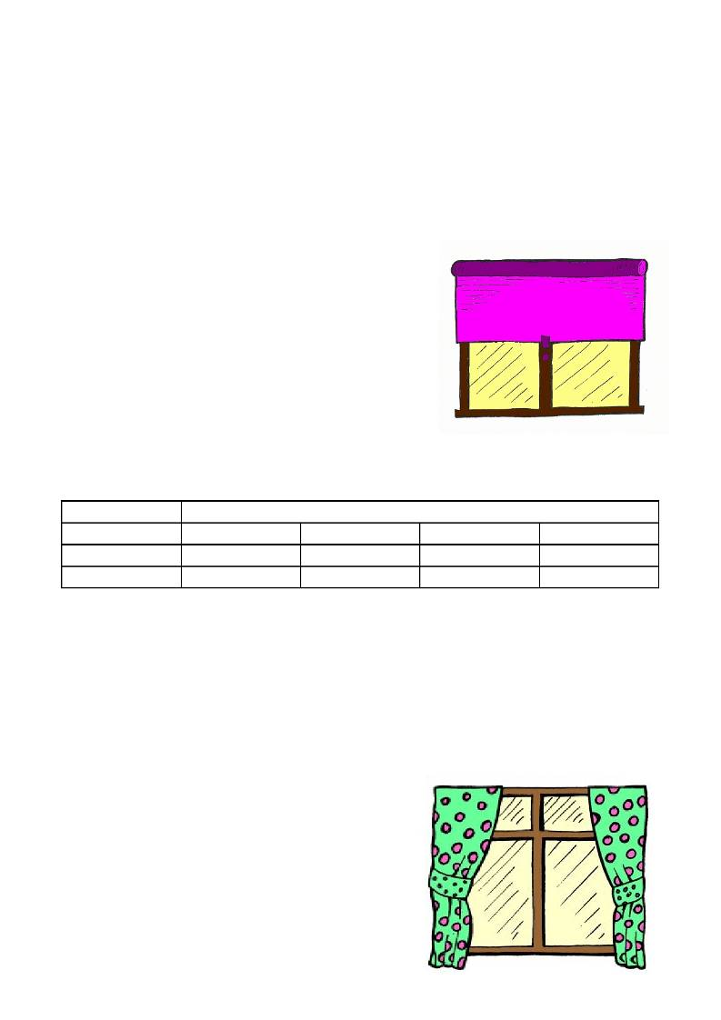
Logging time:

• Repeat the experiment with another object chosen at random by a child and discuss the results. Get
the children to think about how much light level this second object allows to pass through it.
Introduce transparent for see-through and translucent for lets light through.
• Choose an object which colours the light it lets through. Discuss this and help the children to see that
this would be called translucent. It lets the light through but is not completely see-through.
• Talk about the bars you have created, encourage descriptions of differences, get some counting
going on (count the blocks, show the number above the bar)

Showing the data.
• Use the Horizontal display initially as this will more closely
match the number line work they are doing.
• Swap to vertical start adjusting them to a conventional
graph layout, if this presents difficulties go back to number
line form.
o Ask about the sizes (height, length) of the bars.
Remind the children Big is more, Small is less.
• Try to get them to use words implying relative difference
i.e. they are all the same size, that one is shorter than the
others, that one is bigger than all the rest

Teacher's notes
Introducing the correct scientific word is important, but the table below is provided to link these to other
words that the children might commonly use to help them understand these terms. Space is provided for
your alternatives
Correct word Alternative that might be used by the children
Opaque Light proof
Transparent See through
Translucent Lets light through
Note opaque means no light gets through, everyday use confuses it with translucent - and how many times
do you use that as word!
A false friend when talking about transparent materials with colour is to use clear as an alternative to no
colour, all transparent materials are clear, if they are not clear they are translucent!
Key Questions.
1. How do you know how much light there was?
2. How do we describe the different materials we use?
3. How does the light level change when we try to block it using the different materials?
4. How do you find out the difference?
5. Do you have to always show numbers as number
symbols?
6. How do we know the test was fair?
The pictogram display of the quantity and the block form of
quantity will let you practice counting and number with the
children as they investigate one of their first exercises in
science. Remember the activity is as much about supporting
numeracy, counting, number and quantity as it is about science.
Using light to start to study science. Light is an everyday thing
that matches children experiences well.

2
Logging time:

You can use the logger to record what happens to the quantity of light when you place things between it and a source of light.
Children will need to understand that the height of a bar on the graph is a measure of how much (quantity),
relate this back to number lines.
The projector is a powerful source of light. The effect to of it on the work should be talked about. Invite
suggestions as to how you would control this.

3
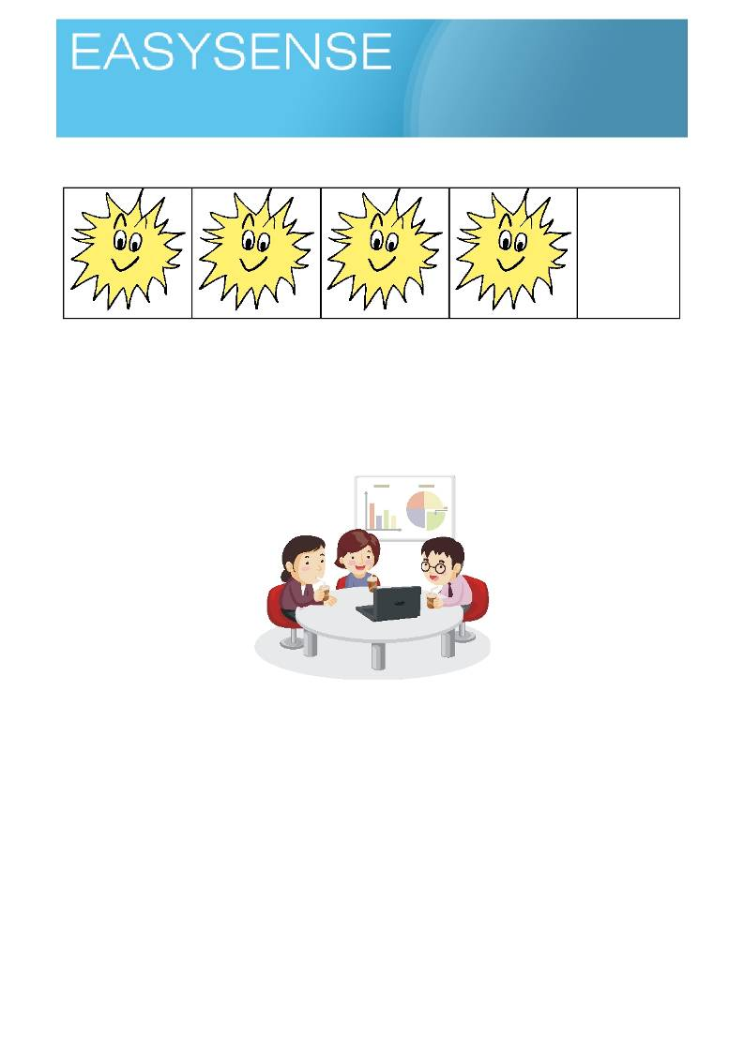
Age 4 - 6
Activities
Sensors: Light Logging mode: EasyLog

How much?
=

Learning experiences covered.
• Science activities and methods.
• Number and counting.
• Quantity.
• Graphing.
• Describing and comparing.

You will need.
• A datadatalogger with a light sensor (attached to the computer linked to your interactive whiteboard,
projector or other large display)
• Software that shows the product of the datadatalogger as pictograms and bar charts
• A g o o d lig h t s o u r c e ( c la s s lig h ts , w e ll lit w in d o w , to r c h ) .
• A s e l e c t i o n o f o b je c t s t h a t :
1. block light
2. let light through clearly
3. let light through to some extent
4. let light through but colour it (e.g. A4 sheets of card, paper, plain and coloured translucent
film, different fabrics etc)

1
Logging time:

Suggested method.
Hopefully before this activity the children will have tested the light proofness of some things and they will be
using the same things, so the only difference within this activity is the use of numbers to describe the quantity - the how much or how little.
• Connect the datalogger to the PC and show the software on the screen / whiteboard.
• Use the horizontal bars or pictograms. If using pictograms use a symbol to match the activity e.g.
suns for light.
• Quickly repeat or do the light and bars activity to check the class understands that big bars mean
more light, small bars less light. Simply point the datalogger to the bright light and then to a dark light
and possibly something in between. Count the pictograms with the children, ask them for
suggestions of light and dark places to test.
• Place the datalogger next to the bright light source and take a snapshot, make sure it is known that
this is the brightest light.
• Place something between the light and the datalogger that everyone agrees will block light.
Snapshot the data.
• Spend a few minutes talking about the difference seen, introduce a describing word to describe the
something e.g. light proof,
• Replace the something with another - try at this point to use things that will give similar results.
• Ask the children to choose an item that they think lets light through.
• Talk about the bars you have created, encourage descriptions of differences, get some counting
going on, count the blocks etc.
Showing the data.
• Use the Horizontal display initially as this will more closely match the number line work they are
doing.
• Swap to vertical start adjusting them to a conventional graph layout, if this presents difficulties go
back to number line form.
o Ask about the sizes (height, length) of the bars. Remind big is more, small is less.
• Try to get them to say words of difference i.e. they are all the same size, that one is shorter than the
others.
Using the datalogger as a standalone device.
The Vu datalogger can be used as a standalone device for this activity and allow individual or group work.
Use the Snapshot mode of the datalogger to record the data for each of the materials tested.
You can show the data on the dataloggers screen using the review mode or connect the datalogger to a PC
and use Remote, retrieve to download the data to the EasySense software.
Use Meters mode to select and deselect which sensors will be active for the investigation.

Teacher's notes.
Using light to start to think about science. Light and dark is an every day experience for us. The children will
probably be happy with extremes of light and dark but the bit in between may be less obvious (easy to describe or share as an experience) to them.
Use the datalogger to record what happens to light when you place things between it and a source of light.
Use the bars created by the measurement of light levels to get children counting and attaching numbers to
quantities.
Key Questions.
1. How many are there?
2. Which has more?
3. Which has less?

2
Logging time:

4. What does the bar on graph represent?
5. How does a bar on graph tell how much there is?
6. If we are not using individual pictograms, how do I know how many there are?
Children will need to understand that the height (length) of a bar on the graph is a measure of how much
(quantity). Children can be encouraged to count up and match the number. Use the pictogram modes display display to behave as number line, counting blocks or number tower.
The pictogram display of the quantity and the block form of quantity will let you practice counting and number
with the children as they investigate one of their first exercises in science. Remember the activity is about supporting numeracy, counting, number under the pretence of a science activity.

3
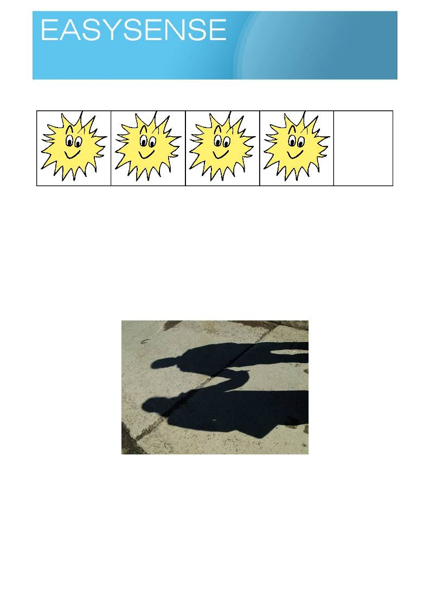
Age 4 - 6

Sensors: Light Logging mode: EasyLog

How dark is a shadow?
=

Learning experiences covered.
• Science activities and methods.
• Number and counting.
• Quantity.
• Graphing.
• Describing and comparing.
Using shadows to start to study science. Shadows are an every day thing that matches students experiences
well. This is not an activity on shadows, but a way of using a shadow based activity to enhance learning in interlinked topics.

You will need.
• A datalogger with a light sensor (attached to the computer linked to your interactive whiteboard,
projector or other large display)
• Software that shows the product of the datalogger as pictograms and bar charts
• A s e t o f o b je c t s t h a t b l o c k l i g h t .
• Number lines

1
Logging time:
Loggers

Suggested method.
An introductory activity about shadows and exploring how shadows can be made using torches. Talking
about shadows and how we make them or how different objects make them. Use digital cameras to get
pictures of shadows and shadow making activities, share the pictures and talk about them. Show how some
shadows are very dark and others are lighter, perhaps even that some are sharp and others are fuzzy. Talk
about why this could be so. Show a data logger and light sensor and demonstrate how it can be used ot
measure different light levels
• Connect the data logger to the PC and show the software on the screen / whiteboard.
• Use the horizontal bars or pictograms. If using pictograms use a symbol to match the activity e.g.
suns for light. Check the number with the bar is on.
• Quickly repeat or do the light and bars activity to check the class understands that big bars mean
more light, small bars less light. Simply point the logger to the bright light and then to a dark light and
possibly something in between. You can use your hand passing between the logger and light source to create a difference and start a conversation about shadows. Use Snapshot to snap a few different light levels and count the pictograms with the students, Point out how the number changes, that the number must have something to do with quantity.
• Start to formalise the collection of data. Place the datalogger next to the bright light source and take
a snapshot, make sure it is known that this is the brightest light.
• Place something between the light and the datalogger that everyone agrees will block light. Use a
simple screen to show it is a shadow, you could use your shadow on the whiteboard! Snapshot the
data.
• Spend a few minutes talking about the difference seen between shadow bars and no shadow bars,
• Talk about the bars you have created, encourage descriptions of differences, get some counting
going on (count the blocks, show the number above the bar).
• Encourage discovery about the shadows. Allow the children to explore shadows thinking about what
makes the shadow change? what about the shape of the shadow? (link to literacy and the shadow
puppet etc)
Showing the data.
• Use the Horizontal display initially as this will more closely match the number line work they are
doing.
• Swap to vertical start adjusting them to a conventional graph layout, if this presents difficulties go
back to number line form.
o Ask about the sizes (height, length) of the bars. Remind big is more, small is less.
o Watch out for big and small, these are relative, they may not be sure of numbers.
• Try to get them to say words of difference i.e. they are all the same size, that one is shorter than the
others.
Using the logger as a standalone device.
The Vu logger can be used as a standalone device for this activity, and will allow individual or small group
participation. The show of data on the screen is still very powerful and should be considered as part of the activity.
Use the Snapshot mode of the logger to record the data for each of the materials tested. You can show the
data on the dataloggers screen using the review mode or connect the datalogger to a PC and use Remote, retrieve to download the data to the EasySense software.
Teaching notes
Key Questions.
1. How many are there?
2. Which has more?
3. Which has less?
4. How does a bar on graph tell how much there is?

2
Logging time:
Loggers

5. If we are not using individual pictograms, how do I know how many there are?
The activity uses a logger to record what happens to light when you cast a shadow and uses the graphical
representation of the light value of shadows / no shadows to help with number work. Use the bars created by the measurement of light levels to get students counting and attaching numbers to quantities.
The height of a bar on the graph is a measure of how much (quantity). Children can be encouraged to count
and match the number. Use the pictogram display to show the number in a variety of ways to show how graphing represents data.
The activity is equally divided between supporting numeracy, counting, number and a science activity.

3
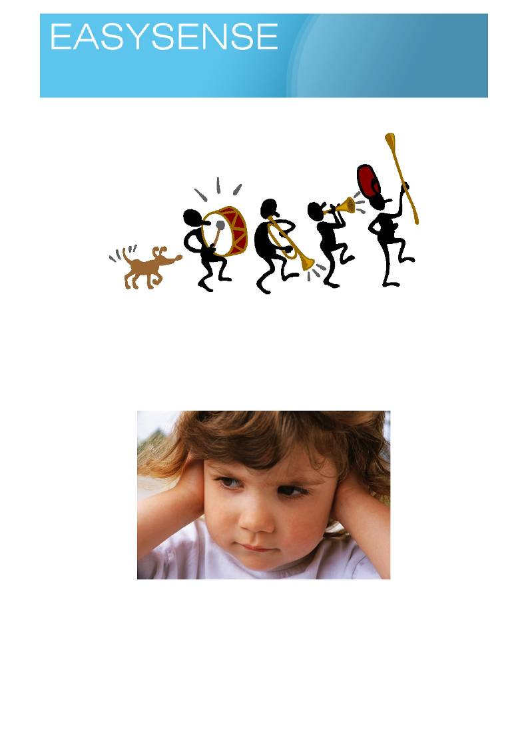
Age 4 - 6
Activities
Sensors: Sound Logging mode: Snapshot

Noise, more or less?

Learning experiences covered.
• Science activities and methods.
• Number and counting.
• Quantity.
• Graphing.
• Describing and comparing.
A fun activity, children will love it, the class next door will be full of envy!

You will need.
• A good sound source (the class, a radio, whistle).
• A datalogger connected to an interactive whiteboard or a large screen.
• Number lines
Suggested method.
An introduction about making noises and seeing how big they are!
• Connect the datalogger to the PC and show the software on the screen / whiteboard.

1
Logging time:
Dataloggers

• Use the horizontal bars or pictograms. If using pictograms use a symbol to match the activity e.g.
ears for sound.
• With the software in Snapshot mode and showing a bar ask the class to be as quiet as they can. Use
snap to record the quiet.
• Place the datalogger on the teachers' table and ask everyone to come close, make noise (loud). As
the bar goes up snap and record the data.
• Ask the class to move back to the centre of the class, repeat the noise making and recording.
• Ask the class to all move to the back of the class and repeat the noise making and recording. • You should have 4 bars on the screen, a short one (quiet) a very tall one (noise close up) etc.
• Ask them what the graphs show, if you get a confused response, remind them about Big bars are
more, small bars are less and that they moved closer and further away form the sensor.
• If your ears, headache and willpower are strong enough repeat with different noise making things.
You are trying to show that noise appears quieter as you move away from it.
Extensions to the basic activity.
How about a mini field trip? Use the open space of the play areas to make even more noises and get bigger
distances? You will need to use the datalogger as remote recorder, good for showing the class how
dataloggers can work. You are taking sound pictures! Like an audio camera
Who is the noisiest in the class? Who can make the most noise at 5 metres? Wall of shame, pictures
barchart!
Showing the data.
• Use the Horizontal display initially as this will more closely match the number line work they are
doing.
• Swap to vertical start adjusting them to a conventional graph layout, if this presents difficulties go
back to number line form.
o Ask about the sizes (height, length) of the bars. Remind big is more, small is less.
• Try to get them to say words of difference i.e. they are all the same size, that one is shorter than the
others.
Teaching notes.
A simple activity that has the potential to be a lot fun and very interactive. Underneath there are some
important concepts to start embedding.
The control in science - does the noise change or does it get quieter simple because you are further away?
It's a bit like perspective, we know people don't change in size but when they are further away they are
smaller (or do we mean they look smaller?). Some of those medieval pictures before they discovered
perspective could be useful?
Talking about things, how do we know? How can we be certain?

Using the datalogger as a standalone device.
The Vu datalogger can be used as a standalone device for this activity with no loss of impact.
Use the Snapshot mode of the datalogger to record the data for each of the materials tested. You can show
the data on the dataloggers screen using the review mode or connect the datalogger to a PC and use Remote, retrieve to download the data to the EasySense software.
Use Meters mode to select and deselect which sensors will be active for the investigation.

2
Logging time:
Dataloggers

Teacher's notes.
A datalogger has a sound sensor that measure loudness. It uses a scale of decibelsA (dBa) which is sound
measured in the same way we hear it (we don't hear all sounds equally or even at all).
Key Questions.
1. How many are there?
2. Which has more?
3. Which has less?
4. What does the bar on graph represent?
5. If we are not using individual pictograms, how do I know how many there are?
6. Do we have fair test?
7. Why do we use units with numbers?
Children will need to remember that the height of a bar on the graph is a measure of how much (quantity).
The number above each bar will be the value of the bar. Children can be encouraged to count and match the number. Use the pictogram display to behave as number line, counting blocks or a number tower.

3
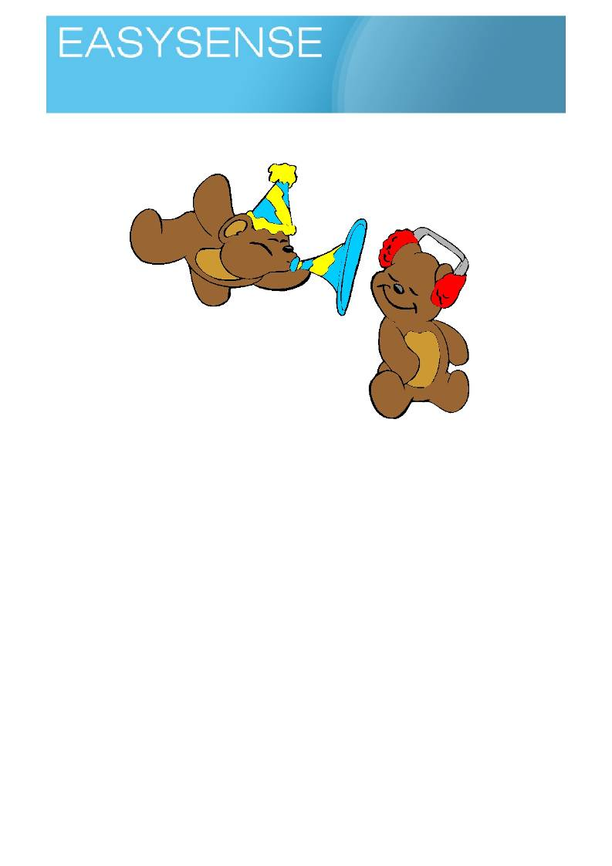
Age 4 - 6
Activities
Sensors: Sound Logging mode: Snapshot

Noise, making it quiet?

Learning experiences covered.
• Science activities and methods.
• Number and counting.
• Quantity.
• Graphing.
• Describing and comparing.
A fu n a c tiv ity , s tu d e n ts w ill lo v e it, th e c la s s n e x t d o o r w ill b e fu ll o f e n v y !
You will need.
• A good sound source (the class, a radio, whistle, alarm clock).
• A logger connected to an interactive whiteboard or large screen.
• Number lines.
• Things that may block sounds, blankets, foam, papers, boxes.
Suggested method.
Try to get them thinking about how they can make somewhere quiet when everywhere is noisy - shutting the
door, for example. Have different groups of children with different sound makers
• Connect the logger to the PC and show the software on the screen / whiteboard.
• Use the horizontal bars or pictograms. If using pictograms use a symbol to match the activity e.g.
ears for sound.
• With the software in Meters mode set off each group of sound makers or each sound maker. Show
the sound, use this to show a sound is being made and detected by the logger.
• Use Snap to record the sounds when you start to compare and reduce sounds.

1
Logging time:
Loggers

• Get the children to talk to their learning partners and suggest ideas of things or ways to make it
quiet. Test the suggestions and Snap the recording.
• Repeat the noise making and recording for a few more ideas.
• You should have many bars on the screen. Ask them what the graphs show, if you get a confused
response, remind them about big bars are more, small bars are less.
What did you find is the best noise reducer?
What did you do to reduce the sound? Is there a pattern? E.g. did soft things reduce the sound most?
How are you sure the sound has really got quieter?
Showing the data.
• Use the Horizontal display initially as this will more closely match the number line work they are
doing.
• Swap to vertical start adjusting them to a conventional graph layout, if this presents difficulties go
back to number line form.
o Ask about the sizes (height, length) of the bars. Remind big is more, small is less.
• Try to get them to say words of difference i.e. they are all the same size, that one is shorter than the
others.
Teacher's notes.
The activity is quiet simple, on the surface it is about how to reduce sounds. With a bit of skill you can quickly
add challenges to the work to set the children thinking. Ask about patterns they can see, ideas about why the
sound was reduced, how did they know the sound was reduced?
Use the activity to start a conversation about the activity as well as simply leaving it as "this did this"
exercise. Apart from creating the inquiring mind, it gives opportunity for a conversation and language skills and use to describe what they know and how they know.
Using the logger as a standalone device.
The Vu logger can be used as a standalone device for this activity with no loss of impact.
Use the Snapshot mode of the logger to record the data for each of the materials and noises tested. You can
show the data on the loggers screen using the review mode or connect the logger to a PC and use Remote, retrieve to download the data to the EasySense software.
Use Meters mode to select and deselect which sensors will be active for the investigation.
A logger has a sound sensor that measure loudness. It uses a scale of decibelsA (dBa) which is sound
measured in the same way we hear it (we don't hear all sounds equally or even at all). 40 dBa is the sound of silence in quiet place.
Key Questions.
1. How many are there?
2. Which has more?
3. Which has less?
4. How do you know which has more and which has less?
5. Can you count how many are there?
6. What does the bar on graph represent?
7. How does a bar on graph tell how much there is?
8. If we are not using individual pictograms, how do I know how many there are?
9. What are units for?
10. Does it make sense to have 6 sounds? 12 lights? Is there confusion without units?
Students will need to remember that the height of a bar on the graph is a measure of how much (quantity).
The number above each bar will be the value of the bar. Students can be encouraged to count and match the number. Use the pictogram display to behave as number line, counting blocks or a number tower.

2
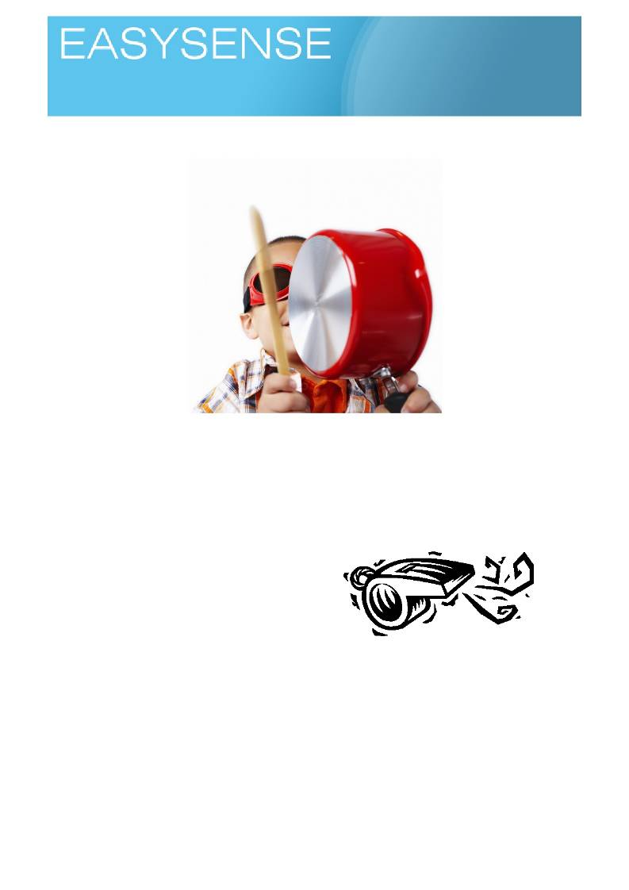
Age 4 - 6
Activities
Sensors: Sound Logging mode: Meters

Noise or sounds?

Learning experiences covered.
• Science activities and methods.
• Number and counting.
• Quantity.
• Graphing.
• Describing and comparing.
You will need.
• A g o o d s o u n d s o u r c e ( th e c la s s , a r a d io , w h is tle ) .
• A datalogger with a sound sensor (attached to the
computer linked to your interactive whiteboard,
projector or other large display)
• Software that shows the product of the logger as
pictograms and bar charts
• Number lines
Suggested method.
An activity to make noises. Give groups of children different noise makers. Listen to the noises made talka
bout how nice, noisy, loud they are. Try to get them thinking about pleasant sounds and unpleasant sounds,
and why we call it a noise when we don't like it!
• Connect the datalogger to the PC and show the software on the screen / whiteboard.
• Use the horizontal bars or pictograms. If using pictograms use a symbol to match the activity e.g.
microphones for sound.
• With the software in meters mode and a bar ask the class to be as quiet as they can and then as
loud as they can! if they are watching the screen they will see the bar very small and then really tall.
Try with a range of sounds. Emphasize loud and soft

1
Logging time:
Dataloggers

• With the software in Snapshot mode, start to formalise the collection of data. Get the class to be very
quiet, take a snap of the sound level, get ready, make a big noise and snap the loudest sound.
• Spend a few minutes talking about the difference seen between quiet bars and noisy bars,
• Talk about the bars you have created, encourage descriptions of differences, get some counting
going on (count the blocks, show the number above the bar).
• Encourage discovery about noises. What does the datalogger tell you? Does it match what you feel?
• When you say HB11 is the noisiest class, are they? How can you tell? Can we test this?
Extending the basic activity.
How about a map of the school, where is the noisiest place and the quietest place. Are the noisy places
always noisy?
What if you let it record all night? Does the school stay noisy at night?
Who is the noisiest in the class? Wall of shame, pictures barchart!
Showing the data.
• Use the Horizontal display initially as this will more closely match the number line work they are
doing.
• Swap to vertical start adjusting them to a conventional graph layout, if this presents difficulties go
back to number line form.
o Ask about the sizes (height, length) of the bars. Remind big is more, small is less.
• Try to get them to say words of difference i.e. they are all the same size, that one is shorter than the
others.
Using the datalogger as a standalone device.
The Vu datalogger can be used as a standalone device for this activity and encourage individual or group
work.
Use the Snapshot mode of the datalogger to record the data for each of the noise makers tested. You can
show the data on the dataloggers screen using the review mode or connect the datalogger to a PC and use Remote, retrieve to download the data to the EasySense software.
Use Meters mode to select and deselect which sensors will be active for the investigation.
Science is the tool by which we make sense of the world, it helps us describe events and things and
compare them to others. In this activity the idea of noise being a type of sound is being explored. It is also
introducing the idea of value judgements against empiricism - a sophisticated way of saying we can
measure how loud a sound is, but its up to you decide if it is noise, science can't tell us that part!
A datalogger has sound sensor that measure loudness. It uses a scale of decibelsA (dBa) which is sound
measured in the same way we hear it (we don't hear all sounds equally or even at all). 40db is normal room silence, there is always noise we just ignore it after a while - notice how peaceful the classroom feels after
home time? When you are busy with the class it stops being noisy!

Teacher's notes.
Key Questions.
1. How many are there?
2. Which has more?
3. Which has less?
4. What does the bar on graph represent?
5. How does a bar on graph tell how much there is?
6. If we are not using individual pictograms, how do I know how many there are?
7. Why do we have units? What does it mean if we have 6?

2
Logging time:
Dataloggers

Children will need to remember that the height (length) of a bar on the graph is a measure of how much
(quantity). The numbers on the display will be the value. Children can be encouraged to count and match the number. Use the pictogram mode display to behave as number line, counting blocks or a number tower.
The pictogram display of the quantity and the block form of quantity will let you practice counting and number
with the children as they investigate one of their first exercises in science. The activity is equally divided between supporting numeracy, counting, number and a science activity, with more of the science.

3
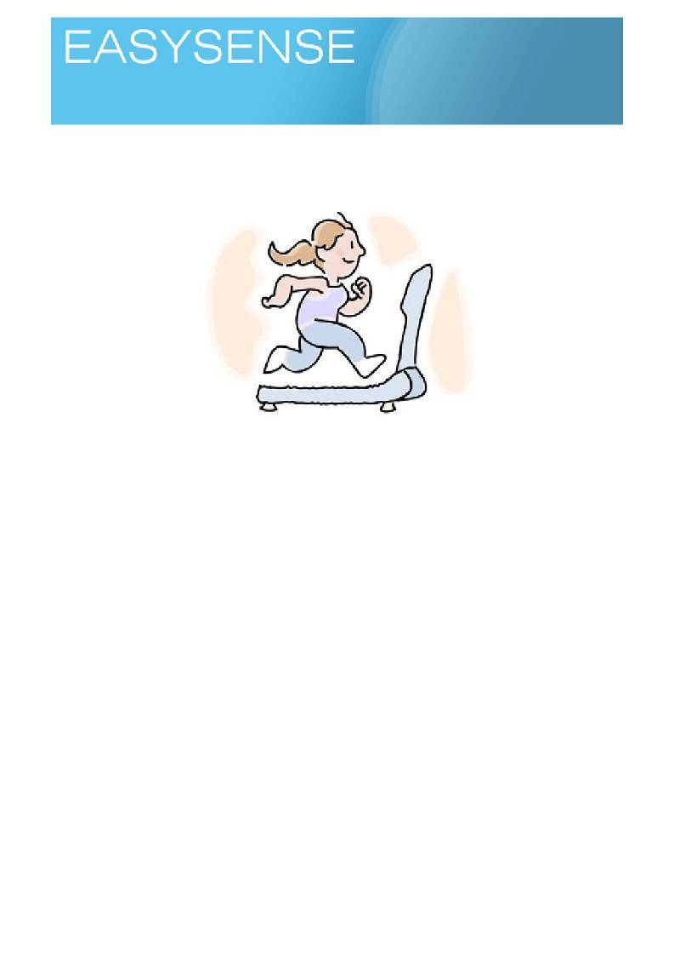
Age 5 - 7
Activities
Sensors: Heart rate, Pulse Logging mode: Meters

What changes when we exercise?

Learning experiences covered.
• Science activities and methods.
• Number and counting.
• Quantity.
• Collecting data and drawing tables of data.
• Describing and comparing.
• Using time to define an activity period.
There are several small activities under a common umbrella of keep fit.
Sensors you can use:
• Body temperature - Fever strips (lcd strips applied to forehead), non contact thermometers, ear
thermometers.
• Breathing - none really suitable, simply count breaths in 30 seconds (or an easily measured time
period).
• Heart rate / pulse - Heart rate sensor for datalogger, Pulse oximeter (clips onto finger).
You will need.
• A space for exercise, leaping jumping etc.
• A datalogger with a heart rate sensor connected.
• An interactive whiteboard or a large screen.
• Number lines.
Optional sensors and equipment.
• Pulse oximeter.
• Non contact thermometer

1

Logging time:
Dataloggers

• Fever strip.
• Ear thermometer.
• Stop clock or stop watch.

Suggested method.
Ask the children about exercise (activity). Use the children's learning partners to talk about how they feel
when they have been running around or exercising, and what they have seen when they have seen
footballers, athletes after exercise.
Using the heart rate sensor and datalogger.
• Use the heart rate sensor connected to the datalogger and PC have the display, to large screen, in
pictogram mode showing blocks.
• Use yourself to demonstrate and show how the sensors is used. Ask one of the children to be
connected to the sensors. Use the data from yourself and the class volunteer to start a talk about
how everyone is different and will give different numbers. To be different is normal, it is called
variation.
• Outline the exercise routine and how the test is going to be completed, time is important make sure
the children understand they cannot dawdle around or rush things.
• Ask the children to record the values before they did any exercise. This is the resting value..
• You can use the datalogger to show readings from the heart rate sensor on the screen, children will
write down numbers. They may need you to help.
• Do the exercise, and as soon as possible repeat the measurement and record its value.
• After 5 minutes Repeat the measurements.
If the children work well and appear to understand the method, use the datalogger, software and heart rate
sensor to take snap readings and display them on the whiteboard. Use the software to place them in order.
Work on the data is about defining the difference before and after exercise, anything else is a bonus!
You could try,
• Using the numbers collected to work out differences of value.
• Recording the data on a big (flipchart sized) paper graph.
• Describe to the class what each group found out.
• Find who had the most and who had the least.
• Make display posters about the activities.

2
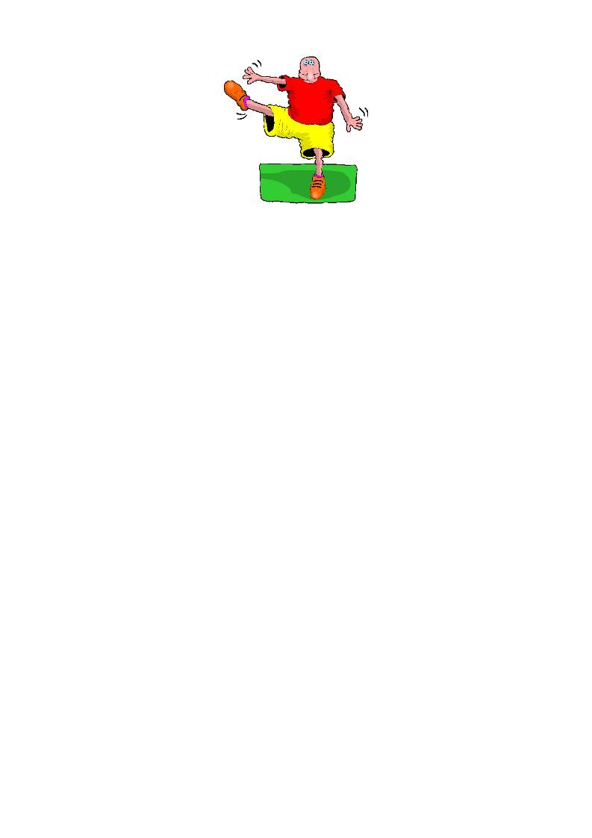
Logging time:
Dataloggers

Measuring other changes in exercise.
In reality you will have enough to do with a class of exercisers.
Heart rate is not the only part of you to change with exercise. The children can easily measure many of the
other changes they experience with exercise. Datalogging will not be needed for this and can give individual
or group activity
1. How your breathing changes. Count breaths in a time
2. How your temperature changes. Use a fever strip or non contact thermometer.
3. How your heart rate changes. Count the hear beats or use a pulse counter (pulse oximeter)
Teacher's notes.
Children will be required to measure themselves at rest (normal), measure themselves after exercise and
again after a few minutes rest. Time organisation of the class will be critical in this set of activities, if you get
backlogs while making measurements the effect of exercise will be lost - children recover quickly!
We can measure three simple markers of exercise, body temperature, breathing and pulse. Pulse is the
more difficult, the concept of recording for a time and then multiplying up for a rate per minute will not be
accessible to the majority (it's not the arithmetic, it's the why do you have to do this?). A sensor that can give
a value is a significantly better option, remember you are trying to talk about changes in physiology (the
body) not give a lesson in hard sums!
Counting methods for different types of sensor.
o Pulse oximeters - clip the sensor onto the finger and wait 30 seconds, copy the number
down.
o Heart rate sensor - clip it on, wait 30 seconds and record the number shown, it will vary and
of you wait you will just see a lot of different numbers around a value. It is easier to just take
whatever value you see after a common time.
o Breathing - use a stop clock to time 30 seconds, simply count breaths in that time and
record.
o Body temperature - use a non contact thermometer, point to the ear or forehead and record
and copy down (make sure everyone uses the same part of the body, ears are quite good as
everyone knows where they are!).
Key Questions.
1. What happens to us as we exercise?
2. What do we see changes about us when we exercise?
3. Are the changes good or bad for us?
4. How can we measure how much we change with regular exercise?
5. How do we know we are back to normal after exercise?

3
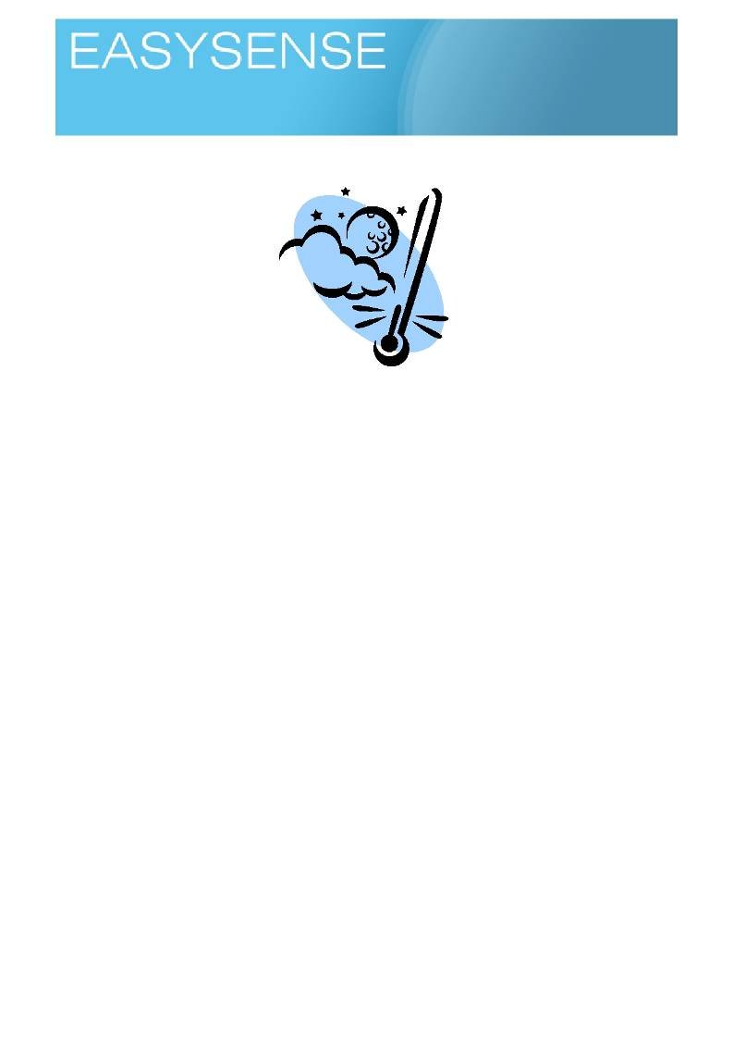
Age 5 - 7

Sensors: Temperature, Light, Sound Logging mode: Snapshot

What's different?

Learning experiences covered.
• Science activities and methods.
• Number and counting.
• Quantity.
• Collecting data and drawing tables of data.
• Describing and comparing.
Sensors you can use:
• Temperature - find the hottest and coldest parts of a room or space.
• Sound - what level of noise is there in the rooms.
• Light - find the brightest and darkest parts of a room or space.

You will need.
• A set of spaces that can be visited in lesson time that are different. You will need to check where
children are allowed to go in lesson time and check there are no conflicting uses of the rooms /
spaces.
• A datalogger.
o Temperature sensor use external.
o Light sensor use built in.
o Sound sensor use built in.
• An interactive whiteboard or a large screen.
• Number lines.
Suggested method.
Introduce the spaces they are going to compare and ask them to talk about how they are the same or
different. Show a datalogger and describe what it can measure. Ask the children how they could use it to show how different or the same the spaces are.
• Connect the datalogger to the PC and show the software on the whiteboard or large screen.
• Use Pictogram mode of the software to show data as horizontal bars or blocks.
Datalogger based activities.

1
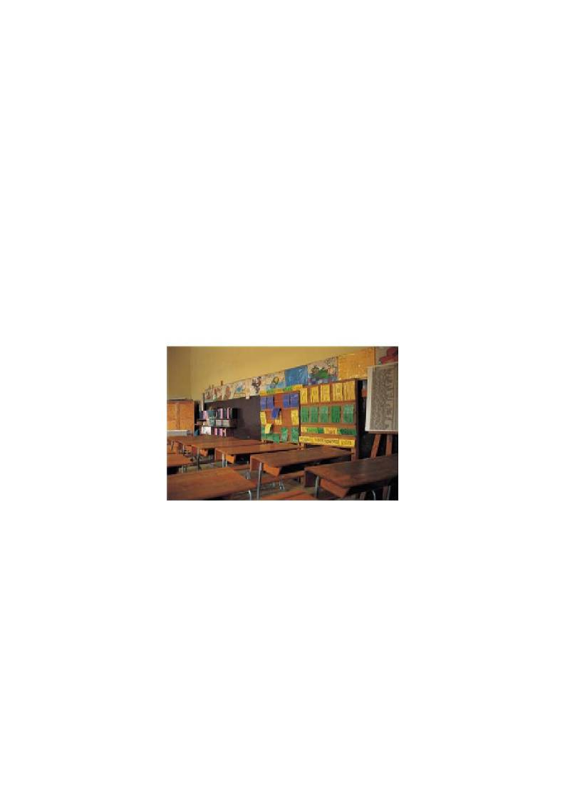
Logging time:
Dataloggers

• Have the children set their datalogger to pictogram mode with icons (pictures).
• Describe the areas they are to measure. You could have measuring points marked up in each room
with a number on to show the order of data collection
• Ask the children to take the datalogger to the counting points and collect the temperature, light and
sound values by pressing the right hand arrow button.
• Use the datalogger to show readings from the counting points on its the screen. The children will
have to write down numbers. Or you can connect the datalogger to a class PC and download the
data into the software for review.
Encourage the children to explore how to display the data in many forms, graphs, written statements,
photographs, plans, diagrams etc.
Work on how the data describes the difference (or similarities) between the chosen spaces, anything else is
a bonus!
You could try,
• Using the numbers collected to work out differences of value.
• Recording the data on a big (flipchart sized) paper graph.
• Describe to the class what your group found out.
• Find who had the most and who had the least.

Teaching notes.
The datalogger will have to be taken to the data, this does make it child centered activity, they will need to
use the datalooger
This is a simple activity to encourage children to go out and measure the environment and come back with
some numerical based way of describing the places they have visited.
Exactly how you will conduct the work will depend upon the resources you have available. In the description
we will go for the commonest denominator, the near to the class environment.
We can measure a few simple environmental parameters using the datalogger, temperature, light and
sound. This should be ample for the exercise.
The task will be to compare at least two different areas of the school and report back about why they are
different or how they are the same. The important thing about the exercise is that the children are
encouraged to state why the areas are different and provide proof. The evidence does not have to based
entirely on the datalogger information, you could include measurements of area, volume, colour etc and encourage the children to use cameras to provide evidence of the comparison.

2

Dataloggers

Key Questions.
1. How can I show difference to someone who has not been there?
2. When you see something is different, how is it different?
3. Can we measure difference?
4. What do we use to measure the environment?
Logging time:

Although it is long time off. in secondary schooling comparisons expect linked statements, for example the
area of room one is 12 sq m, the area of room two is 13 sq m or room one is painted blue and room two is painted yellow. It is not acceptable to simple say room one is painted yellow. Encourage the use of the two
part comparison
For the exercise as described, it would be worthwhile setting up sample stations in a set of spaces and
instruct the children to stand by the sample station to take readings. This works well if it is incorporated into
some sort of "treasure" trail, where the children have a simple map and the sample points give a clue or direction to the next sample point.
You can use the same basic principle to compare two outside areas or points on the school nature trail. The
key point is to remember it is an exercise about making comparisons and justifying your ideas to others,
giving proof to support your opinion. The spaces where you collect the data from are almost unimportant. It
would be poor practice to not have an ulterior motive in the activity, but at this stage it needs to be fairly obvious e.g. compare a wooded area to an open grass area.
There is a lot of implicit teaching within the topic, map reading, measuring, scientific method, communication,
arithmetic, maths to name a few. You will need to be clear about what the outcomes form the activity are and tailor it accordingly, it is an enjoyable activity with emphasis on the activity.

3

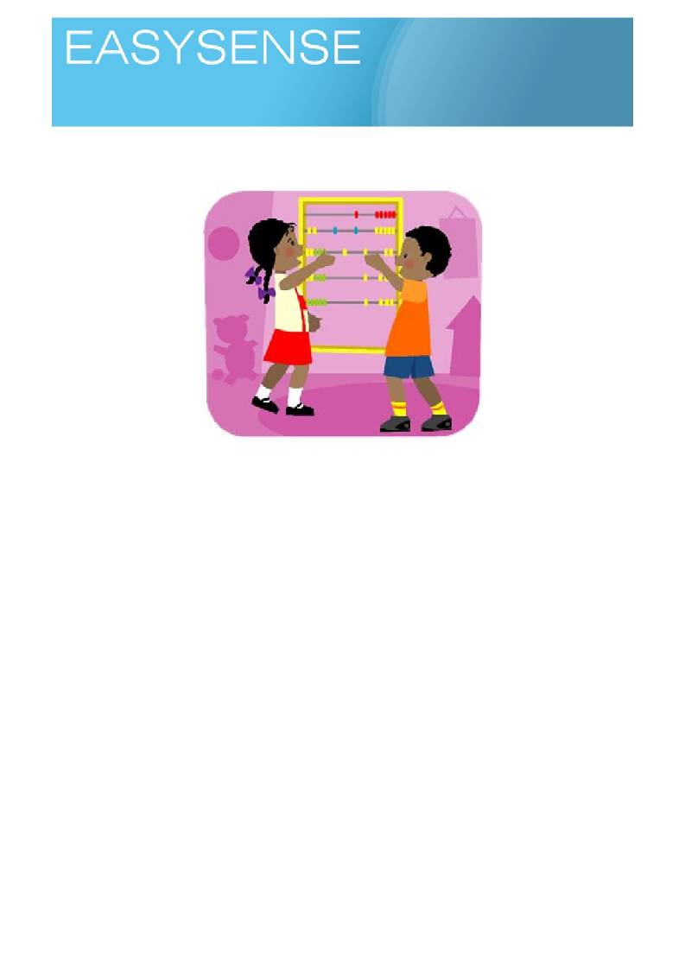
Age 5 - 7

Sensors: Push Switches Logging mode: Counting

How many?

Learning experiences covered.
• Number and counting.
• Quantity.
• Collecting data and drawing tables of data.
Counting how many is basic skill for science and maths.
1. The logger can be used to count events or things.

You will need.
• A s o m e th in g to c o u n t .
• A logger with one or more push button switches connected.
Suggested method.
There are lots of ways you can go about an activity such as;
1. Have the logger connected to the pc and whiteboard, have a count of every time someone says a
word or does something. Results appear directly onto the screen.
2. Have the switches connected to the logger and count something simple like the number of drawing
pins on the notice board! Have someone make tally marks and then compare.
Show results as soon as possible after the counting activity on the screen, the activity needs to be fresh
in the minds of the counters.
The datalogger will count when used away from the PC. Try, for example, but let the imagination go!
1. Counting the number of Boys and girls going into assembly.
2. Ask the children a question and then get them to press the "yes" or "no" switch and see who wins.
3. Repeat number 2 but have the count show on the screen, does seeing the result change how many
say yes or no!

1

Logging time:
Loggers

Teacher's notes.
Each push on the switch counts one, a logger can collect how many of two things, if you are lucky to have
multiple loggers you can collect many things.
If you do not have the switches the up and down arrows on the logger can be used to count. The up arrow
counts the A things and the down arrow the B things. Difference and total of things counted can be shown on the logger screen using the right arrow.
All you need to do is make sure everyone who is counting understands what they are counting. You need to
accept a small amount of error at this level.
Key questions.
2. What is a difference?
3. Does it matter which way round you take the numbers from each other?
4. What do negative numbers mean?
5. When you draw a bar chart, how do you know how many it represents?
6. Are the bars in bar chart linked to each other?
7. What are scales?
a. Why do we use them?
b. How do we know which one to go up and which one to go along?

2
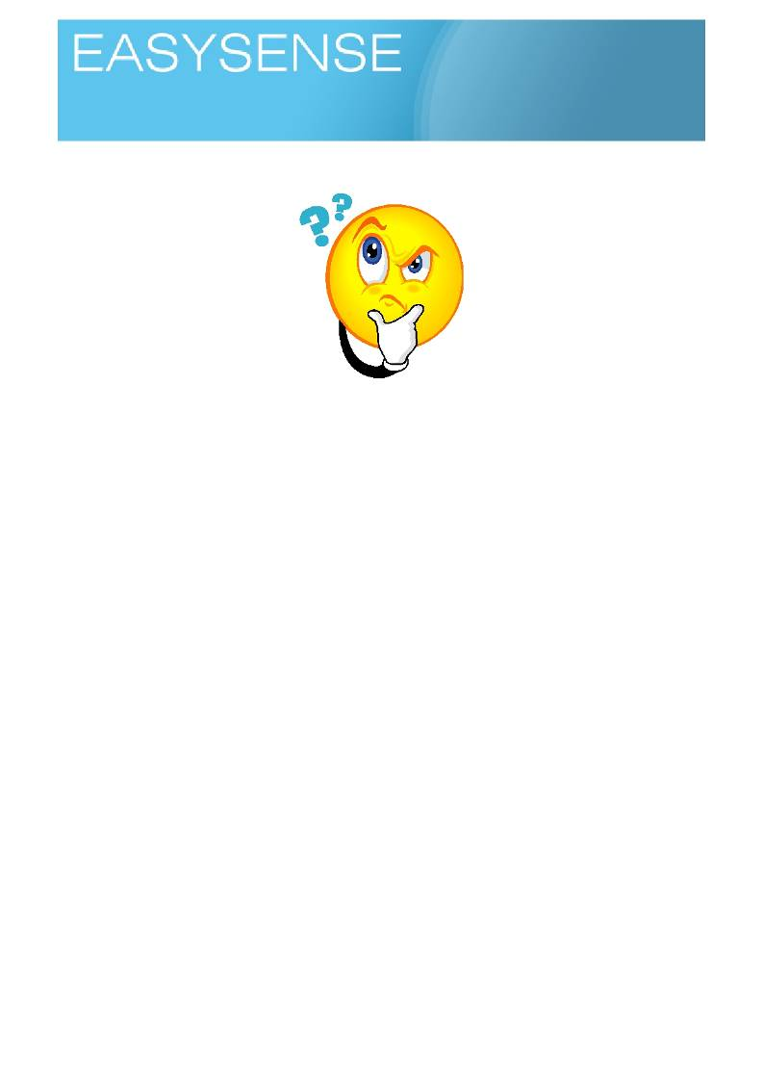
Age 5 - 7
Activities
Sensors: Light Logging mode: Snapshot or Meters

Light and dark?

Learning experiences covered.
• Number and counting.
• Quantity.
• Collecting data and drawing tables of data.
When is it light and when is it dark? How do you decide when it is dark or when it is light?

You will need.
• A datadatalogger with a light sensor (attached to the computer linked to your interactive whiteboard,
projector or other large display)
• Software showing the product of the datalogger as pictograms and bar charts.
• Places that will be bright or dark.
Suggested method.
Start by showing a real difference e.g. the light coming in from a window to the inside of a draw or bag. Ask
the children to suggest places of bright and dark to test.
1. Point the datalogger at the places the children have chosen. Snap the data to keep it on screen.
2. Talk about the bars produced, ask which ones were for light and which for dark. Use the facilities of
the screen to (get children to) add notes and marks to group bars together.
3. Get the class to suggest a dark place and a light place you can reach with the datalogger connected
to the computer.
4. Now ask them to find two places they think are the same brightness or darkness. Use the logger to
check. Use number lines to count differences.
5. Measure other places to see if you can get the class to decide when it is dark and when it is light. If
anyone is interested in cricket or tennis use this to give an example of how we may need to decide
when it is dark or light and a light sensor is used.
Other examples of where we have to decide light and dark, Street lights.
Car headlights.
Automatic lights on houses.

1
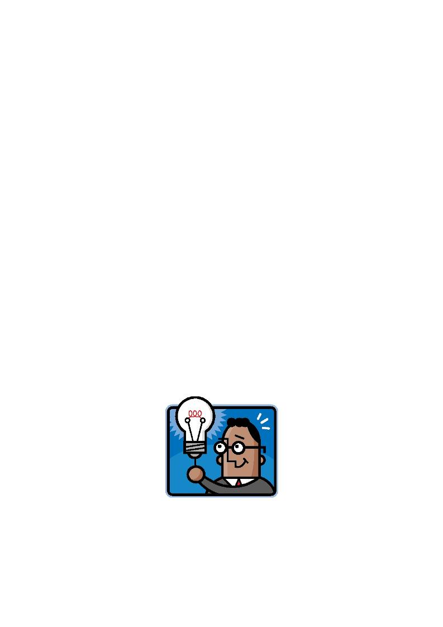
Logging time:
Dataloggers

Using the datalogger as a standalone device.
The Vu datalogger can be used as a standalone device for this activity.
Use the Snapshot mode of the datalogger to record the data for each of the areas being tested. You can
show the data on the dataloggers screen using the review mode or connect the datalogger to a PC and use Remote, retrieve to download the data to the EasySense software.
Use Meters mode to select and deselect which sensors will be active for the investigation.

Teaching notes,
Extremes of light and dark are easy to deal with, it is obvious at midnight it is dark and noon it is light, but
what about under the table where it is a little bit less light or a little bit darker?
This is a sort of introductory activity before looking at light, in the same way you might teach about distance
before using rulers, this activity starts to tell children about how we can measure light and what differences in light values may mean.
We use the datalogger and the light sensor to give a value to our statements about "it's dark" or "it's much
lighter".
Key Questions.
1. What do we measure light in? what units?
2. Greater means? Lesser means?
3. How much difference can you detect?
4. Can you describe light and dark to another person?
5. How do you talk about difference to other people?
6. If I say it is darker. What do I mean?
We are building on the idea of using number to define similarity or difference, we are also using the activity
to make the datalogger appear a normal part of class equipment not a special thing. The ability to show the
data direct to the screen is where the impact of this activity lies. If you know that the datalogger cannot be stretched to a dark place, have a stage prop handy, something the children will all understand is dark - a bag for example or a large box.
Once the idea of dark and light is set in the mind, try giving the datalogger out to the children with the
challenge to find the darkest place, the lightest place or even to simply measure the light at their desk, work
area for comparison. You can then use this as a tool for some simple arithmetic and descriptive language work. For example "how much brighter is jo's desk from izzie's desk" "Tel me where the darkest place is in
the room, why do you think it is darker than…?"

2
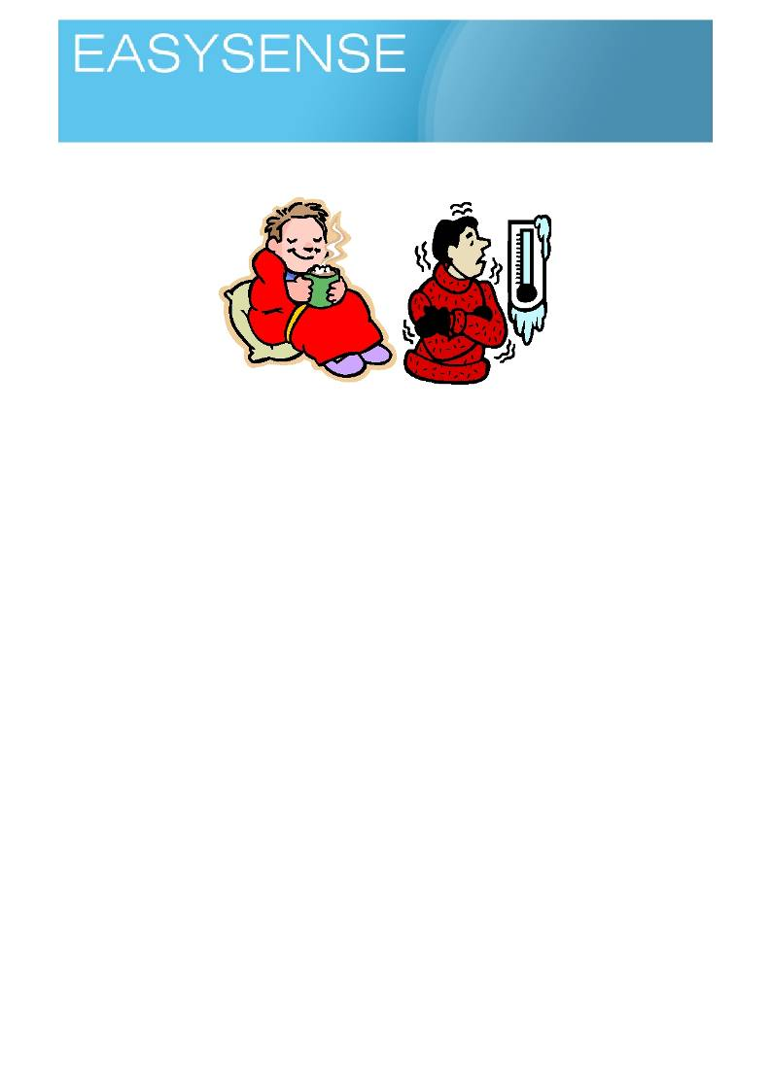
Age 5 - 7
Activities
Sensors: Temperature Logging mode: Snapshot

Cold hot!

Learning experiences covered.
• Number and counting.
• Quantity.
• Collecting data and drawing tables of data.
• Making comparisons.
• How to decide hot and cold.
Key Questions.
1. How hot is hot and how cold is cold?
2. Why do you feel hot or cold?
3. Can you tell anyone exactly how hot or cold it is?
4. What are the units for temperature?
5. What is boiling (water)?
6. What is the temperature at which water solidifies?
7. What is ice?
8. Should we really use boiling or freezing to describe hot and cold?
9. If you see the temperature for tomorrow on weather forecast, do you know how it will feel?
You will need.
• Some hotter and colder places - a simple comparison is between your body heat and the room.
• A lo g g e r .
• A C o m p u te r .
• A i n t e r a c t i v e W h i t e b o a r d a n d o r p r o je c t o r .
• Software

Suggested method.
The simplest activity to use here is the one that produces a real difference using situations that students will
be familiar with and used to. In this way there will be belief that the logger is showing something they know but in different way.

1
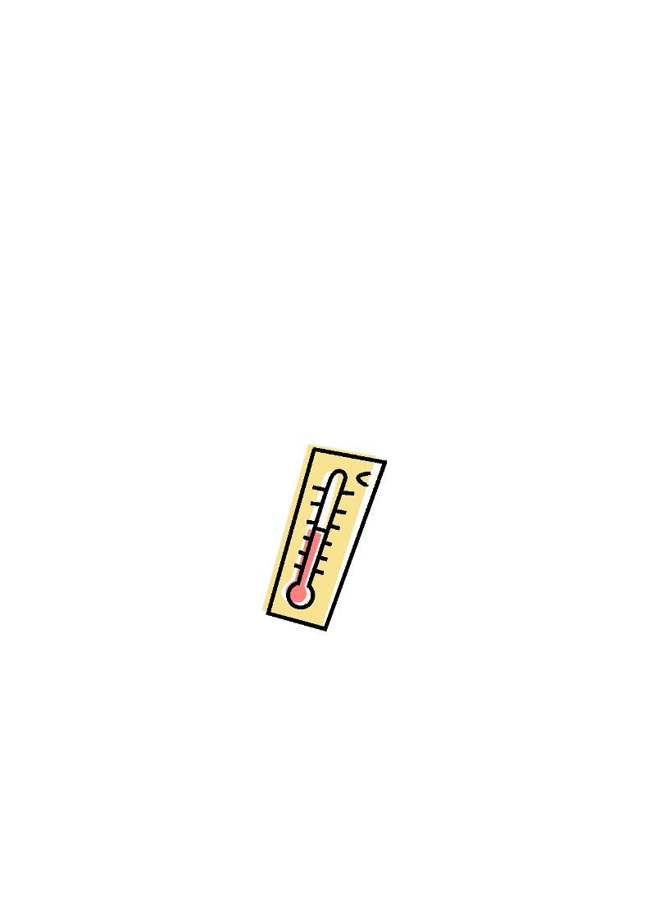
Logging time:
Loggers

1. Have the logger connected to the pc and whiteboard, Software set to show numbers as a set of
blocks or barchart.
2. Place the temperature sensor in a hot place (hold it in your hand).
3. Talk about the bar produced, do a bit of counting, Check they understand what the bar means, how
the numbers it uses got there etc. Why did the temperature go up? Why did it stop going up?
4. Get the class to suggest something cold for a comparison (you may need to do a bit if guided
suggestion here, e.g. cup of cold water in an obvious place!)
5. Repeat the temperature collection from the cold place.
6. Use the data to talk about hot and cold. Use number lines to count differences.
7. Measure other places to see if you can get the class to decide when it is hotter and when it is colder.
Use the numbers from the logger to see who can make the best guess.
Other examples of where we have to decide if it is hot or cold,
• Controlling the heating.
• Taking the correct clothes on holiday.
• Is what we are going to eat or drink the right temperature.
There can be confusion created between cold and feeling cold. In a room at a set temperature all things in
the room will be the same temperature, they will have reached balance with the room temperature. However
metal objects will feel colder, they do not have different temperatures. There are exercises that ask the
students to go round and touch things to say if they are colder or hotter, be sure that they really are different
temperatures and not just feeling different!
How hot it feels is very subjective, watch a group of people in room, the room is the same temperature for
everyone, why then do one or two people always feel they have to open windows or ask if it is hot? or cold?

Using the logger as a standalone device.
The Vu logger can be used as a standalone device for this activity.
Use the Snapshot mode of the logger to record the data for each of the areas tested. You can show the data
on the loggers screen using the review mode or connect the logger to a PC and use Remote, retrieve to download the data to the EasySense software.
Use Meters mode to select and deselect which sensors will be active for the investigation.
If you do not connect the logger to the PC data will have to copied from the screen onto a worksheet or
notebook, this may of course be part of the lesson objectives.

Teacher's notes.
This is an activity about measuring difference and giving a value to quantity. When is it hot and when is it
cold? How do you decide when it is hot or when it is cold? We use the logger and the temperature sensor to give a value to our statements about "it's hot" or "it's much colder".

2
Logging time:
Loggers

Extremes of hot and cold are easy to deal with, it is obvious when a radiator is on and hot or the inside of a
fridge is cold, but what about in the back corner of the class where it is a little bit less hot or a little bit colder?
Heat, which produces hot and cold, is a difficult topic. Heat is the energy and hot cold is the sensation of the
transfer of heat energy, if it is moving in to us we feel heat, if it is moving out of us we feel cold. We are not
very good at detecting hot and cold, only relative change - this is why draughty rooms or windy days feel colder. We need something like a thermometer to give a value for heat and allow comparisons.
These are all ideas you can explore with a well structured lesson. When finished the students should start to
understand that hot is where there is "more temperature" and cold is where there is "less temperature"
Simple things can then be explored.
• Why does it feel warmer on a sunny day?
• Why does it feel hot when you come into a room from a cold corridor and then it stops feeling warm?
• Why does wearing slippers make you feel warm?
We are building on the idea of using number to define similarity, or difference, we are also using the activity
to make the logger appear a normal part of class equipment not a special thing only used for….
You may be surprised at how little change in temperature is recorded to make us feel hot or cold!
New words or word use
The use of heat, hot, cold, boiling, freezing and temperature are so commonly used for each other in normal
everyday speech it is often easy to forget that they have specific meanings. Try to be consistent and use
them in a standard form to create confusion being created, take the time to correct wrong use
• A tip is to s u b s titu te th e w o r d s in to a s im p le s e n te n c e a n d s e e if th e y s till m a k e s e n s e , fo r e x a m p le
"Is the radiator hot" simply sounds better than "Is the radiator heat". There are better examples!
Remember, freezing is when a liquid turns to a solid and boiling is when a liquid turns to a gas. Very cold, or
very hot are better phrases!

3
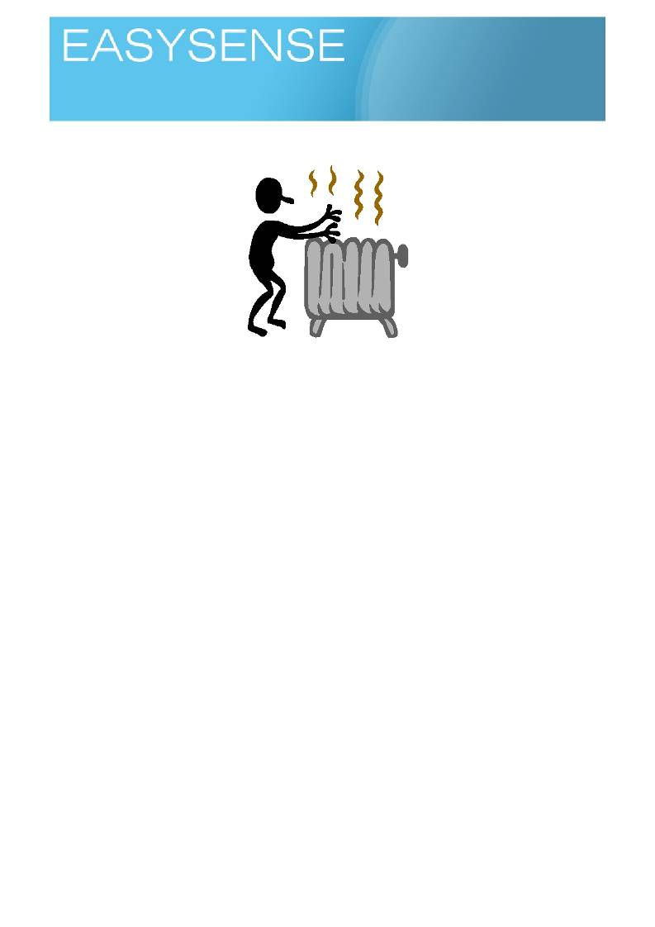
Age 5 - 7

Sensors: Temperature Logging mode: Pictogram

Where is it cold and hot?

Learning experiences covered.
• Number and counting.
• Quantity.
• Collecting data and drawing tables of data.
• Making comparisons.
• How to decide hot and cold.
• Normal values.
You will need.
• Some hotter and colder places - a simple comparison is between your body and the room.
• A datalogger with a 2 external temperature sensors, connected to a PC and whiteboard or large
screen.
Suggested method.
The simplest activity is to use situations that children will be familiar with.
1. Have the software set to show temperature as a set of blocks or barchart.
2. Ask the children to think and talk with their learning partners where the hot and cold areas are in the
classroom or where there might be examples of hot and cold they can test.
3. Use the children's examples placing one temperature sensor in a hot place and the other as far
away as you can place it. Alternatively place the temperature sensor in cold place and use your hand as the hot place comparison.
4. Get the children to suggest places in the classroom where you have a hot thing and a cold thing
close by for comparison. Show how far you can stretch between the two sensors .
5. Repeat the temperature collection from another pair of places.
6. Use the data to talk about hot and cold. Use number lines to count differences.
7. See if you can get the class to decide if a place in the class is hotter or colder, then measure the
temperature.
8. Are hot places always the same temperature? And even more confusing did you find any hot places
that were actually colder than cold places!
9. Introduce the idea of collecting temperatures over a period of time.

1
Logging time:

For a longer record.
1. Explain that the datalogger can collect temperature data when you are not watching. Show simple
demonstration by showing temperature change over time when holding the sensor in your hand.
2. Ask the children to think about how temperature would change in the classroom over night or when
they leave the room to go for dinner (for example). Can they draw a line to show how they think the
temperature will change?
3. Make sure they understand how we show the time passing on graph. Perhaps even suggest terms
such as axes, X and Y?
4. Suggest we record how the temperature in the room changes over night (over a day). Ask the
children to identify a place to set the datalogger up (You will need to use your knowledge of the class
to make sure the temperature does fall over night, e.g. not place it near any hot water pipes).
5. You should be able to have look at what the datalogger has recorded after 10 minutes or so, you can
then have a sneaky look just before going home time and make sure it is recording something.
6. Next day, connect the datalogger to the PC and bring back the data. Hopefully you will see the
temperature fall and rise.
7. Ask the children in their learning groups or with their learning partners to talk bout what they think the
lines are telling us. You will want to encourage statements about the temperature going down or going up, and some link to the time line.
Use their experience to help them understand what is going on. If they suggest a repeat, why not? Looking
at the bars and using the numbers is all good practice, as is using the datalogger.
Teachers notes.
Once we have established the idea of hot and cold and that we can measure the value of the temperature
we can start to explore simple things like,
• Where is the hottest place in the room?
• Where is the coldest part of the room?
• Can you draw a map of the room and show the cold and hot spots?
• What is the normal temperature in the room?
• What is the temperature outside the room compared to inside.
We use temperature sensor to give a number value to our discoveries We can start to say "it is coldest by
Charles' desk because the temperature was only…..".
We are building on the idea of using number to define similarity, or difference, we are also using the activity
to make the datalogger appear a normal part of class equipment.
You may be surprised at how little change in temperature is recorded between areas that make us feel hot or
cold!
Key questions.
1. What is the difference between heat and temperature?
2. How much does temperature have to change before you feel hot or cold?
3. What happens if you sit in a place for a time? Does it feel hot or cold any more?
4. Why don't we feel temperature always?
5. What is hand hot?
6. What is the normal temperature of a room? How would you find out?
There can be confusion created between cold and feeling cold. In a room at a set temperature all things in
the room will be the same temperature, they will have reached balance with the room temperature. However
metal objects will feel colder, they do not have different temperatures. There are exercises that ask the
children to go round and touch things to say if they are colder or hotter, be sure that they really are different
temperatures and not just feeling different!
How hot it feels is very subjective, watch a group of people in a room, the room is the same temperature for
everyone, why then do one or two people always feel they have to open windows or ask if it is hot? or cold?

2

Logging time:

Using the datalogger as a standalone device.
The Vu datalogger can be used as a standalone device for this activity.
Use the Snapshot mode of the datalogger to record the data for each of the places tested. You can show the
data on the dataloggers screen using the review mode or connect the datalogger to a PC and use Remote, retrieve to download the data to the EasySense software.
Use Meters mode to select and deselect which sensors will be active for the investigation.
Children can move to different areas of the room or collection stations and use snapshot to record the data.
Using the review button will let them see the data and transfer it to a worksheet, notebook, number line or
class activity.

3
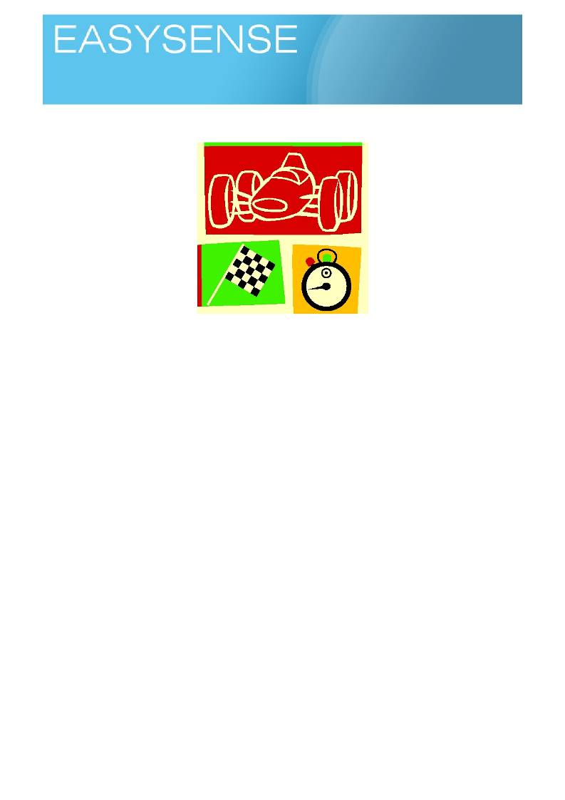
Age 5 - 7
Activities
Sensors: Light Gates or Push Switches or Timing Mats Logging mode: Timing A to B

Speedy cars?

Learning experiences covered.
• Time as a measure of speed.
• The connection between speed, distance and time.
• Quantity.
• Collecting data and drawing tables of data.
• Making comparisons.
• Normal values.
You will need.
• Some cars.
• A datalogger with a timing switch or light gate (attached to the computer linked to your interactive
whiteboard, projector or other large display)
• Software showing the product of the datalogger as bars of different sizes for different times and
speeds.
• A te s t tr a c k / r a m p .
• To know the distance between the timing points e.g. marks on the ramp, the magnetic switches in
the ramp, between floor timing mats. Distances as cm or metres and cm.
Suggested method(s).
Timing a car with push switches.
1. Have the datalogger connected to the pc to show results to a whiteboard or large screen. Have two
push timing switches connected.
2. Set the software to time from A to B.
3. Have the children in a test team of three, one to push the car, one to start timing and one to stop
timing.
• The starter is at the beginning of the track and the stopper at the end.
• The pusher pushes the car along the track, letting go so it travels on its own!
4. As soon as the car passes the starter they press their switch.

1
Logging time:

5. As soon as the car passes the stopper they press their switch.
6. You should see a bar appear on the screen! The size of the bar indicates the speediness of the car!
Big bars are slow, short bars are fast.
7. Repeat until tedium sets in!
There will be confusion at the beginning with starting and stopping, try not to let this get in the way of the
lesson. Most children will love seeing the bars and will latch onto the idea of the size having something to do
with the push. One advantage of the software is that you can always get rid of the mistakes!
Try to make sure the distance between the starter and stopper stays constant, it will be prone to drift.
Try to make sure the buttons are pressed only when the car passes!
Most of all enjoy!
Alternative 1
Using the class athletes.
Very similar to the car activity outlined above. You can use floor switches to start and stop timing. You will
need to use the hall or a corridor for this, most classrooms will not have a good running space.
Each time the floor switches are stepped on they act is if a push switch has been pressed.
The children will feel the effort they put into the work of running. They will feel the connection between force
and motion.
1. Place two timing mats a known distance apart, you may need to move them once you see how far
and quickly the children run. You will need some way of stopping the mats from slipping (tape, gym mat, under a carpet etc.).
2. Set the software to time from A to B, showing the results on a whiteboard or a large screen creates a
more involving atmosphere.
3. Ask the children to run from just before the start mat to the stop mat, making sure they step on each
mat. This last bit will create problems, experience shows that the children are very forgiving, it is the
teacher who gets annoyed!!
4. Results will be seen as bars, the height of the bars is linked to speed and time.
Alternative 2
Using a timing ramp.
A timing ramp is a custom made apparatus for time and speed work. It is a wooden track and support. The
position of the track can be altered to give steeper and shallower slopes.
The timing ramp gets rid of variability; it can also reduce spontaneity from the activity.
The timing ramp will have the facility to add a switch of some sort, the Data Harvest ramp uses magnetically
operated switches in the base of the ramp and magnet on the car.
Advantages are you can do a lot of work quickly, reliably and with certainty.
1. Set up the ramp with only the bare wood of the track.
2. Connect the magnetic sensors in the base of the track to the datalogger, the Start (top of the ramp)
must go to A and the stop to B. Make sure the magnet secured to the car.
3. Use a low angle of slope to begin with, make sure the cart can move down the ramp easily, don't
worry if it does not move on its own.
4. Start the software, to record time from A to B.
5. Give the car a push down the ramp. Look at the time. 6. Repeat, use a firmer push, compare the results.
7. Repeat until your pushing hand gets sore or you loose the will to live!

2
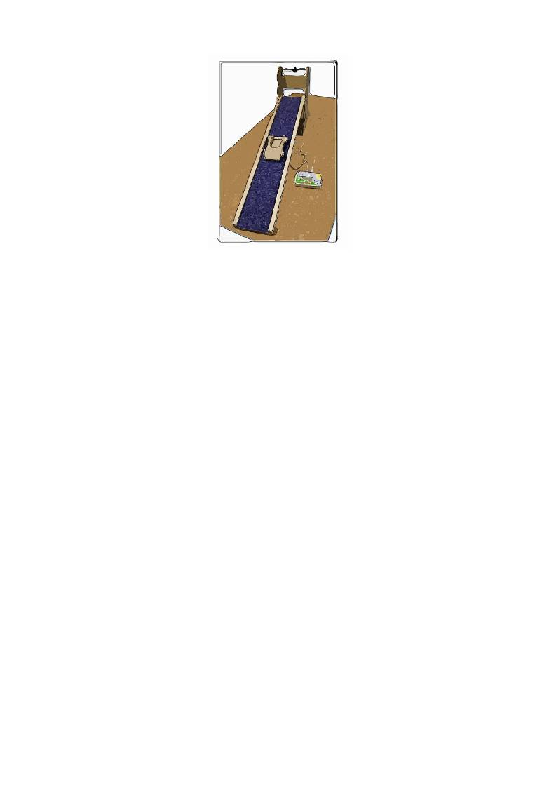
Logging time:

Teacher's notes.
You can introduce a lot of "thinking about" with this activity. Ask the children in learning groups to talk to each
other about
• How do we know how much push we used every time?
• How do we make it a fair test?
• What stops the car from moving?
• If we had not got timing switches and dataloggers how could you measure the speed of the
cart?
Using the datalogger as a standalone device.
The Vu datalogger can be used as a standalone device for this activity.
Use the Timing mode of the datalogger to record the data for each of the cart runs. You can show the data
on the dataloggers screen using the Review mode or connect the datalogger to a PC and use Remote, retrieve to download the data to the EasySense software.
When you start timing, select time from A to B, Use the up and down arrow buttons to alter the distance
between timing switches. Distances are to the nearest 10cm.
Click the right arrow to start timing mode, time will only be recorded when switch is activated. Teacher's notes.
At this early stage, seeing the numbers and bars on a screen can be very motivating for the investigator.
Software is set to show numbers as a set of bars.
The activity is introduced as an exercise to see how a car responds to the amount of push it gets, a simple
relationship between more push and a faster speed is required.
The data datalogger can be used in several ways, using light gates or timing switches on a formal car and
ramp, using push switches to time a cars' journey or push switches and timing mats to time budding athletes
running across a space.
According to what you measure;
• bigger bars are faster journeys - As the speed increases the bars get bigger, this way matches the
experience of any other datalogger and data based activity e.g. hot and cold. It does need to bring in
the idea of speed, perhaps too early.
• Shorter bars are faster journeys - it takes less time to go a distance so the time bars get smaller as
the car gets faster.
Key Questions.
1. What is speed?
a. If you are going at a speed how far do you go in 1 second?

3
Logging time:

b. What units do we measure speed in?
c. How does time relate to speed?
2. What is fast and slow?
a. Is a longer journey slower than a short journey?
3. How do we calculate an average? A difference?

4
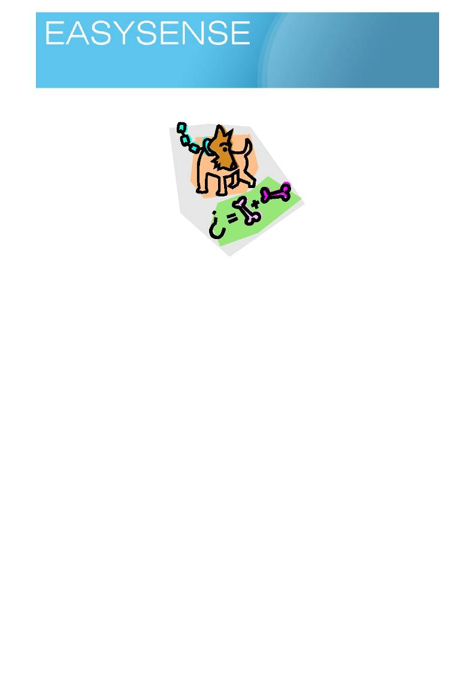
Age 6 - 8

Sensors: Push Switches Logging mode: Counting

How many?

Learning experiences covered.
• Number and counting.
• Quantity.
• Collecting data and drawing tables of data.
You will need.
• A s o m e th in g to c o u n t .
• A datalogger with one or more push button switches connected (attached to the computer linked to
your interactive whiteboard, projector or other large display)
• Software showing the product of the datalogger as counting bars.
Suggested method.
There are lots of ways you can go about an activity such as this.
1. Have the datalogger connected to the pc and whiteboard, record every time someone says a word or
does something. The results will appear directly onto the screen, good for introducing how the datalogger can present counted data as barcharts, numbers etc.
a. You can collect the data on the datalogger independent of the PC. Groups in the class could
be given dataloggers and set off to count other things. Data can be reviewed on the datalogger screen.
2. Have the switches connected to the datalogger and count something simple like the number of
drawing pins on the notice board!, doors in the corridor, times a teacher goes past the door.
3. Show results as soon as possible after the counting activity on the screen, the activity needs to be
fresh in the minds of the counters.
Using the datalogger as a standalone counter.
There are two counting options on the datalogger,
a. Use a switch connected to the ports A or B.
b. Use the up and down arrows on the datalogger to count. Up arrow counts on A, down arrow
counts on B.
When you have data on the datalogger you can use the right hand arrow to show;
1. Sum of counts at A and counts at B = total count.

1
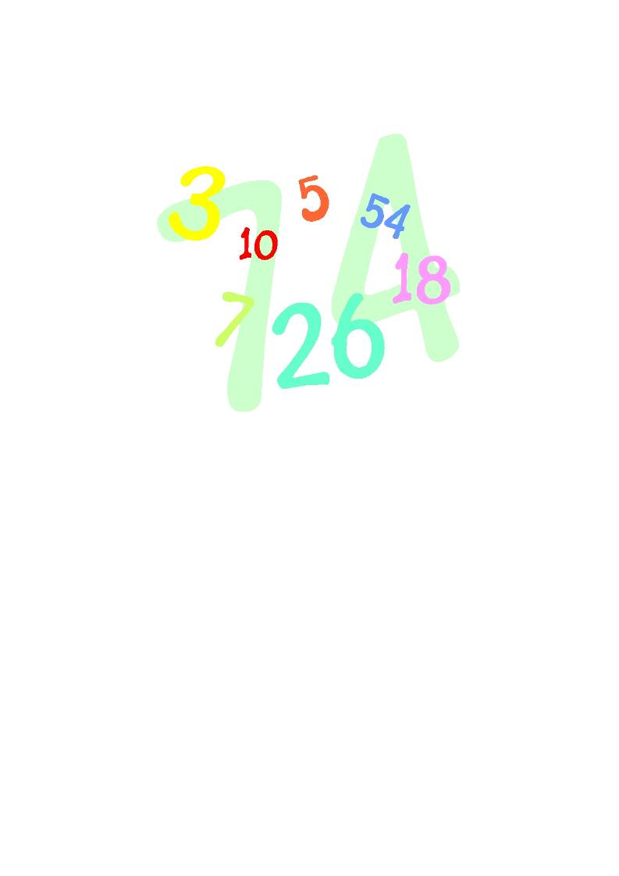
Logging time:
Dataloggers

2. Counts at A - the counts at B
3. Counts at B - counts at A.
4. Difference between A and B.
The number values of option 2,3,4 are all the same, but options 2,3 allow the showing of negative numbers.

Teacher's notes.
This is a revisit of work from the first years at school. It is envisaged as a revisit and reminder for the
datalogger and software. The activities used to count will present the extension upon earlier work, as an
introduction to survey work, for example.
The datalogger can be used with push switches to count events or things. Each push on the switch counts
one, a datalogger can collect how many of two things, it can also show the difference between the two sets of counts.
Key Questions.
2. How can we show how many we have counted?
3. How do I use numbers to show someone how many I have?
4. How else can I show number and quantity?
5. Can I use the number collected as evidence in a project?

2
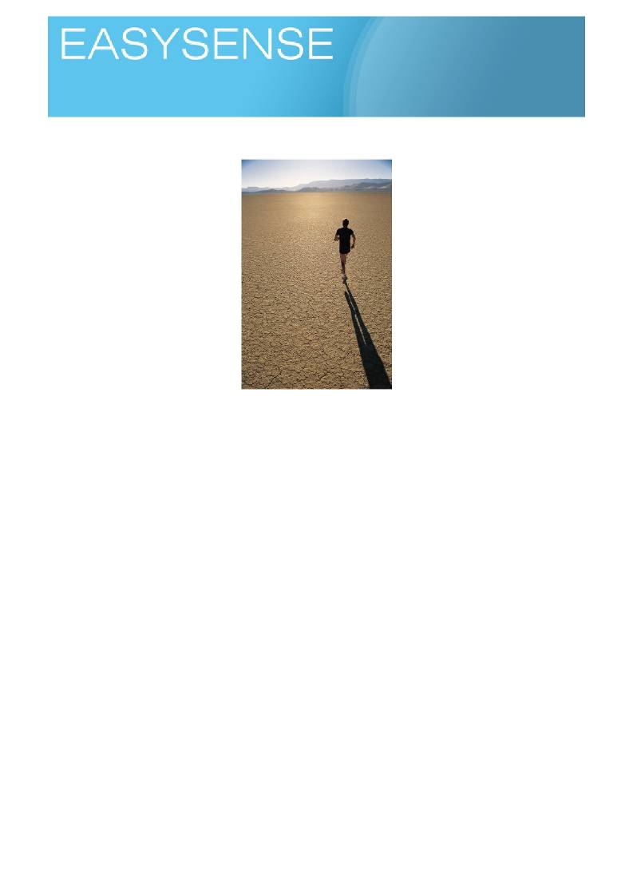
Age 6 - 8

Sensors: Light Logging mode: Snapshot

What are shadows?

Learning experiences covered.
• Collecting data and drawing tables of data.
• Using data as evidence.
• Describing events and observations by number.
• Writing a report.
• Presentation of data in a graphical format

You will need.
• A good directional light source - the sunlight or a torch. Desk lamps tend to give poorly defined
shadows. The white board projector makes very good shadows.
• Shapes to make shadows.
• A datadatalogger with a light sensor (attached to the computer linked to your interactive whiteboard,
projector or other large display)
• Software showing the product of the datalogger as bar charts.
Suggested method.
Before using a datalogger, get the children to talk about shadows. If it is sunny take them outside to make
and measure shadows.
Get the children to make a list or table of what shadows are and do, how they look, when you see them, and
when you don't. Get as much information from the children as possible about shadows.
Using the datalogger.
1. Set the software to show numbers as a set of blocks or barchart.
2. Perhaps do a bit of waggling of the datalogger in and out of light, ask the children to pass comments
on what is happening to the screen and how it relates to your activity or the dataloggers position.
3. Bring the lesson to a more formal base, point the datalogger at something obviously bright, the class
window or lights. While the whiteboard projector appears perception makes it brighter than it really is

1
Logging time:
Dataloggers

(you can of course test this, how bright is the screen compared to the lights?). A whiteboard seems the obvious bright object in the room but it can often give disappointing values.
4. When you have values you want to keep, snap the data to keep it on screen.
5. Talk about the bar produced, do a bit of counting, Check they understand what the bar means, how
the numbers it uses got there etc.
6. Set the datalogger to measure the light. Snap the data to show it on the software as a bar.
7. Place an object between the light and the wall (or floor, any flat pale matt surface will do) to cast a
shadow. It would be good at this point to arrange to have the datalogger inside the shadow without moving it!, or have the shadow move across the datalogger.
8. Measure the light in the shadow, use the snap to record the data.
9. Ask the children to compare the light and shadows bars, encourage the use of numbers to describe
what they see or are trying to explain.
10. Ask about differences in the bars, numbers and calculate differences.
11. Repeat with other shadows. Does:
a. The colour of the shadow maker make difference? b. The size of the shadow maker make a difference?
c. The opaqueness of the shadow maker make a difference?
d. If you use see through colours does the colour make difference?
e. What abut the colour or texture of the surface the shadow is cast onto?
12. Just explore, keep noting down the discoveries, is there a pattern? Are we starting to see the
"shadowness" of shadow? Or is it still to difficult to define?
Using the datalogger as standalone device.
The Vu datalogger has a range of options to let you look at data without using the link to a PC.
You will need to work out which sensors you wish to record and use Meters to turn off the sensors not
wanted. With this exercise you will only want the Light set to ON. Perhaps on hot day, if you are casting
shadows outside in the sun, you could use an external temperature sensor to see if temperature changes? It
is cooler in the shade, shade is only a big shadow!
To collect the data, choose snapshot. Every time you press the right arrow you will record a set of data.
You can use the Review function on the datalogger to scroll through data collected or connect the datalogger
to a PC and download the data into the EasySense software.
Note on the datalogger you will only see one set of recorded data at a time and you will need to use the up
and down scroll buttons to move between data sets.
Teacher's notes.
Shadows will have been introduced to the children in earlier years, at this stage the a more scientific study of
shadows is required. The emphasis of the work should be more to the idea of data collection, presentation of data, use od data as evidence and creating reports of discoveries.
Our question is how do we define a shadow? They are so obvious it is quite difficult to describe them to
others. Perhaps we can say we have shadow when…. But what is the when?
In the activity we will create shadows and measure the light in the shadow and the light outside the shadow,
perhaps we can answer some questions;
• What sort of light do you need for shadow?
• How bright does it have to be to cast shadow?
• Is the difference between light and shadow a constant?

2
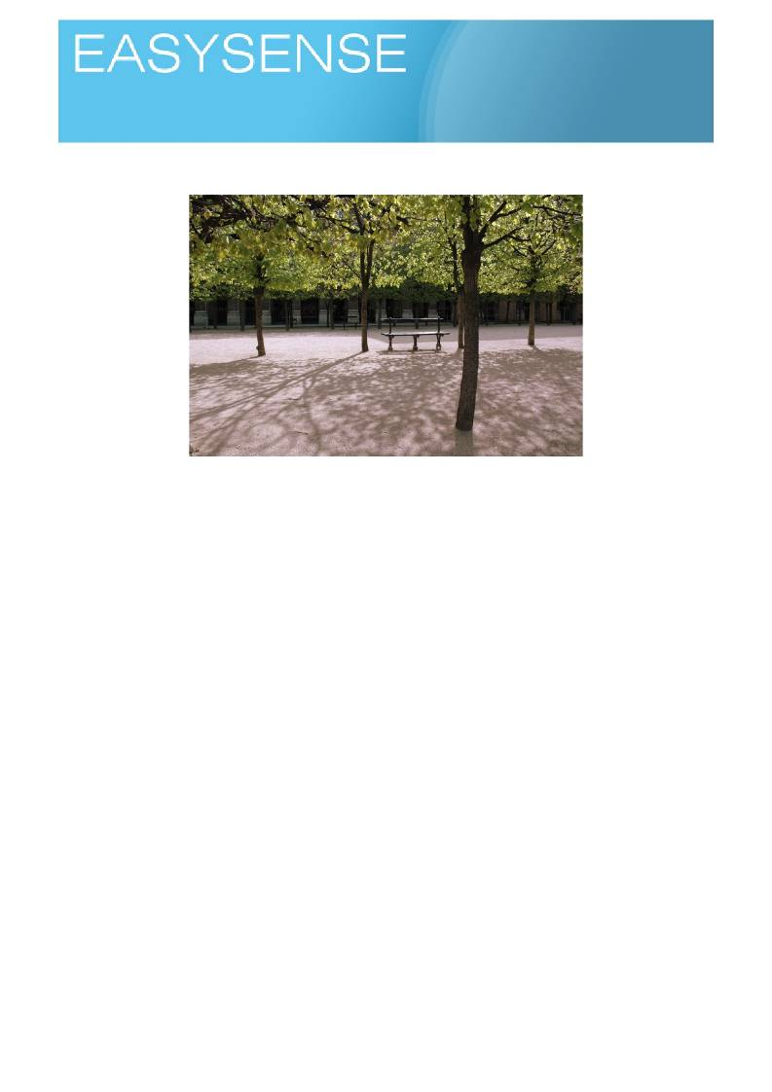
Age 6 - 8

Sensors: Light Logging mode: Snapshot

Light dark and somewhere in between?

Learning experiences covered.
• Number and counting.
• Quantity.
• Collecting data and drawing tables of data.
• Describing things by number.

You will need.
• A datalogger with a light sensor (attached to the computer linked to your interactive whiteboard,
projector or other large display)
• Software that shows the product of the datalogger as bar charts or numbers (meters)
• A g o o d lig h t s o u r c e ( c la s s lig h ts , w e ll lit w in d o w , to r c h ) .
• A s e l e c t i o n o f o b je c t s t h a t :
1. block light
2. let light through clearly
3. let light through to some extent
4. let light through but colour it (e.g. A4 sheets of card, paper, plain and coloured translucent
film, different fabrics etc)

Suggested method.
Ask the children to talk about what lets light through and what does not. See if they remember the words that
describe letting light through, blocking light, disturbing light changing colour of light.
Ask them in learning groups to make lists of 5 things (of each) that let light through without change
(transparent), distort the light or what you see (translucent), don't let through (opaque). Create a master list and check the grouping is correct, challenge any that are in wrong place to see why.

1

Logging time:
Loggers

Using the logger.
1. Set the software to show numbers as a set of blocks or barchart.
2. Check they understand that big numbers or longer bars means more light, less dark and smaller
numbers and shorter bars means less light and more dark.
3. Measure the light without any blocks or things in the way. Snap the data to show it on the software
as a bar. This is your reference (control, as science describes it) point against which all others are compared.
4. Place an object between the light and the sensor in the logger. Snap the value.
5. Place a block over the sensor, use the snap to record the data. Compare the open light, shaded and
blocked bars.
6. Ask them to think of the brightness or darkness of the light as a number not a word description. For
example, "I know this is bright because it shows 2000lx", "I know this is dark as it only shows 100lx". We are trying to build up the idea of describing by numbers.
7. Now a base for comparison has been created, repeat with other things you have selected.
a. Does the colour make difference?
b. Does the size of any dark patch make a difference?
c. Does the opaqueness of the shadow maker make a difference?
d. If you use transparent thing does the colour make difference to the amount of light?
8. Just explore, keep noting down the discoveries, is there a pattern? Are we starting to see the
"shadowness" of shadow? Or is it still to difficult?
If you have access to enough transparent filters of colour, get the class to look through them and put them in
order of brightness!
Some colours appear much brighter than others, yellows often seem brighter than reds, blues can appear
dull.
As a diversion, ask them about how the colour makes them feel, some colours like reds are supposed to
make things look warm, while blues make it feel cold!
You can use coloured paper presentation folders (the ones you clip into a file folder). Ask them to place over
work and see if helps reading? Some people find bright white paper too bright to read off (we are getting
close to dyslexia testing here, so a bit of awareness is required). They may already be aware of colour
combinations that make reading difficult e.g. bright yellow on bright white!

Is light shining through? or a bright light shining onto it? Transparent? or Translucent?

2

Loggers

Teacher's notes
Key Questions.
1. What is light and what is dark?
2. Can we use numbers to describe something as well as words?
3. What else changes light?
4. How do you describe things that change how you see light?
5. What is colour?
In previous work we have looked at dark, light and shadows.
We have been telling a story that;
Logging time:

• We can define dark and light
• We can say something is brighter or darker than something else and give a number to support.
• We can define a shadow.
• We can use numbers to describe to others what we see, but they may not.
Our next part of the story is, what about the graduations between dark and light? How can we describe ot
others how much light or dark we have seen?
Coloured filters should give lower light readings, this is clue that some light has been blocked by the filter and
that only a small part has passed through. The part that passes through is what we see as colour. White light is a mixture of many colours.
A r e m i n d e r o f t h e t e r m s u s e d t o d e s c r i b e t h e a b i l i t y o f o b je c t s t o l e t l i g h t t h r o u g h t h e m .
• Opaque = Lets no light through, a brick wall is opaque.
• Transparent = lets light through without changing it, a clear glass window is transparent. If we put
colour into it we make a filter, but transparent will do.
• Translucent = lets light through but distorts what you see, a frosted glass window to a bathroom is
translucent.
• Filter = blocks parts of light but lets parts through without changing. The blocking removes some light
and produces colour.

3

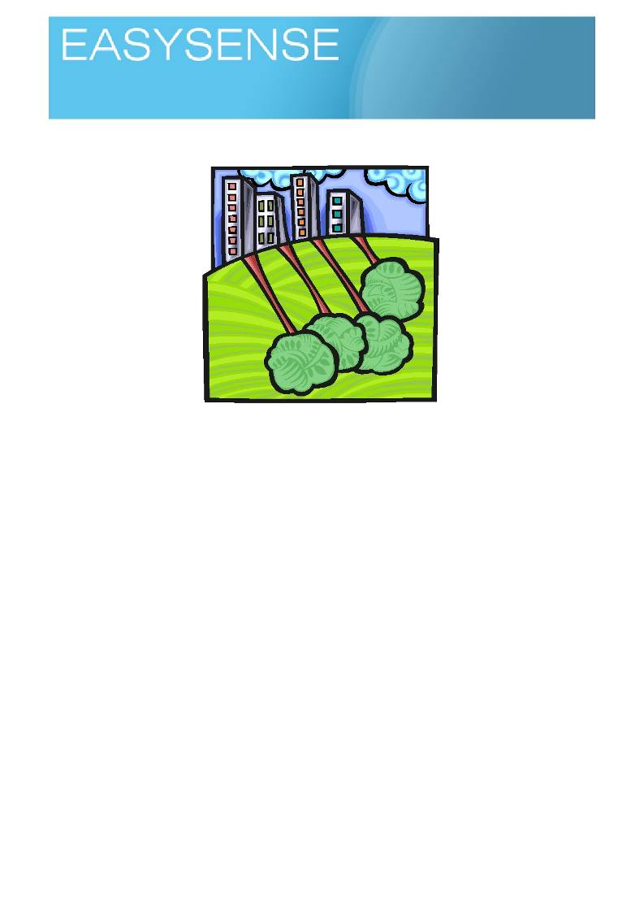
Age 7 - 9

Sensors: Light, Temperature, Sound Logging mode: Snapshot

Why is it different over here?

Learning experiences covered.
• Science activities and methods.
• Collecting different types of data e.g numbers, observation.
• Graphing and presenting data.
• Describing and comparing numbers.
• Using different types of data to make a conclusion.
You will need.
• A study area with contrasting environments - an open field to a shady edge is good, or an open well
tended field compared to a slightly shaggy perimeter.
• A datalogger with light, sound and temperature sensors connected.
• A PC connected to an interactive whiteboard or a projector to show and share the data collected.
Suggested method.
You will need to do a bit of close field work with the children before their own activity starts. Take them to an
area and get them to talk about what they can see, make lists of what is obvious even what is missing.
Give each learning group of children a small area to study. Ask them to look closely and decide how many
types of plant there are, let them talk about the plants they can see.
Pictures can be drawn or take a few leaves and all decide that the leaf or the picture is plant 1, 2, 3 etc (we
can obsess about names, plant 1 is perhaps more meaningful than grass (again)).
Talk to the groups and ask them to think and talk about why these plants may be growing there. What things
may encourage the plant to grow here.
Introduce a datalogger and talk about what it can measure and how we can measure at a study area.
Showing the data.
The data collected with the datalogger is most valid when used with the observation data, it will probably
have low value on its own.

1
Logging time:
Dataloggers

The data from the datalogger should be
Presented as vertical (conventional graph layout) bars, with a scaled axis.
Other non datalogged data can be tabled, picture based r photographic. Perhaps the main thng is that it
should show some form of organisation and coherence. Links between the data are clearly shown.
• Try to get them to usewords and phrases of difference i.e. "both places we studied had the same
temperature", "the shady site had less light than the sunny site". (note In secondary science when a
difference is given, both parts of the difference has to be given, it is not enough to say site one is
sunny).
• Take care with the "non difference". Most activities in school science are designed to give a
difference. Perhaps in this case we need no difference in something to prove it is something else
making the change. A difficult task to start with. For example if both sites have the same light and
temperatures but have different plants, we must assume the difference is due to something else we
have not measured. The non data has not been useless, it has been very important in identifying that we need to look further for a difference.

Using the datalogger as a standalone device.
The Vu datalogger can be used as a standalone device for this activity.
Use the Snapshot mode of the datalogger to record the data for each of the sites being looked at. You can
look at the data on the dataloggers screen using the review mode or connect the datalogger to a PC and use Remote, retrieve to download the data to the EasySense software.
Use Meters mode to select and deselect which sensors will be active for the investigation.
Children can move to different areas of the school site (or study area) or collection stations and using
snapshot to record the data. Using the review button, after all the data has been collected, will let them see the data and transfer it to a worksheet, notebook, number line or class activity.
Teacher's notes. Key Questions.
1. How do we show (prove) difference?
2. How can I describe a difference?
3. Is it always true that big differences are important and small differences do not matter?
4. When someone says that something is different how can we trust them? Why would we trust them?
This is revisiting the change in the environment topic. It is asking us to make a more scientific study of the
areas and the differences seen.
A lo t o f e n v ir o n m e n ta l w o r k is a b o u t s ta tin g th e o b v io u s . T h e ta s k o f te a c h in g e n v ir o n m e n ta l s c ie n c e is a b o u t
making people notice the obvious and not to overlook or over simplify what they see. Put simply a grassy
field is not just grass, it is a community of plants. A moments pause and you will find variety where everyone else sees conformity. The other big task in environmental work is to prove the differences or similarities and present the findings in clear way for others to work with.
The data datalogger can help us to start thinking about measuring for evidence, we say the field is hotter, but
is it? And by how much? And how do we prove this to someone who has never been there?
This movement from proof by experience to proof by evidence is a key skill in science development. Put
simply, "I know this is true, I measured it and I can show you the proof, you show me I am wrong!" We are also encouraging the move from concrete to abstract, to say the field is hotter is one thing, but what about
the sceptic standing on the field on cold day? Perhaps the relative difference between areas is more important.

2
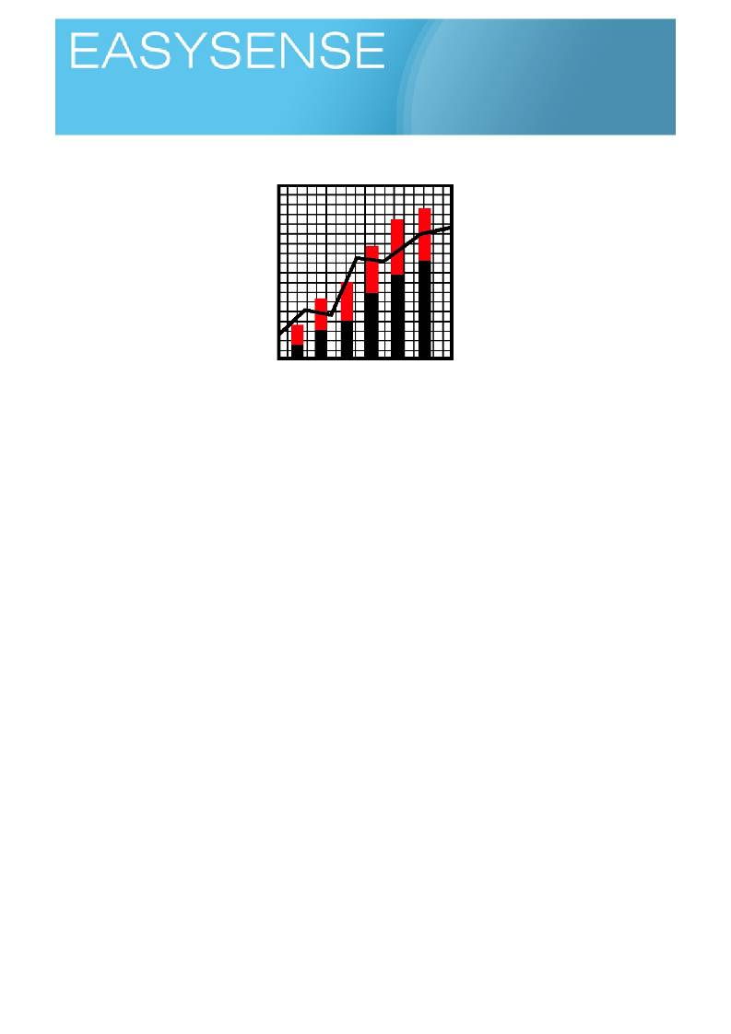
Age 7 - 9

Sensors: Light Logging mode: EasyLog

What happens when I am not here?

Learning experiences covered.
• Science activities and methods.
• Collecting data remotely.
• Quantity.
• Graphing (Line).
• Describing and comparing.
• Time as a variable.
• The controlled experiment.
You will need.
• A study area that will show a change in temperature over time - the classroom over night is a good
example, but you may have other inspiration.
• A data datalogger with an external temperature sensor.
• A PC with the software to show what the datalogger recorded.
Suggested method.
Your children need to be familiar with the datalogger and what a datalogger does. A recap of its capabilities
would be a good idea.
Connect the datalogger to a PC so results can be shown to the class on a whiteboard or large screen. Use
Easylog to show what happens when you hold onto the temperature sensor for a period of time.
Give the children a few moments to talk about what the graph line is showing. Ask individuals to come and
show important areas of the graph e.g. the axes, time, where temperature is going up, going down etc
Pose the question, what happens to the temperature in the study area over the chosen time period? Ask
them to talk to each others in learning groups or partners and draw a picture to show what they think will
happen to temperature for the rest of the day and overnight. Pin the diagrams on a display board. There are
activities you can use to help with this, a simple one is to have a child hold the pen, use a long paper and
pull it along. Have one edge of the paper labelled HOT and the other edge COLD, Ask the pen holder to
move the pen to the hot side, cold side, hold steady as the paper is slowly pulled along under the pen. Then
examine the graph.

1. Use an external temperature sensor if available, it gives a clearer indication of what is being
recorded. There is an internal temperature sensor that can be used as an alternative when collecting the overnight data.

1
Logging time:

2. Ask the children talk about and decide a place to put the datalogger and how long to record for. They
will need to consider where does the sun come into the class, where are radiators, what the lesson structure is the next day etc.
3. Next day, remind the class about the activity.
4. Ask them to reclaim their graphs and add to them some predictions e.g. what happens when the
class is empty? what changes overnight? (e.g. sun goes in, heating turns off etc).
5. Get some ideas of time for events. For example time when the class became empty. The time when
the school closed for the end of the day. When the school opened for the day (you may be interested in the replies!).
6. Connect the datalogger to the computer and use the software to show the collected data.
7. If you are using a white board, use the whiteboard software to mark up areas of interest. Try to go for
big changes and diminish small changes, they are often "artifacts".
8. You could repeat the next night, but include light and sound - ghost hunting! Looking for borrowers!
Anything to encourage predictions and explanations.
Showing the data.
The data collected with the datalogger is most valid when used with observation data.
• Data from this exploration should be shown as a line graph.
• Check the understanding of the time axis by asking members of the class to point out (or mark up
using whiteboard tools) key times in the school day on the time axis.
• Try to get them to say words and phrases of difference i.e. It was colder at midnight than just before
we left the class to go home. (note In secondary science when a difference is given, both parts of the
difference has to be given, it is not enough to say site one is sunny).
• Things to look for on the graph.
o When was it coldest?
o How do we know it was colder at.(a given time).
o Why did it get colder or hotter.
o Why did it get hotter before anyone arrived
o When was midnight on the graph, and why did you decide on this?
How did the children's graphs drawn the day before match the real data? Who was closest in shape? With
times?
Teaching notes.
Key Questions.
1. What does a graph show?
2. How can we trust the data collected when we are not around is correct?
3. Why and when do you use different types of chart?
4. Do you understand X and Y axis?
5. How do you decide on the scales to use?
6. How do you know where to place the data points on the graph?
7. What are the rules for drawing graphs?
By this stage, it is hoped that children will be used to seeing a datalogger in class use and using the software
in a variety of lessons. A datalogger is capable of collecting information when the observer is absent, this is
an area that has not been covered in many of the previous activities, nor has the idea of showing the data
collected as a line graph.
A b a r c h a r t o r b a r g r a p h s h o w s d a ta in g r a p h ic a l fo r m a t, te c h n ic a lly it d o e s n o t c r e a te lin k s b e tw e e n th e d a ta ,
the bar format indicates that each data is separate from other data. For much of the work so far, this is correct, and allows us to consider simple differences in value between locations or events.

2
Logging time:

A lin e g r a p h fo r m a t in d ic a te s th e d a ta is lin k e d to th e d a ta e ith e r s id e . In th is a c tiv ity th e lin k is th e tim e th a t has passed, we want to see what happens to temperature as time changes. Everything else in the activity has stayed constant.
Graph drawing is an important skill for science. There is however a slight difference in the way that
mathematics and science use graphs and draw graphs.For science a graph is a graphical representation of data.
There is an excellent package form the ASE that teaches scientific graphing call AKSIS and a primary
publication called Science and Numeracy. Both publications use and teach the graphing standards. A search on the internet on "how to draw graphs" will also reveal information about graphing.
Plotting the data by hand can be useful exercise in its own right, the data logging software will allow a lesson
to flow freely by reducing the time between data collection and discussions about what the graph tells us. A
short time between collection of the data and its presentation can be very important when teaching how to decipher the content and message in a graphed data set.

3
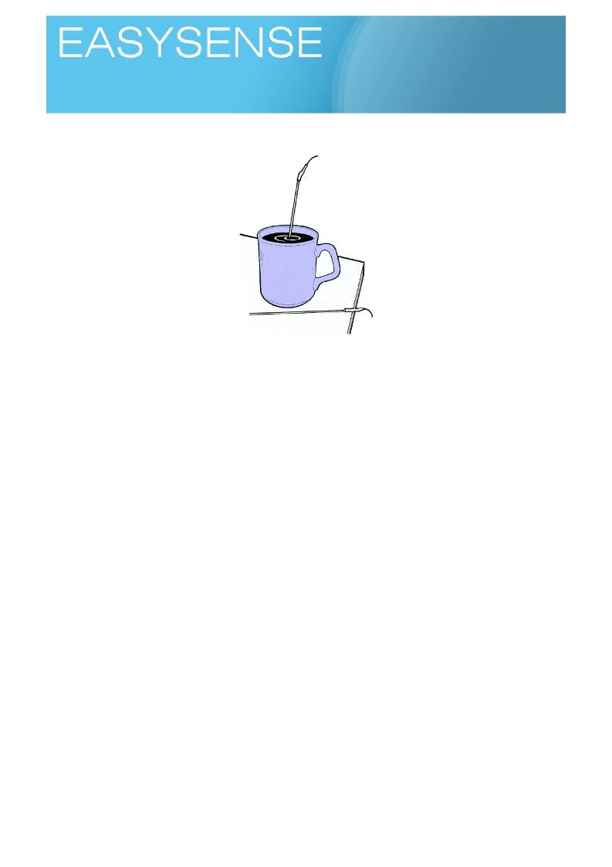
Age 7 - 9

Sensors: Temperature Logging mode: EasyLog

How does heat move around?

Learning experiences covered.
• Science activities and methods.
• Collecting data with dataloggers.
• Graphing (Line).
• Describing and comparing.
• Time and prediction.
• Controlled experiment.
You will need.
• A datalogger with an external temperature sensor (attached to the computer linked to your
interactive whiteboard, projector or other large display)
• Software showing the product of the logger as line graphs.
This is a good activity to show on screen.
Suggested method.
Use Easy log to show what happens when you hold onto the temperature sensor for a period of time.
Recap with the children that a line graph allows you to link past and future data and make predictions.
1. Show what happens to a hot thing getting cold, this then becomes the reference point for the activity.
The first step should be to use a beaker of hot water cooling down.
Hint. It is matter of physics how things cool, a big mass of water takes a long time, a bigger surface area
cools quicker and a bigger hot to cold difference cools quicker. Don't expect a thick stoneware pint mug filled to the brim with luke warm water to cool quickly. Use a small amount of water in a metal container
for the most dramatic demonstration.
2. Use Easylog to show the temperature without water. Note Try to position the temperature sensor
that it is not touching the sides or bottom of the container.
3. Use the class clock to get the time.
4. Add the hot water and point out how the temperature went up, then leave it. Use the time it is cooling
to think about what we do to keep warm or cool.
5. Use your judgement, once it is obvious that cooling has taken place, get the time from the class
clock and stop logging.

1
Logging time:
Loggers

6. Add notes to the graph, time you started, time you finished. Bring in the idea of it cooled this much in
this time - a rate of cooling statement.
7. Ask the children, in study groups, to work out a time when the water would be at the same
temperature as the room. Ask them to show on the graph how they reached that answer. Use the whiteboard drawing tools to draw solutions over the graph.
8. Ask the children to talk about and come up with ideas ways to keep the water hot longer. And try!
9. Ask them to explain if their idea worked or did not work. The idea of a controlled experiment should
be slowly forming and may need a little nudging to be created. How do you know it cooled quicker?
Did you start at the same temperature? End at the same temperature?
10. Move from the activity to a topic about keeping warm. Ask the children to design a cup or something
to add toyour cup to keep your tea warm on playground duty etc. Make the activity work for you,
don't leave it as just a science activity!
Showing the data.
Things to see, and comment upon.
o Where did the heat go?
o How do you know how quickly it was cooling?
o Any ideas of how we could make this work for us?
Teaching note.
You will get best progress form this work if you can do a quick demonstration of the graph developing. Use
your hand to hold the temperature sensor and show how the software shows heating and cooling. Children
can be quite strong concrete thinkers at this stage so use a cup of hot water as well, anything to just
reinforce the message that we can record changes over a period of time, and this is what a line graph shows us in this activity.
Key questions.
1. Why does heat move from place to place? 2. What affects how quickly the heat moves?
3. Can we produce a speed of cooling? A rate of cooling?
4. Can you transfer the ideas you saw to a new situation?
This activity lends itself to an illustrated activity very easily.
The story could be "Goldilocks", the problem is how does goldilocks know which bowl of porridge is right to
eat, she can't taste it in case she leaves "bite" marks and gives away to the bears it was her! Or you could give a mystery twist (marie celeste) (scooby doo), no none at home but there is a cup of hot coffee on the
table, how long ago did the last person leave the room. Let your imagination go wild to create a wrapper
around the activity that will appeal to the class, you know them best!
You can use the logger as a standalone for this activity, but a screen projection of the data allows you talk
about and discuss the data while it is fresh in the students mind.

2
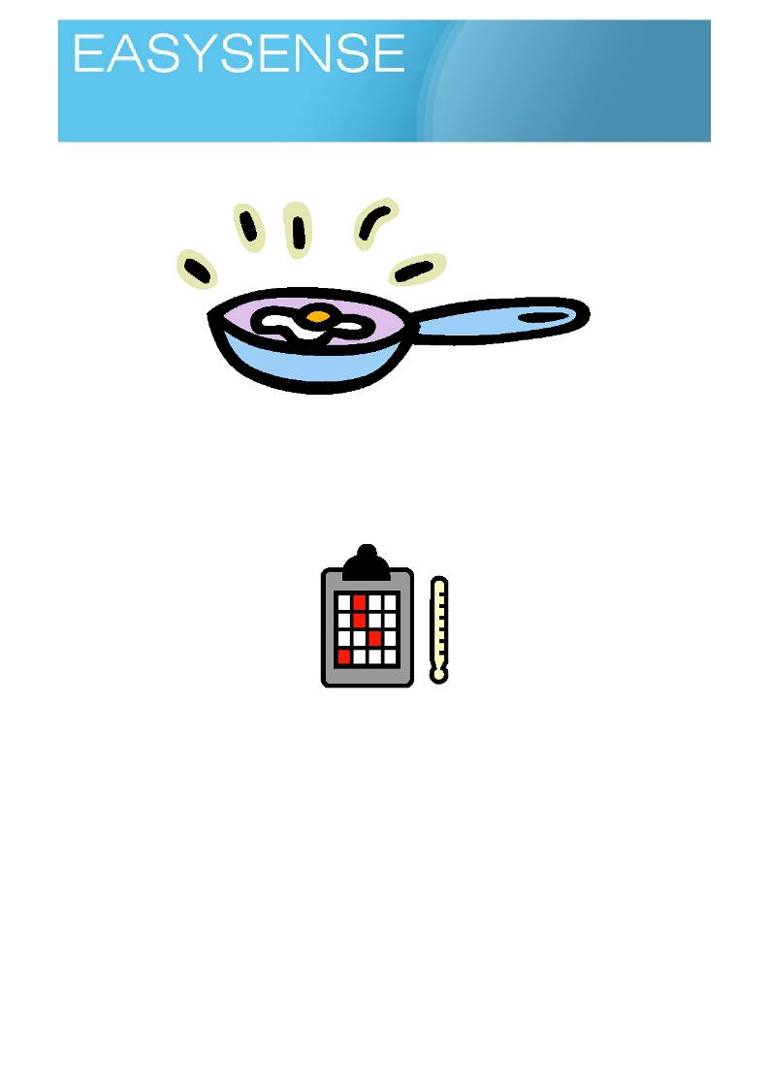
Age 7 - 9

Sensors: Infra-red Thermometer

Conduction of heat?

Learning experiences covered.
• Science activities and methods.
• Describing and comparing.
• Time.
• Controlled experiment.
• Correct apparatus for activity.

You will need.
• Something that is hot. Suggestions from ASE and CLEAPSS include bottles of hot water, secure
cups of hot water. Hotter things require more care but heat moves best when there is a big
difference, you may need to move out of your comfort zone to get the most meaningful results.
• A set of similar objects made from different materials e.g. a metal and plastic spoon.
• An Infra red non contact thermometer.
• A m a r k e r p e n t o d i v i d e t h e o b je c t u p i n t o s e c t i o n s .
• Perhaps a flipchart picture of the hot object, you can write temperatures onto the image to show
what's happening.
Hint. Some of the non contact thermometers come with a laser guide. Lasers are not appropriate for this age
group. If there is a laser fitted use tape or opaque silicon sealant to block it. Blocking the laser will not do any
harm to the thermometer, it is only a guide to show where you are pointing. Alternatively you may find that
the front end of the sensor comes off and you and you can place a more permanent shield in front of the laser pointer.

1

Logging time:
Loggers

Suggested method.
Your students need to be familiar with a thermometer and what it shows, i.e. the units, an idea of what
number is how hot.
• Have a beaker of hot, cold and room temperature water available.
• Point the thermometer at the beaker and press the trigger to record the temperature. Show how you
need to be pointing at the object (obvious, but often forgotten).
• Record the temperature at each of the marked segments on the objects when it is just in the room
(they should all be the same).
• Fill the test beaker, tin or pans with hot water. Place the objects into the water. Make sure most of
the object is out of the water (you want heat to enter the object and move along it).
• Wait 3 minutes and record at each of the marked segments on the object the temperature (segments
closest to the heat should be hotter).
• Plot the segment temperature against distance from the heat source. Good practice at graph
drawing.
• Repeat with things made of different materials, remember to have the hot source at the same
temperature each test.
Working with the data.
• Use flipchart pictures of the objects to add temperatures to. You can then use the physical distance
of the object to become the distance axis of your graph, using previous knowledge of a higher bar is
hotter, build up a graph.
• Things to see, and comment upon.

oooo
o
Extension.
How far along the object did the heat reach?
Did the heat ravel quicker through anything?
Was there anything similar about the things that let heat move through them?
Where did the heat go?
Why didn't the object get as hot as the heat source

Having got the infra red thermometer out, why not test other things…
• What is the hottest thing in the room?
• What is the coolest thing in the room?
• (bit sneaky really, in a classroom everything should really be the same temperature, excepting any
heat sources e.g. radiators).
• Does everything feel equally hot or cold?
• If something feels cold what is it likely to be made from?
• Can you tell which seat was last sat on?

2

Logging time:
Loggers

Teacher's notes.
Heat conduction is one of those things we know, we have experienced but often take for granted or just
simply ignore. We know that a metal handle on a saucepan is going to get hot, what we often do not do very well is take that knowledge to novel situations. We forget and pick up a cup filled with hot water and wonder
why it is hot!
Key questions.
1. Why does heat move through some things and not others? 2. Can you predict if something may let heat travel through it?
3. When does heat become harmful to us?
4. What is conduction?
Often the heat being measured is very small, touching a thermometer onto an object will take the heat away
and not show anything. If you are not careful all the objects can appear to be the same heat if you use a
contact thermometer. Non contact thermometers use infra red radiation given off by hot objects to measure
the temperature. You can get small clinical versions for fever monitoring or larger semi industrial version that can measure a range of temperatures.
The activity use a larger non contact infra red thermometer to record temperatures. The advantage of using
one of these thermometers is that you can use real numbers to describe heat, other methods often show
conduction by indirect methods e.g. drawing pins falling off, heat sensitive papers changing colour. You
should really use a mixed selection of methods, using one to demonstrate, another to explain and describe what you see.

3
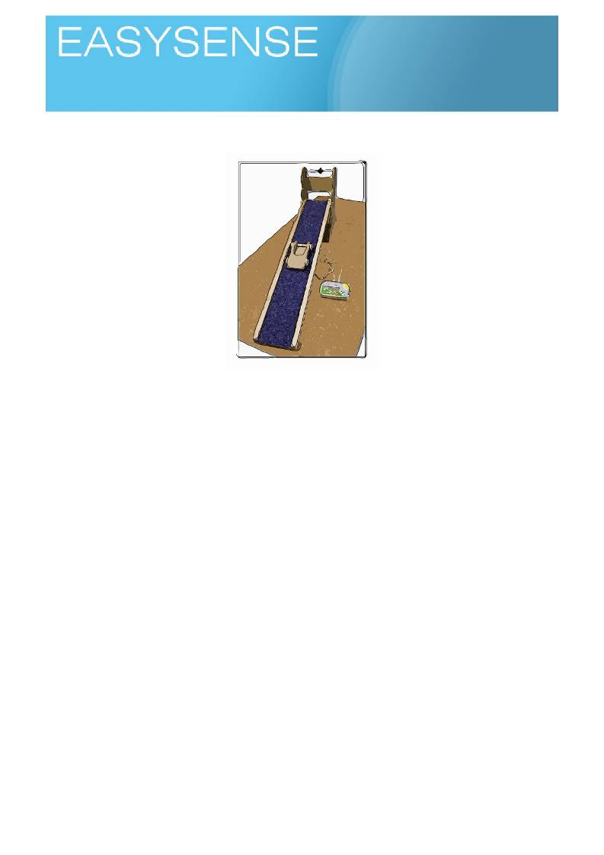
Age 7 - 9

Sensors: Push Switches or Light Gates or Timing Mats Logging mode: Time A to B

Speedy cars, what stops them going faster?

Learning experiences covered.
• Time as a measure of speed.
• Collecting data and drawing tables of data.
• Making comparisons.
• Normal values.
• Finding out one thing from another.
You will need.
• Some cars.
• A datalogger with timing switches connected (attached to the computer linked to your interactive
whiteboard, projector or other large display)
• Software showing the product of the logger as time from A to B.
• A te s t tr a c k / r a m p .
o Some surfaces to place on the ramp to alter its' friction.
Note: The Data Harvest primary timing solution gives a ramp that has adjustable heights, different
surfaces and a timing system.
Suggested method.
The cart is allowed to run down a slope of fixed angle and it is timed for how long it takes to make the
distance. Addition of different surfaces will let the car cover the same distance on a ramp of the same slope in less or more time.
If you have access to a gym or hall you could perhaps try a large scale version of this, pulling each other
across the floor on different types of mat or trying to push something in bare feet, stockinged feet or shoed
feet!
Before starting quickly revisit how timing works, perhaps do several runs on the fastest surface to show you
always get the same speed.

1
Logging time:
Loggers

1. Timing a car with push switches.
1. Have the logger connected to the pc and whiteboard or large screen Software set timing form A to B.
Have two push button switches connected.
2. Arrange the test team into a three, one to let the car go the car, one to start timing and one to stop
timing.
3. The starter is at the beginning of the track and the stopper at the end.
4. The car is released at the top of the track so it travels on its own! 5. As soon as it passes the starter they press the switch.
6. As soon as the car passes the stopper they press their switch.
7. You should see a bar appear on the screen! The size of the bar indicates the speediness of the car!
8. Repeat until tedium sets in!
There will be confusion at the beginning with starting and stopping, try not to let this get in the way of the
lesson. Most students will love seeing the bars and will latch onto the idea of the size having something to do
with the speed of the journey. One advantage of the software is that you can always get rid of the mistakes!
Try to make sure the distance between the starter and stopper stays constant, it will be prone to drift.
Try to make sure the buttons are pressed only when the car passes!
Most of all enjoy!
2. Using a timing ramp.
A timing ramp is a custom made apparatus for time and speed work. The track can be height adjusted to
give steeper and shallower slopes.
The timing ramp will have the facility to add timing switches The Data Harvest ramp uses magnetically
operated switches in the track and a magnet on the car.
Advantages are you can do a lot of work quickly and reliably.
1. Set up the ramp with only the bare wood of the track.
2. Connect the magnetic sensors into the base of the track and to the logger. The start (switch at top of
ramp) must go to A and the stop (switch at the bottom of the ramp) to B on the logger..
3. Make sure the cart can move down the ramp without any push.
Hint pre test the activity to find which is the slope needed to make the car move downhill on its own on
the "stickiest" surface. Use this as the standard slope.
4. Start the software, set to record time from A to B.
5. Release the car and let it roll down the slope. Look at the time.
6. Repeat, compare the results. When there is agreement it always travels at the same speed, add a
different surface and repeat
7. Repeat with as many different surfaces as you have (remember if you are using the DHG ramp,
each surface has two sides and therefore two surfaces.)
The key to understanding and developing this activity is making sure the students accept the consistency of
a given surface and they the only thing that changes the car speed is the surface.

You can introduce a lot of "thinking about" with this activity.
• How do (are) we make it a fair test?
• What stops the car from moving?
Using the logger as a standalone device.
The Vu logger can be used as a standalone device for this activity.

2
Logging time:
Loggers

Use the Timing mode of the logger to record the data for each of the cart runs. You can show the data on the loggers screen using the Review mode or connect the logger to a PC and use Remote, retrieve to download the data to the EasySense software.
When you start timing, select time from A to B, Use the up and down arrow buttons to alter the distance
between timing switches. Distances are to the nearest 10cm.
Click the right arrow to start timing mode, time will only be recorded when switch is activated.

Teacher's notes.
Conceptually students of this age can have difficulty with speed, distance and time. They may well show
understanding of more or less time to cover distance, but linking this to distance travelled in a period of time
may create conflict. Don't assume that because they can answer questions such as "the cart went faster on
the bare wood" or "the cart took more time to go down the carpeted slope" that they have understood that the
speed of the cart has changed. It could well be worth asking if they know what the speed is of the cart, or even what they need to calculate the speed.
Depending on the cart you may need to have quite a steep slope for the high friction surfaces like carpet, this
will mean that the cart will move very quickly on the low friction surfaces. Be prepared to catch it!
Get the class to come up with a definition of friction, try and see if they can use words like force to describe
rather than sticky!
Friction is the force that opposes motion. Stickiness only provides the force!
Speed is the distance travelled in a period of time. By convention this is metres travelled in a single second.
You may want to do a bit of division revision and even start to use word equations to describe what you are
doing mathematically to calculate speed.
If space allows, use measured distances to show how far you travel in 1 second. A line drawn out that is 15
metres long and being told you have to travel that in 1 second gives a very powerful connection between speed limits and distances moved.
As rule of thumb, double the metres per second number to give a miles per hour value e.g. 15 m/s is 30 mph
and vice versa. It is not exact and will become more unreliable as speeds get quicker but it is a good rule to quickly convert form one to the other, especially in a busy classroom.
This is a piece of work for the forces and movement topic. It lets students look at how a car moves down a
ramp with a more quantitative approach.
According to what you measure;
• bigger bars are faster journeys - As the speed increases the bars get bigger, this way matches the
experience of any other logger and data based activity e.g. hot and cold. It does need to bring in the
idea of speed, perhaps too early.
• Shorter bars are faster journeys - it takes less time to go a distance so the time bars get smaller as
the car gets faster.
In a controlled experiment the result of what you change gives another truth. In this experiment the use of
the same cart, on the same slope, the same distance lets us understand that any change in journey time must be due to something we have not controlled. In this case friction.
Friction is the force that resists movement, it is the sum of all forces acting opposite to the force of motion.
We use the expression friction a lot in everyday language, often not as the physical scientist would. For
example friction between people is not about stopping them from moving! We need to be aware of this when trying to explain.
Friction is increasingly taught as good and bad friction, again the physical scientist would say there is only
friction, it has no moral viewpoint! Good friction is the friction that lets us do things, the grip of your fingers on
coins, your shoes on the floor and car tyres on the road. Bad friction would be the rusted up hinges that stops a door closing, the squeaky axle on a bicycle or the slowing down of the roller skates.
Key questions.
1. What is speed?
2. What do we need to measure speed?

3
Logging time:
Loggers

3. Does it matter what has the speed? (is a car travelling at 10 m/s as fast as a person running at 10
m/s - you might surprised at the answers!)
4. How do metres travelled in second match to the students everyday experience.
5. Is speed the same as fast?
6. What might stop you going as fast as you would like?
7. What is a force?

4
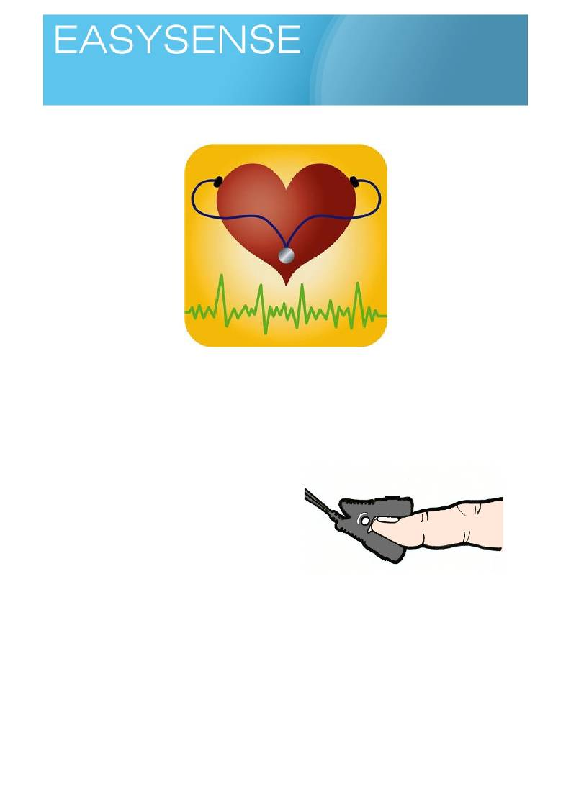
Age 8 - 10

Sensors: Temperature, Heart Rate Logging mode: Snapshot

How does exercise change us?

Learning experiences covered.
• Science activities and methods.
• Collecting data and drawing tables of data.
• Describing and comparing.
• Using time to define an activity period.
You will need.
• A s p a c e f o r e x e r c i s e , l e a p i n g ju m p i n g e t c .
• A datalogger.
o Heart rate sensor.
• Pulse oximeter (option).
• Non contact thermometer (option).
• An interactive whiteboard or a projector.
Suggested method.
Start with an introduction about exercise (activity) and how they feel or what they have seen after it, for
example getting hot, feeling tired, heart beating harder. Consider with them what it means to be the fastest or
the slowest, how many people are really fast and how many are about the same? We are building the idea
that there is spread of ability, that individuals are better in some things and worse in others. We are also
suggesting that data does not always give a direct answer but points to a probability of a solution i.e. most
people have a heart rate of 65 bts per min, but no one actually has 65 bts per min recorded.
Datalogger based activities.
• Connect the datalogger to the PC and show the software as meters, numeric .
• Use yourself to show how the sensors will be used and to reassure the children, ask one to volunteer
for test. Point out that everyone is different and everyone will give different numbers, this is normal, it
is called variation.
• Outline the exercise routine and how the test(s) are going to be completed, time is important make
sure they understand they cannot dawdle around or rush things.

1

Logging time:
Dataloggers

• For the best outcome you will need to collect data from the whole class, to collect the data you will
probably want to divide the class into groups measuring pulse, temperature or breathing. You can
then run a circus of activities.
• Ask them to record the rest values,
o Heart rate - clip onto a finger and wait 30 seconds, write down the indicated number.
• Use the datalogger to show readings from sensors on the screen, children write down numbers.
They may need you to help, the numbers may be changing around a value.
• Do the exercise, and as soon as possible repeat the measurement.
• After 5 minutes Repeat the measurements.

Non data datalogger based recordings.
You need to establish a recording protocol, this acts as a control for the data ensuring ti was all collected the
same way. Collection of data will be paper based in some way.
o Pulse oximeters - clip the sensor onto the finger and wait 30 seconds, copy the number
down
o Breathing - use a stop clock to time out 30 seconds, simply count breaths in that time and
record.
o Body temperature - non contact thermometer, point to ear or forehead and record and copy
down.
If the children work well and appear to understand the method, use the datalogger, software and heart rate
sensor to take snap readings and display them on the whiteboard.
Work on the data is about defining the difference before and after exercise, anything else is a bonus!
You could try,
• Using the numbers collected to work out differences of value.
• Recording the data on a big (flipchart sized) paper graph.
• Describe to the class what your group found out.
• Find who had the most and who had the least.

Teacher's notes.
There are several small activities under a common umbrella of keep fit.
Children will be required to measure themselves at rest (normal), measure themselves after exercise and
again after a few minutes rest. Time organisation of the class will be critical in this set of activities, if you get
backlogs while making measurements the effect of exercise will be lost - children recover quickly!
We can measure three simple markers of exercise, body temperature, breathing and pulse. Pulse is the
more difficult, the concept of recording for a time and then multiplying up for a rate per minute will not be
accessible to the majority (its not the maths, it's the why do you have to do this?). A sensor that can give a
value is a significantly better option, remember you are trying to talk about changes in physiology not give a
lesson in hard sums!

2
Logging time:
Dataloggers

This develops the same topic from earlier years when a simple more or less analysis was conducted on the
heart rate data. By this age children should now consider data as having some meaning. The activity is
driven more by the need to collect data. The activities will allow us to develop the idea of a spread or
continuum of data and individuals. This is an important social aspect of learning, we may be different, but as
humans we are never that different from our neighbours. The fastest runner is just that, the fastest runner,
they are the exception not the norm. Data from these activities should be used to show the spread of abilities and performances not just to find the best.
Sensors you can use:
• Body temperature - Fever strips (lcd strips applied to forehead), non contact thermometers, ear
thermometers.
• Breathing - none really suitable, simple count of breaths in 30 seconds.
• Heart rate / pulse - Heart rate sensor for datalogger, Pulse oximeter (clips onto finger).
Key questions.
1. Can you feel your heart beating?
2. How do you count a heart rate?
3. What is a rate?
4. What happens to you when you exercise? Does it happen to every one?
5. How can you describe what happens to you, to others?
6. Can you recognise the effects of exercise when you look at someone?

3
Age 8 - 10

Sensors: Heart Rate Logging mode: Snapshot

Pulses, what's normal
Learning experiences covered.
• Science activities and methods.
• Collecting data and drawing tables of data.
• Describing and comparing.
• Spread of values.

Sensors you can use:
• Heart rate / pulse - Heart rate sensor for datalogger,
• Pulse oximeter (clips onto finger).

You will need.
• A s p a c e f o r e x e r c i s e , l e a p i n g ju m p i n g e t c .
• A datalogger.
o Heart rate sensor.
• Pulse oximeter (option)
• Number (pulse) lines. (perhaps 2, one for Boys one for girls? Directly above each other)
• Number / data handling software.
Suggested method.
Introduce the idea of everyone being the same but different, that we think we are very different but in reality
the differences are of no consequence. If we were too different we would not be human!.
Datalogger based activities.
• Use the datalogger with a heart rate sensor to show results on a whiteboard or large screen. Have
the heart rate sensor set to beats per minute range.
• Set the software to show data in meters mode, numeric
• Use yourself to show how the heart rate sensor will be used and reassure the children. Ask one of
the children to volunteer to show how the sensor will be use don them and what we are looking for
on the graph.
• For the best outcome you will need to collect data from the whole class.
• Connected each child to the sensor and after a set time (30 seconds) make a note of the number on
the display. You may find it works best to have the person who is being monitored with their back to
the screen.
• Write down the pulse number on a number line (one for boys and one for girls) and or a class table.
• After 5 minutes Repeat the measurements.
Non datalogger activity.
1. Use a pulse oximeter to collect a normal resting heart rate. For the activity one reading should be
enough from each person. In the spirit of science we should really take several readings and create an average.
2. Note the reading down on the pulse line or in the exercise book.

1
Logging time:
Dataloggers

Using the numbers.
• Place the pulses on number line or an axis. You will need to find the highest and lowest
pulse numbers to mark the upper and lower limits of the graph.
• Divide the line into number classes, e.g. 84 -85, 86 -87, 88-89 etc.
• Stack same class numbers on top of each other.
• Use two lines, one for boys and one for girls (answers the is gender important?)
Hopefully you should produce a bell shaped diagram, with a fe outriders and a tall centre peak. This tells us
and the children that most people are the same
Extension.
You could try,
• Using the numbers collected to work out differences of value.
• Recording the data on a big (flipchart sized) paper graph.
• Describe to the class what your group found out.
• Find who had the highest and who had the slowest, who was the most average (emphasis on
normal?).
Teaching notes.
The activity is about measuring heart rates, the data is being used to teach variation and a normal value.
Most people are normal, we do however look to extremes to emulate. This is perhaps an opportunity to do a
reality check and show that it is the extreme which is unusual and not the other way around.
The resting values identified by the children can feed into the next activity which is about fitness.
With luck you will find the class has a spread of heart rates, with a bunching around a value. You may find
that if you separate the data by gender (hence the boys and girls number line) the bunched value is slightly different. You may find gender has no difference. Either outcome is good, what we are trying to show is that differences are often no more than mathematical curiosities and have no significance to us in every day life. The difference only becomes important when people use the difference to justify social positions.
How far you take this is up to your comfort and skill. Ideas like (for example) you cannot do this because you
are a girl should be challenged, we know it is not true, why perpetuate it? Most -isms come from fine points
elaborated into significance beyond truth.
Key words and phrases are Normal, usually, spread, variation, small, significant, statistical!
Some information about pulses,
1. Pulse is an indicator of fitness.
2. A low pulse usually shows a fit person.
3. A fast pulse is common in young people.
4. If you know what you are today, you can measure it tomorrow or the day after to see if it has
changed - you can see the effect of exercise and measure it. You don't have to believe you are fit
you can show it!
5. Recovery times are an indicator of fitness - the quicker your pulse gets back to normal after exercise
the fitter you are.
6. Young people have higher resting hear rates than adults, within the age group we are considering
this could be a significant factor (there could be nearly a year between the eldest and youngest in
the class, this is a 10%+ difference in age.)
Key questions.
1. What is normal?
2. Why do we need to find the normal?
3. Does it matter if you are different form normal?
4. How far from everyone else do you have to be to be different?

2
Logging time:
Dataloggers

5. Are differences really that important?

3
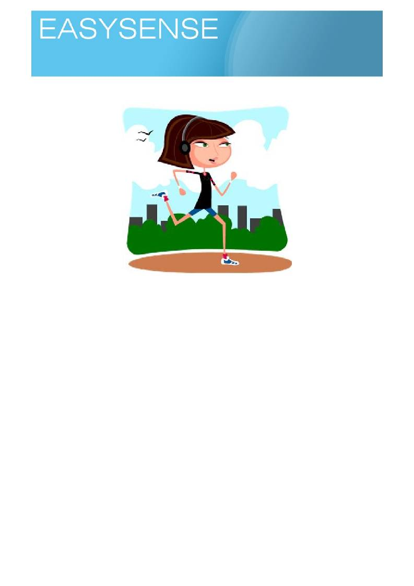
Age 8 - 10

Sensors: Heart Rate Logging mode: Snapshot

Pulses, who is fit!

Learning experiences covered.
• Science activities and methods.
• Collecting data and drawing tables of data.
• Describing and comparing.
• Using data to compare and set targets.
• How to define and measure fitness.

Sensors you can use:
• Heart rate / pulse - Heart rate sensor for logger,
• Pulse oximeter (clips onto finger).
You will need.
• A s p a c e f o r e x e r c i s e , l e a p i n g ju m p i n g e t c .
• A lo g g e r .
o Heart rate sensor.
• Pulse oximeter (option)
• An interactive whiteboard or a projector.
• Number lines. (perhaps 2, one for Boys one for girls? Directly above each other)
• Number / data handling software.

1
Logging time:
Loggers

Suggested method.
There are lots of variations on recovery rates, by all means use a method you are used to or understand.
They all work on the same basic idea.
• Exercise for a given time.
• Measure your pulse as soon as you stop.
• Wait a time and measure your pulse again.
The quicker the peak pulse value falls to the normal level the fitter you are.
A short period of activity and testing at the end of the activity and after 2 minutes will give as good results as
15 minutes of graded aerobics to thumping rock music followed by 5 minutes warm down to chill out!
Logger based activities.
• Use a datalogger with a heart rate sensor (attached to the computer linked to your interactive
whiteboard, projector or other large display)
• Software showing the product of the logger as numbers (meters mode).
• Use yourself to show how the heart rate sensors will be used and work, use yourself to demonstrate
and outline the exercise task (respect to teach!).
• You will need to divide the class up, there will be confusion!
• Ask them to record the rest values or find the value form the previous activity in their workbooks.
• Do the exercise, and as soon as possible after stopping find the heart rate. This is the exercising
heart rate. Note: If the measurement cannot be made immediately have them "jog on the spot" to
keep the active heart rate going
• After 5 minutes Repeat the measurements to find the recovery hear rate.
• You will have 3 heart rates to work with, a resting hear rate, an exercise heart rate and a recovery
heart rate.
Not using a logger.
You can complete the same activity using heart pulse oximeter. Make sure you all understand which of the
numbers on the screen is the heart rate. The activity sequence is the same and you will need the same 3
heart rate values..
What to do with the numbers collected?
Work on the data is about defining the difference before and after exercise, anything else is a bonus! The first value is the change of heart rate from exercise to recovery.
You can express the number as a;
1. Simple difference.
2. Rate of change (difference dived by time) 3. As a percentage change.
The numbers generated can be placed on graphs to show distribution or kept on a board and if you do some
class exercising everyday show the improvement over time.

Teachers notes.
The heart beats with a natural rhythm for each of us. We know that as we exercise our heart rate gets faster,
we equally know that as time passes our heart rate goes back to normal.
Over years of study, sport scientists have established that the speed of return to a normal hear rate after
exercise is a measure of fitness. A quick return to normal indicates someone who is fitter.
Exercise creates changes in the body to cope with the exercise, your heart beats faster and stronger, your
breathing becomes more effective and muscles grow to produce more power and stamina.
Many of the changes are only noticeable if you go looking for them. Same for recovery times and resting
heart rates.

2

Loggers

As part of the activity we will collect data that will let us work on;
1. Definition of an average.
2. Calculation of an average. 3. Show a spread of numbers.
Logging time:

4. Show a statistical difference. (i.e. a mathematical difference, but is it really important or just
interesting?)
Key questions.
1. How fit are you?
2. Can you see that you are getting fitter?
3. How do you know if you are fit? What do you compare it against?
4. What is so important about being fit?
5. What are the consequences of an unfit lifestyle?
6. Is fit the same as athletic?
7. How can you build in exercise to your daily life?
8. Is your health only of concern to you? Who else will be affected if you are unfit?
You could even do a mini project of getting the class to do few minutes exercise every day and watch the
changes, it shouldn't take more than a week to show difference! (even for you!). this is very powerful
message - small amounts of exercise are nearly as good as massive irregular stage managed sessions
driven by guilt!

3

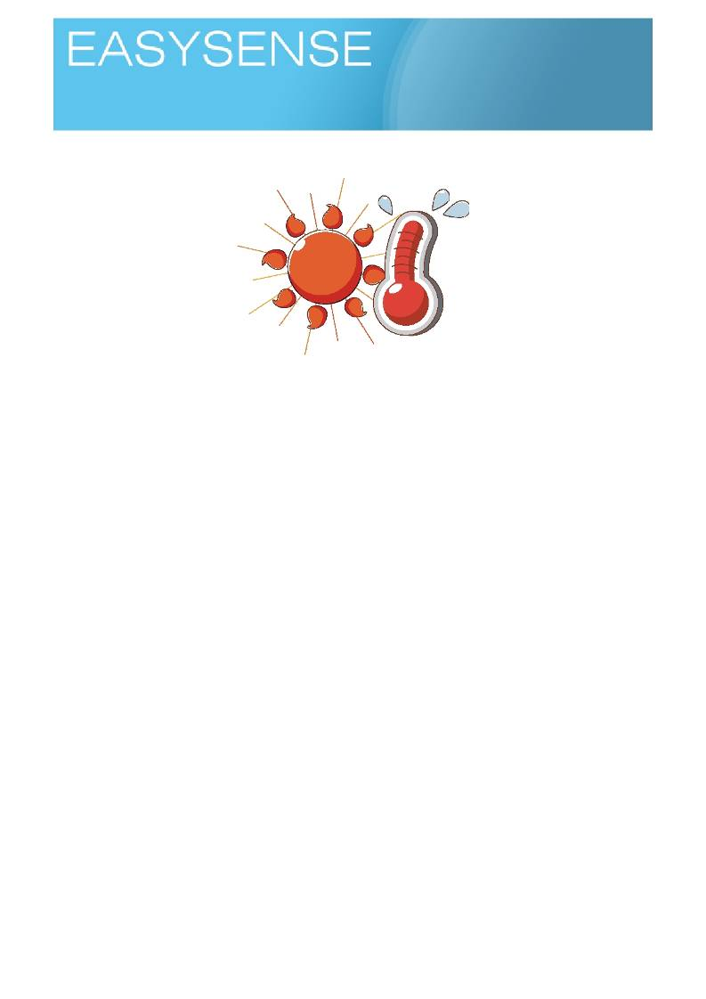
Age 8 - 10

Sensors: Temperature Logging mode: EasyLog

How does temperature change as you heat water?

Learning experiences covered.
• Line graphs
• Extrapolation of data and prediction,
• Collecting data and drawing tables of data.
• Making comparisons.
• The fair test in science.
• What happens at boiling point?
You will need.
1. A datadatalogger with an external temperature sensor (attached to the computer linked to your
interactive whiteboard, projector or other large display)
2. Software showing the product of the datalogger as a line graph. 3. A volume measure for water.
4. A pan / container for heating water (kettle, saucepan)
5. A heat source (reference local restrictions, CLEAPSS or ASE for guidance).
Suggested method.
Check the children understand a line graph, the significance of the direction of the line and the time line axis. Introduce the activity, remembering to say how the activity is going to be controlled, i.e. the same amount of
water, same starting temperature, same heating device.
1. Set up the datalogger and PC to show results on the interactive whiteboard as a line graph against
time.
2. Connect the external temperature sensor.
3. Do a quick demonstration of how the sensor works, and have a short chat about what it shows etc.
While they should be familiar at this stage with data logging software and technology it may be while since they last had any experience of it.
4. Fill the pan / kettle with a known volume of water - don't just fill it from a tap, this is science, we are
supposed to be in control of the variables!
5. Place the sensor in the water, try to get it about half way up the water, certainly don't have it
touching the bottom or the heating element (if present). You may need to use a stand and clamp or devise a lid to hold the sensor in position.

1
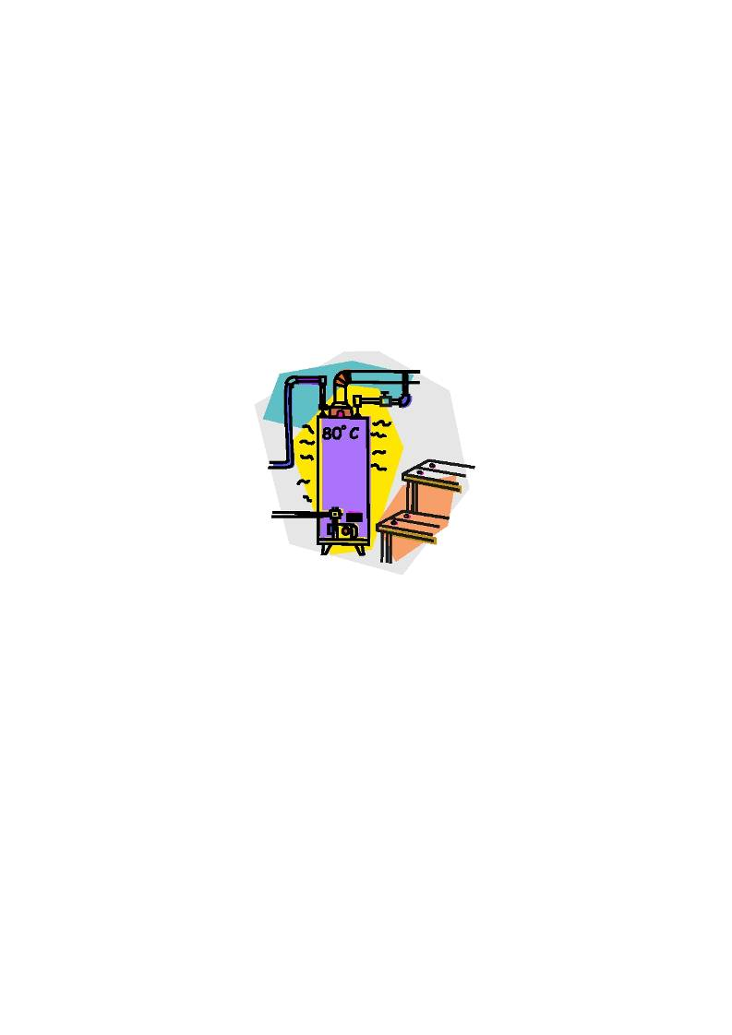
Logging time:
Dataloggers

6. Select EasyLog on the software, click go and turn the heat on to the water.
7. Monitor for as long as your lesson plan allows for. If you are using a kettle you can take it to boiling
(most kettles will boil in under 5 minutes), some interesting stuff happens at boiling point that requires explaining.
8. Stop, save the data.
9. Have a chat about what you found out!
10. Select Overlay and repeat, testing one of the questions in the introduction, or better a question from
the children. Make sure you use the same volume of cold water to make the fair test.
Things to chat about;
1. Shape of the graph - nominally it is straight line, or is it? Use straight edges to test.
2. What happens as we get close to boiling temp?
3. What would happen if we added more heat?
4. Could we use the line to predict when the water will get to boiling or a set temperature?
5. Does the volume of water matter? Or the shape of the water (flat and thing or tall and deep?).

Teaching notes.
A s im p le e n o u g h q u e s tio n , h o w e v e r , th e r e is s o m e th in g o d d g o in g o n , w h y w h e n y o u p u t w a te r o n to th e h o t
flame of a cooker hob does it take so long to warm up? Where is all that heat going? What happens if you
use lots of flames? Does it get hot any quicker if you set the heat control to maximum?
Before we can start answering the questions we need to establish a bench mark. A standard against which
we can compare.
You will need someway of heating water in controlled way. The most obvious, for most classes, is going to
be an electric kettle. You could use a travel boiler or a plug in electric hob. Small tea lights can be used but they can create a lot of smoke marks on the container with the water being heated.
Reference CLEAPSS or the ASE guidance (Be Safe!) for advice and local interpretations.
The base activity is very simple, and probably not very interesting for the audience which makes it an
excellent choice for a screen line graph drawn by a sensor and data datalogger. It can be left to one side
while you do a bit of teaching, explaining, motivating!
You place the sensor into the water, place the water over a heat source and turn the heat on. Let the
datalogger record the temperature change in the water over time.
The result should be a nice steady line going up from the bottom left of your screen to the top right.
The activity will produce data that needs explaining, this is probably the real reason for the activity to be
embedded in most teaching schemes. Walking and talking through the graph is an important skill to be learnt for the next stage in science learning.
Key Questions.
1. Is heat the same as temperature?

2

Dataloggers

2. Where does all the heat go?
3. Why do different things heat up at different rates from other things?
4. What do we control to make fair test?
5. What do you think will happen? And why?
6. What are the units for temperature?
7. How do you spell temperature?
8. What is boiling point and freezing point?
9. Are boiling points and freezing points the same for everything?
10. What is freezing, melting and boiling?
Some science background.
Logging time:

Heat and temperature are funny things, heat is the energy contained within a substance, temperature is the
flow of the heat from one object to another.
Some objects can store large amounts of energy before it shows as a temperature rise, water is one such
material. You can apply energy to it in the form of a heat source (kettle element, gas flame etc) and it will take a long time before it feels to have gained any heat. The opposite is also true, once water has gained heat it takes a long time before it loses it.
Other things heat up and show temperature much more quickly, air for example. This ability to store energy /
heat before it shows as temperature is referred to as the specific heat, the amount of heat per mass to make a 1 Celsius temperature change.
It is this capacity for water to hold onto large amounts of energy that make it potentially a danger in a
classroom, it also explains why burns treatment uses running water to reduce the damage - it can remove
the heat that is damaging the body.
When a material reaches its boiling point, the energy going in is balanced by the energy being lost by
evaporation (the steam above a boiling pan). At this point, it does not matter how much extra energy you add
you will not raise the temperature. In practical terms this means a pan of water once boiling can have the heat turned down under it and keep boiling! You don't need to have the gas burners on max all the time.
The other thing that is missed by many people is that a thermostat controls the maximum temperature
reached, not how quickly it reaches that temperature. Turning the heat up to maximum will not change the speed of heating! If you want to boil water quicker, use less water, not more heat.

3

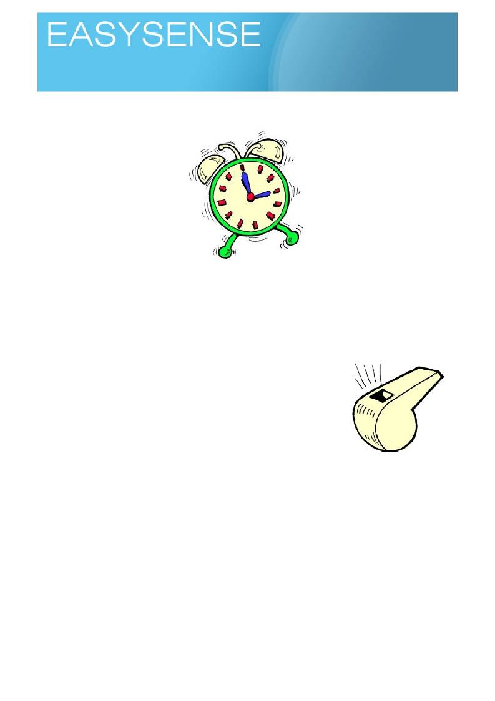
Age 8 - 10

Sensors: Sound Logging mode: Snapshot

Reducing noise

Learning experiences covered.
• Controlled experiment.
• Iterative design.
• The fair test.

What do you need.
1. A constant sound source - we need to be sure the sound is always
the same, tone and volume. An alarm clock is good.
2. A datalogger with a sound sensor (attached to the computer linked to
your interactive whiteboard, projector or other large display)
3. Software showing the product of the logger as bar charts and ble to
record the data.
4. A large tape measure (as used on sports days) or a measuring stick.
5. Assorted things that could muffle sound e.g. bubble wrap, cloth etc.
Suggested method.
We need to create a comparison, a standard to compare the other tests against. Use snapshot to capture
sounds.
You will need to create a method to indicate when to record the sound that does not require the making of a
sound or you will record the command not the noise. You can use a set time or a hand wave.
1. Place the sound maker at a marked location, you want to be able to place the sound maker in the
same place for each test. A piece of paper taped to table with the outline of the noise maker traced onto it, for example.
2. Set up the logger to collect data in snapshot mode.
3. Place the logger at a close distance, not so close you overpower the sensor, you may need a few
test runs before you get the correct distance. When you have a good distance, i.e. a distance that gives a big reading but not at maximum (so you don't know if it was louder).
4. Once everything is set up, set the sound maker to make its noise. Snap the sound on the logger to
record it.
5. Move the logger to a known new distance further away, check the sound maker is ready to go e.g. if
it is an alarm clock wound up.

1
Logging time:
Loggers

6. Repeat the recording.
7. Move the logger again. Record over about 5 distances. Try to make the distances moved equal
e.g.0.5m every test.

Look at the results,
1. What is happening as the distance from the sound source to the sensor increases?
2. Is the change linear? What rule does it follow?
3. Can you work out how far away you have to be before the sensor can't hear the sound.

Extension.
• Does it matter what the sound is?
• Does it matter if you are inside or outside?

Teacher's notes
On occasions, science and reality can combine to make us think nonsense. Even worse, when we make
efforts to correct the nonsense and explain why to others, they think we are being pedantic or nerdy!
For example, When you stand under a street light at night, it is bright. If you walk away from it and look back
at 20 metres, 50metres or 100 metres is it still as bright? Of course it is! Our perception of its brightness has
changed but the street light is still as bright - see what is meant by pedantic! Of course what we mean to say
is the street light looks less bright as we move away from it.
In this exercise we are going to make sound, then we are going to move away from the sound and see what
happens See why we need to consider what we say? In this activity we hear less but the noise remains the
same, or does it?
We are also learning something about sound as a physical phenomena.
The activity starts with a simple measurement of sound and then moves on to test what happens when we
move away from the source of the sound or try to lessen it.
Key Questions.
1. Why does sound seem quieter as you move away from it?
2. Does the type of sound make difference?
3. Do we hear all sounds the same?
4. Does all muffling block all sounds the same way?
5. How would you know the sound has not changed, but the way you hear it has?
6. How would you describe a sound to someone else?
7. How would describe how loud a sound is to someone else?
8. What is the difference between a sound and a noise?
9. Do things always change with a simple relationship e.g. double distance half the sound?
Science background.
All waves radiate from a point source. We see this when we drop a pebble into water, the ripples move away
from the point where the pebble hit the water as circles that get bigger as they get further away.
The mathematics of circles and spheres tell us that as you double the radius you quadruple the area or
volume or surface area of the sphere. A simple plot of distance against volume does not give a straight line
but a curve.
This seemingly uneven change of area or volume with distance is often referred to as the inverse square
law.
More simply, as you move from a point source of energy the drop in energy measured is four fold for every
doubling of distance.

2
Logging time:
Loggers

The application of this is that you may have to only move a short extra distance to make it safe or to lose
contact with the energy source. Standing by a phone mast could be dangerous, standing only a few metres away is safe. It is counter intuitive that small distance will give big changes but they do.
Sound is an energy source, moving away from a sound source will show this same doubling of distance,
quartering of volume.

3
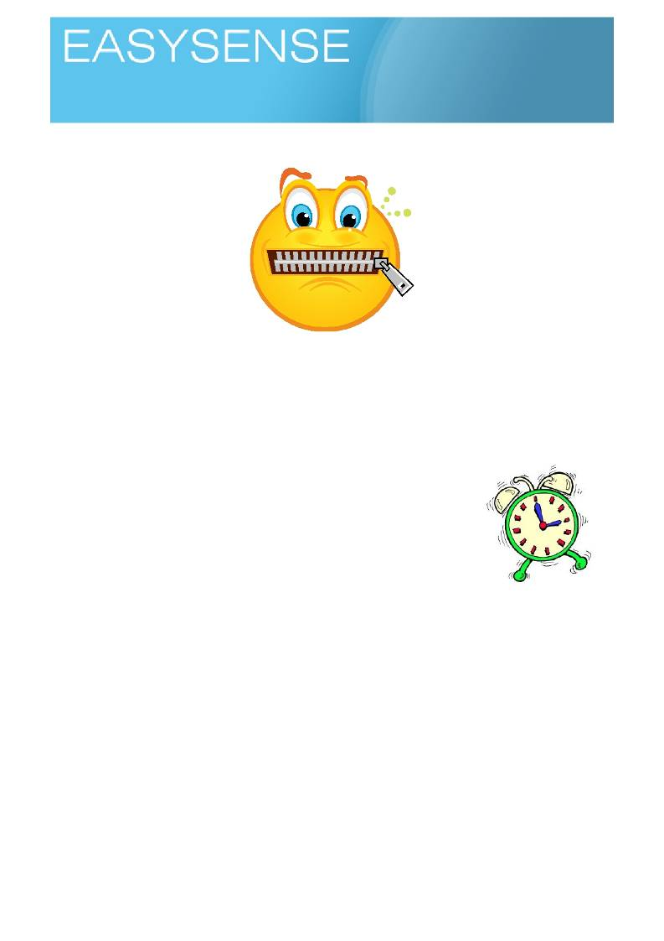
Age 8 - 10

Sensors: Sound Logging mode: Snapshot

Reducing noise

Learning skills.
• Controlled experiment.
• Iterative design.
• The fair test.
In a previous activity we looked at how we detect sound as the distance between us and the sound source
changes. In this activity we look at how we can muffle the sound source, to mimic the effect of being a long way from the sound or simply to reduce it so it does not annoy us.
What do you need.
1. A constant sound source - we need to be sure the sound is always the
same, tone and volume. An alarm clock is good.
2. A datalogger with a sound sensor (attached to the computer linked to your
interactive whiteboard, projector or other large display)
3. Software showing the product of the logger as bars or numbers.
4. Assorted things that could muffle sound e.g. bubble wrap, cloth etc.
Suggested method.
The first thing we need to do is create a comparison, a standard to compare the other tests against. Use
snapshot to capture sounds.
You will need to create a method to say when to record the sound that does not require the making of a
sound or you will record the command not the noise. You can use a set time or a hand wave.
1. Place the sound maker at a marked location, you want to be able to place the sound maker in the
same place for each test.
2. Set up the logger to collect data in snapshot mode.
3. Place the logger at a close distance, not so close you overpower the sensor, you may need a few
test runs before you get the correct distance. Mark where you placed the logger. You don't want the change in distance between the logger and source to upset your work.
4. Once everything is set up, set the sound maker to make its noise, Snap the sound on the logger to
record it.
5. Design a muffle for the sound maker, place it over it, and test for how much the sound has reduced. 6. Repeat for a set of muffles made differently or using different materials.

1
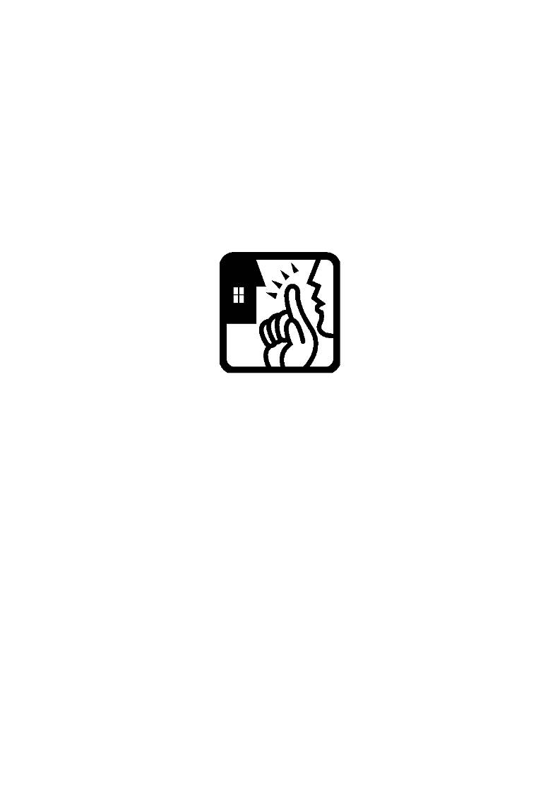
Logging time:
Loggers

Look at the results,
1. How much did the sound decrease with each muffle?
• What is the difference between muffled and non muffled sound?
• What is the percentage it has decreases by?
2. Give a cost for the materials, which muffle was the best for the money?
3. What about the space needed to muffle the sound maker? Which would work best if you only had a
small space?

Extension.
• Calculate the sound reduction as percentage.
• Calculate the sound muffle as noise lost per cm of material.

2
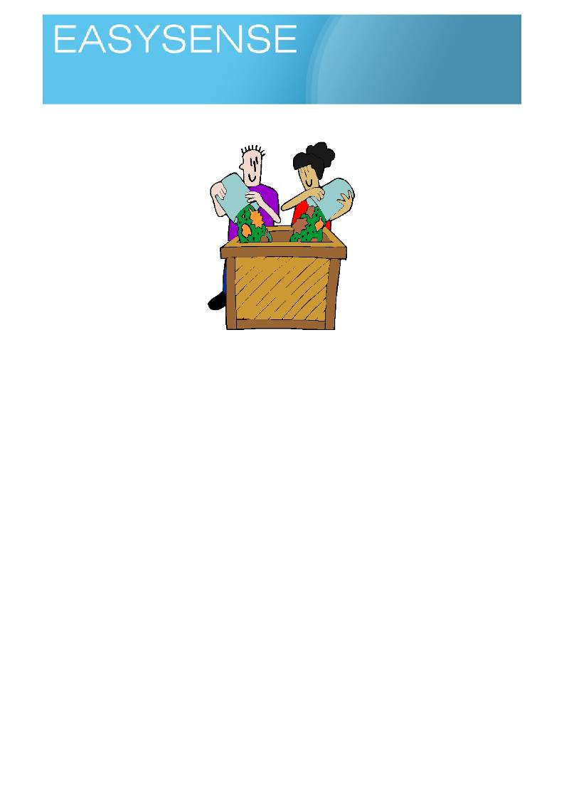
Age 9 - 11

Sensors: Temperature Logging mode: Easylog or Snapshot

Decay

Learning outcomes.
• Study using the scientific method.
• The fair test.
• Respiration.
• Observation.
You will need.
• A datalogger with two external temperature sensors
1. Software showing the product of the logger as a line graph
2. A compost heap, a waste bin should be big enough. Don't use grass cuttings - it will go slimy and
nasty! Use mixed materials and mix in a bit of brown (mud) [1 part of brown to 5 parts of green, check with a gardening site].
3. Papers or similar to insulate the compost heap.

Suggested method.
You can either continually monitor the heap over a period of days or go out and take a snapshot reading
each day for several days. If you snapshot you will need to mark the data down onto a chart or large graph as the data is collected, which can be useful exercise in its own right.
1. Set up the compost heap. Make a note of how far up the container the compost comes.
2. Use the temperature sensors to record the temperature in the heap and the temperature in the air
outside the heap.
3. Leave the datalogger and compost for 5 - 7 days. If the compost is outside make sure the datalogger
is protected from rain and dampness.
4. Collect the datalogger and retrieve the data into the software as a line graph.
Look at the results.
You should notice that the temperature shows an increase over time, it may take a few days to get going.
What is the difference between the outside sensor and the compost sensor? Is it constant?

1
Logging time:
Dataloggers

Questions
• What is making the heat?
• What will the heat do to the compost?
• Why does the compost heap change size?
Teaching notes.
All living things respire, this is so fundamental that when we looked for life on Mars we looked for signs of
respiration.
Respiration is the process by which an energy source (food) is made to release the energy by a chemical
reaction (combining oxygen with carbon to make carbon dioxide). The process is quite efficient but it still
produces more energy than can be used, the excess energy is lost as heat.
We can measure respiration by looking for carbon dioxide increases or by looking for heat increases. In this
activity we will look for changes in heat, it is simple and easy to do.
About compost heaps.
The activity requires us to make a mini compost heap, as organisms breakdown the compost to get energy
for their own use, heat is produced. Composting is science, and can be controlled. The small heap we are testing will be less controlled and can produces things we would prefer to not touch, so make sure that you
can dispose of the compost with minimal contact. It can also make a robust smell! (although, if does it
suggests something has gone wrong) Don't seal it off from the air to stop smells or perceptions of smells, bugs grown in oxygen poor air are especially nasty. You need good air circulation for good compost.
Small compost heaps are notorious for getting going. You will need to think bigger than you first believe.
The heat generated can be very high, large heaps can be seen "smoking" on cold damp days and very large
heaps have been known to start burning. A wastepaper bin heap will not reach this intensity.
Providing you choose your green materials with care, there should be no danger from the composting heap.
Do not include and animal waste (flesh, fat, bones) or wet green (grass clippings for example) materials. A
gardeners recipe is 2 green one brown, i.e. two measures of plant materials to one of soil. The soil provides
the bugs to get the process started. Do not be tempted to use sterile soil in an effort to control perceived
nasty bugs and smells, sterile means without life, it won't work! Hundreds of thousands of people use
compost heaps and compost, it is not the most dangerous thing you will meet! Don't confuse a smell with
nasty!
The decay that is taking place is using the green matter as food source, the heat produced is the waste
energy released from the food.
Composting allows decay organisms such as fungi to thrive and break down the green plant materials. The
stuff that is left is decay resistant material, when added back to the soil it adds "structure" to the soil (spaces
for air in the soil) and nutrients to the soil. The leaf layer on the floor of a deciduous woodland is really a very large flat compost heap, returning nutrients back to the soil. Composting takes on a mystical value for many people who see the cycling of nature back to itself as something special.
Check with ASE and CLEAPSS guidance for details, although much of their guidance refers to garden
compost heaps. You may wish to test you garden heap, if you do please make sure the datalogger is well protected.
Key questions.
1. What identifies something as alive?
2. Can we measure the presence of life?
3. Can you measure something indirectly?
4. Heat is a form of energy, changes in heat indicate changes in energy.
5. What gas is being used in respiration? And what gas is being produced?
6. Why is compost good for the garden?
7. Why do we need two temperature sensors?
Respiration - release of energy in a living organism.
Digestion - the break down of large pieces of food into smaller particles and eventually molecules.

2
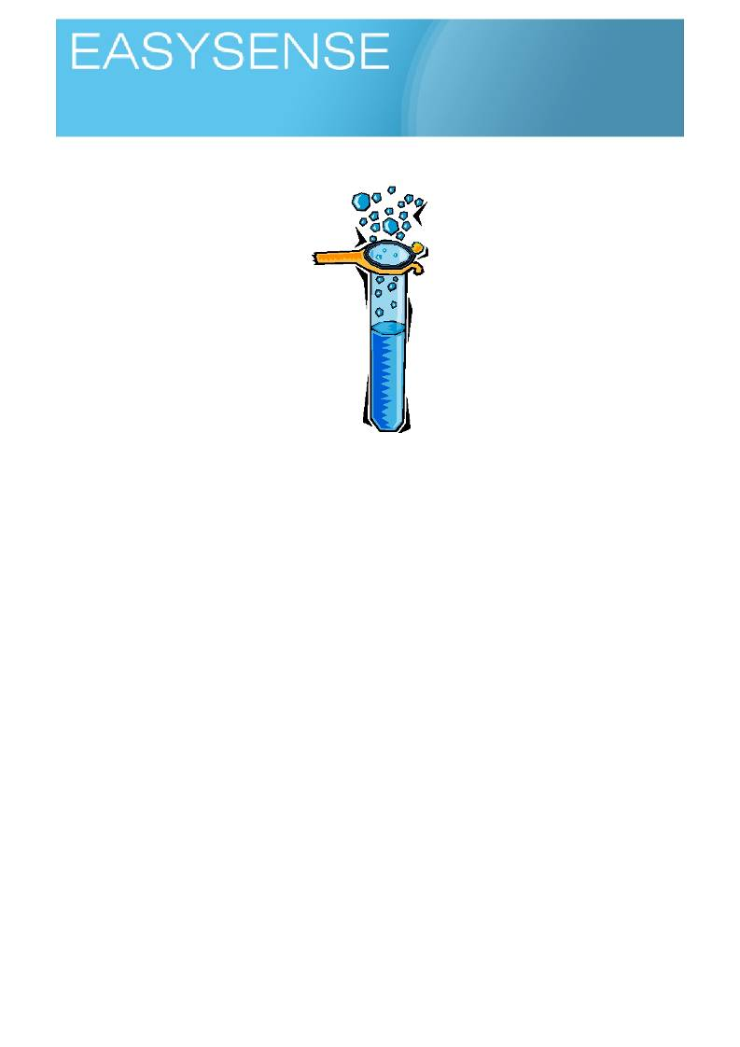
Age 9 - 11

Sensors: Temperature Logging mode: Easylog

Reactions

Learning outcomes.
• Scientific method.
• Observation.
• Pattern making.
• The fair test.
• Observation.
You will need.
1. A datalogger with an external temperature sensor (attached to the computer linked to your
interactive whiteboard, projector or other large display)
2. Software showing the product of the logger as a line graph.
3. Some vessels to do the reactions in. Glass ware is best as you can see what is happening.
4. Some common household acids e.g. Cream of tartare, citric acid (lemon juice), acetic acid (as
vinegar)
5. Some common non acids - bases e.g. baking powder (contains bicarbonate), bicarbonate of soda,
marble chips, chalk dust.
6. A deep tray to contain spills and drips.
Safety note
Use the advice from CLEAPPS and ASE for suitable chemicals and local rules (these may be much harsher
than national guidelines). There are many chemical you can use that are no more risky than the food based
chemicals suggested. You should always be cautious with chemicals, even domestic products - many things
you can buy in the local shop are more risky than the laboratory chemicals! If in doubt seek assistance, and try before use in the class, get the measure of the activity.
Glassware can also produce local problems. Glass is universally seen as a danger, but it is a material that
varies greatly with manufacture and potential use. Jam jars are not good, the glass is far too brittle and prone
to produce sharp shards as are drinking glasses. Pyrex glass is much more robust but when it does break
can make sharp shards. Toughened glass is best, if it breaks it produces a mass of small pieces with
relatively blunt shards. You can get toughened glass drinking glasses quite cheap, these could be useful or even invest in a few pieces of laboratory glass ware - it is not as expensive as you think and is designed for this type of work.

1
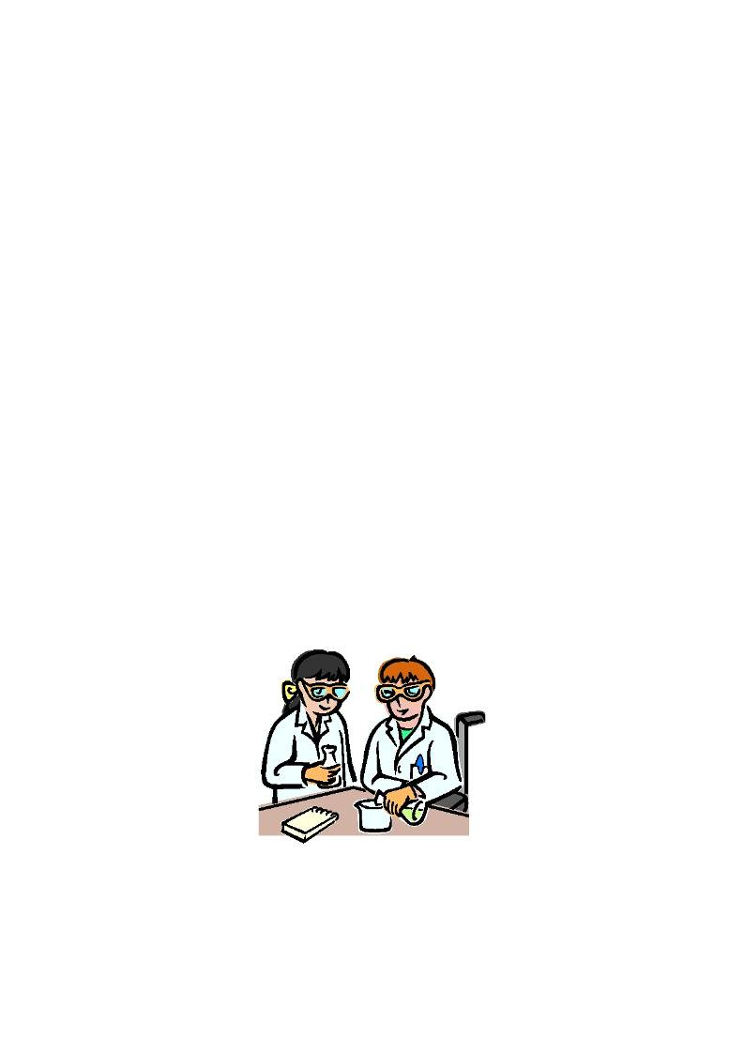
Logging time:
Loggers

Suggested method.
We want to do a few activities that produce lots of fizz and froth - this is a good sign of a reaction, good for
observation. And then, move onto a reaction that looks as if is just sitting there but really working.
The work is best as a PC and whiteboard demonstration so the students can see the reaction and the graph
forming at the same time
Start with a simple Acid + Baking powder reaction. The baking powder is mixture of starch flours and
bicarbonate and is more controlled, the bicarbonate has been diluted amongst the flour.
1. Make up about 300 ml of water and acid (lemon juice or cream of tartar). Start with about teaspoon
of the acid to the water.
2. Place the temperature sensor in the acid water mixture.
3. Have about a teaspoon of the baking powder ready.
4. Start the logger data collection going and after a few moments add the powder, be prepared for the
mixture frothing over the container (use a deep tray to contain any spills, it is so messy to clean up!)
Hint baking powder tends to produce a more robust froth as the flour holds the froth together,
bicarbonate can appear more reactive but is often more controlled after the initial fizz)
5. Look at the graph line, stop the recording when the temperature stops changing. You may need to
use Autoscale to see the temperature change.
6. Ask the children to talk about their observations of the reaction. Check how many saw some of the
things noticed, a slight change in position can observe different things.
7. Talk through the graph and indicate key points on the graph i.e. the period before starting the
reaction, the period of the reaction etc.
Repeat the basic experiment with other acid base combinations, noting the amount of fizz (a measure of the
reaction speed).
You should notice that there is always a change in temperature taking place. This change in temperature is
sign that energy is moving around and a reaction is taking place

Questions
• What is making the heat?
• If you mix two solutions together and you see a temperature change taking place what is happening?

Teachers notes.
When materials combine, there will be a reaction. Often the reaction will be very slow or slight and produce
no real signs - like rusting iron. Other times the reaction will be very quick and produce massive signs of taking place (mints in cola!).
Very often reactions will take place with no visible sign of anything taking place. How do we know anything is
happening if we can't see anything?

2

Loggers

Key questions.
1. How do you know that chemicals are reacting together?
2. What is a chemical?
3. What is heat or temperature?
4. What would be the signs of a reaction?
Logging time:

Reactions involve the making and breaking of bonds. The making and breaking of bonds between atoms
releases or uses energy. Energy changes (heat changes) are therefore an indicator of a reaction taking place.
There are many reactions taking place around us every day. A reaction is when one or more substances join
together to form a new substance. Not the same as mixing (in theory you can separate the parts of a mixture
apart again) or dissolving (sugar in tea is not a reaction!).
• A g a s fla m e is a r e a c tio n b e tw e e n th e g a s a n d o x y g e n .
• The change in colour of food when it is cooked is a reaction.
• Using soap to remove dirt and grease is a reaction.
• Using bleach to get rid of stains.
Ask the students to identify reactions.
The use of laboratory glass ware and pure reagents is about controlling the variables in the work. While it is
recommended to use commercial product such as baking powders and lemon juices, the problem is that the natural provenance can give false security from familiarity. They are also more variable than stock chemicals from a supplier.
Social context of science
There is an opportunity to help with language in this work, the word chemical has many anti social
connections. You hear people talking about food that is chemical free, or chemical free cosmetics. In the
strictest sense everything we are made of, and everything we see around us is chemical. There is no
difference between salt mined from underground, made by a reaction or harvested from the sea, salt is
sodium chloride and it does not matter where it comes from it will be the same!
The use of chemical should be confirmed as a value and emotion free word. Expressions such as "chemical
free" should be avoided as should statements like "we are not using chemicals, only something from the kitchen cupboard".
While we don't want to frighten the student explorer or the adult teacher away from experimentation, you do
need to be careful when thinking about what you are going to do. There needs to be reassurance that what
you are doing is safe, exciting and will teach something but we don't want to create an impression it is safe to
randomly mix anything together and see what happens! There is a truism in science that says you only do the experiment to confirm what you already know and understand. In other words you do not experiment, you test and prove.

3

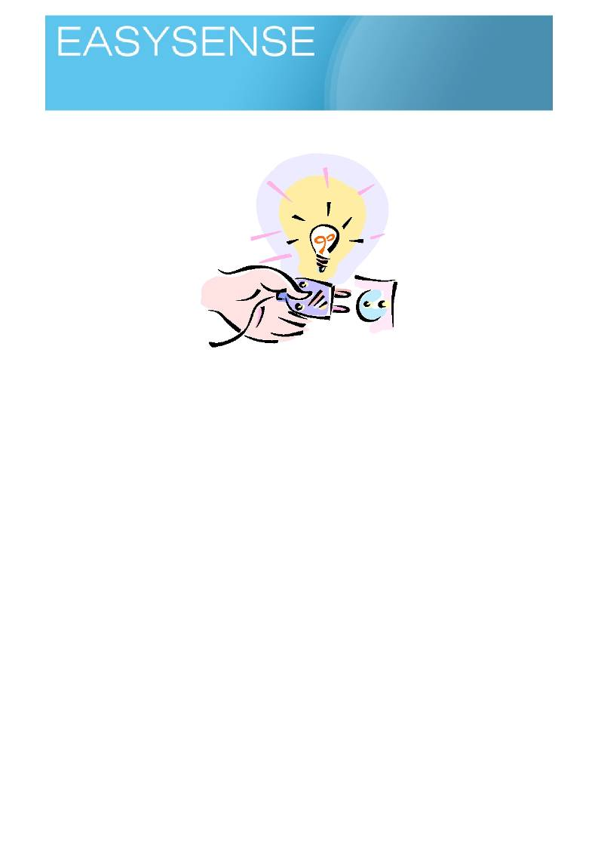
Age 9 - 11

Sensors: Light Logging mode: Snapshot

Long wires less light?

Learning outcomes.
• Scientific method.
• Use of Voltage.
• Use of Power.
• Use of Work.
You will need.
1. Logger with the light sensor on 1000lx range connected to a PC and whiteboard to show results.
2. A light bulb, holder and a power supply (batteries, plug in battery adapter - no more than 4.5 volts
should be necessary).
Make sure the bulb voltage and power supply are matched, the size of the bulb is not an indicator of
voltage needed, you will have peer at the writing on the side of the lamp.
3. Some long pieces of wire, 0.5m, 1.5m and 4.5m long. Cheap single strand wire is best, good wires
conduct electricity far too well for the work!
4. An expanding tape measure (to measure the wire lengths)
You will need to be able to add the lengths of wire into the circuit and twist or connect ends together.
Suggested method.
The difference in light is small, you will want to place the logger and lamp in dark place. Somewhere where
the light will be constant. Placing the apparatus in box is good, but it has the disadvantage of hiding the experiment from the students.

1
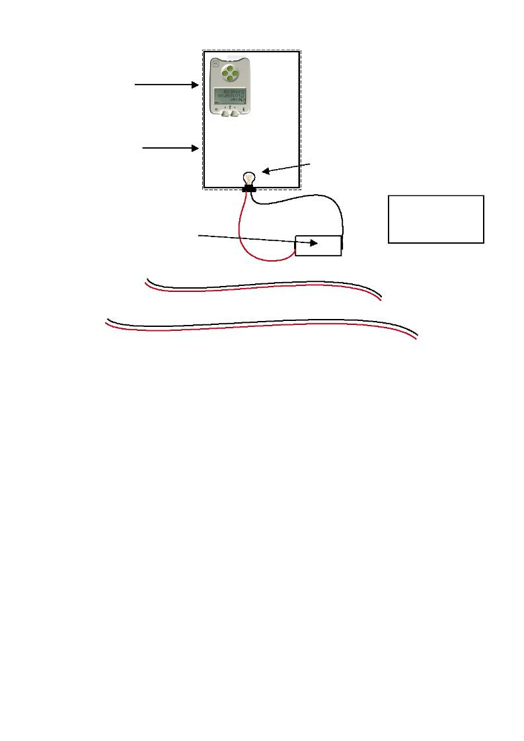
Logging time:
Loggers

Logger.

Box with light proof lid.

Torch bulb holder 4.5 or 6 volt.

A

A = Short wires
B = M e d iu m w ir e s
C = Long wires

Power supply 4.5 v

B

C

Using a box for the activity.
Note the logger and lamp need to be fixed in position so the distance does not change - this could give a
bigger change in light than the wires!
1. Set the experiment up and explain what we are trying to show.
2. Using a white board and projector, connect the logger to the PC and start the software and select
Snapshot. Have the shortest wires connected.
3. Use the starting of the software as a way of testing the brightness of the lamp and adjusting the
position of the lamp to logger.
4. When you are ready, take a snapshot of the brightness.
5. Turn off the power to the lamp, change the short wires for medium wires. Connect power and take
the brightness reading. Don't be surprised if the bars look the same, the difference in brightness can
be very small.
6. Repeat with the longest wires.
7. Measure the length of the wires used and add this information to the table of results.
8. Use Autoscale to adjust the y axis and show the difference. Expect about 10 to 20 lx difference
between the shortest and longest wires.
Point out to the students how small the difference is and how you would not have seen this difference
without using the logger and sensor.
Use a straight edge to show that the change in brightness is linear, linked data and that a pattern to describe
the change can be seen.
Describe and show how with maths we can predict how long the wires would have to be to give no light.
Take advantage to give a bit of safety chat about using;
• The correct extension.
• Not extending extensions by linking them together.
• Not hiding extensions under carpets (they can get hot).

2

Logging time:
Loggers

• Not overloading the extensions by having lots of things connected.
• If the plug or extension feels warm it is being overloaded and you should turn everything off and then
decide what to take off the extension.
• Just because you can does not mean it is correct or safe!
Teachers notes.
You may use extension leads in your room or in your house to get electric power to appliances that cannot
be next to an electric socket. If you were good and read the instructions on the pack when you first opened
the extension lead you may have seen instructions saying "unwind fully" "do not make the extension too
long". Perhaps you followed the instructions, most likely you did not read them, and if you did, you ignored them as you can't see the reason why you should follow them, after all an extension lead neatly coiled up
makes the room tidier!
There is always resistance in a wire, for some metals the resistance is very low. Copper is used in electrical
wires as a balance between cost and low resistance, but even copper has resistance. The resistance is seen
as an increase in temperature in the wire and a loss of power to what is connected. If the power is less, we
get less work. With a bulb you should see a reduction in light as the wires get longer.
In this investigation you model the effect of using a very long extension cord by seeing how the light
produced by a low voltage light bulb is affected as the cable length gets longer.
It is a good use of a logger, to show differences that we are unable to see or quantify by sight. Light can be
troublesome for us, we adapt far too well to low and bright light - it all seems the same to us!
Key questions.
1. What is power?
2. What is voltage?
3. How does voltage affect the brightness of a bulb?
4. Can you see changes in brightness very well with your eyes?
5. How can I show that bulb's brightness has changed if the person is not in the same room as me?
Science background.
Electricity creates problems for learners, in an attempt to simplify learning we are often open to not telling the
real story, if we get it wrong we stand a chance of undermining confidence at later stages.
• Voltage = the quantity of electricity or energy available.
• Current = the flow of electrical charge (electricity) between tow points.
• Resistance = the ability of something to slow the current.
Power and work are more problematic. They are measures of the rate of energy use and have different
meanings to the everyday use of power and work.
• Work is the energy required to move an object a distance,
• Power is the rate at which work is done.
It does make sense, but needs bit of thinking! A motor for example shows work by rotating, the motor has
moved a mass a distance. The speed at which the motor can turn is the power, it is how fast the work can be
done.
Work is measured in joules (the same as the energy content of food).
Power is measured in Watts. A light bulb is measured in watts as it is a measure of how fast electricity can
be changed to light and heat.
In our investigation, the drop in lamp brightness is due to some of the energy in the electricity being
converted to heat by the resistance of the wires.
You can show the conversion of energy to work using a hand powered generator such as a Genecon and a
set of lamps. Switching extra lamps into the circuit make the user feel the extra work need to keep the lamps lit.

3
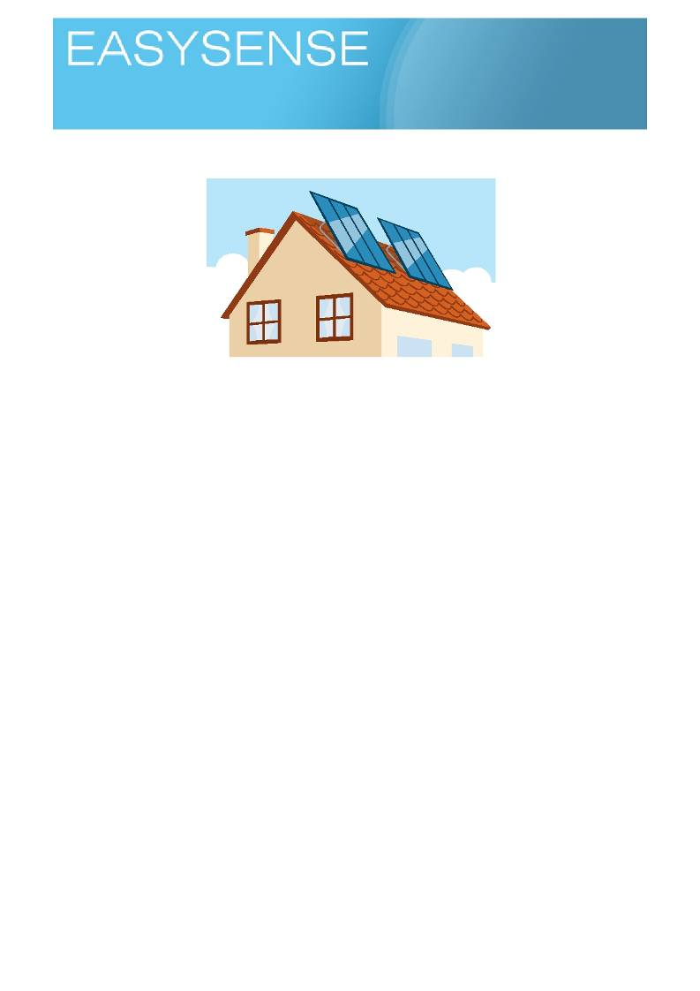
Age 9 - 11

Sensors: Light, voltage Logging mode: Snapshot

Solar cells?

Learning outcomes.
• Scientific method.
You will need.
1. Logger with;
a. light sensor on 1000lx range.
b. voltage sensor 0 - 3 volts
2. A source of bright light, place of darkness.
3. Pieces of opaque and translucent cloth and plastic.
4. A photovoltaic cell with a small resistance to act as load for the panel, typically 100 Ohm.
Suggested method.
The difference in voltages produced is small. Most cells produce 0.5 V per cell. Check the details of any cells
or panels you purchase or decide to use.
There are several linked investigations that can be undertaken.
How does the amount of light change the voltage from the cell?
You will need easy access to very bright light. Sunlight or a good desklamp.
• The cell you use will have the +ve and -ve terminals indicated on it.
• Use the crocodile clips on the voltage sensor to make connections to the cell. Connect the red lead
to the +ve terminal and the black to the -ve terminal.
• Use meters on the logger and see what the voltage is like in bright light ( a sunny window ledge) and
low light.
Note you may need to provide a lightproof box if you are working in sunny window space.

What happens when we vary the light striking the cell?
Connect the solar cell to the voltmeter, check the polarity is correct.
• Use meters to find the cell's voltage.
• Place the cell in bright light to get the maximum voltage reading for the cell.
• Use a piece of light proof material or your hand and slowly cover and shade the cell to see how the
voltage changes.

1
Logging time:
Loggers

You could use the light sensor on a logger as well to measure the light at the same time. Plot the voltage against light to see how light intensity changes the voltage produced.
Note you may find it easier or graphing to try to measure light at pre-determined voltages.

What happens to voltage if the angle of the light striking the cell changes?
You may have noticed that photovoltaic cells are always angled when placed on houses, why?
1. Connect the cell to the voltage sensor and use meters to record voltages. 2. Place the cell flat on a window ledge and see what the voltage is.
3. Hold the cell at 45 degrees facing the light and measure the voltage.
4. Hold the cell at 90 degrees facing the light and measure the voltage.
Note: You may need to move the cell slightly into the shade, the small cells you are using are quite sensitive
to light and may give a maximum reading whatever angle you use.

What colour of light is the cell using to make the electricity?
The cells often look blue, this would suggest the cell is not using blue light - why can we say this? What happens to the voltage the cell produces if you place filters of different colour over the cell?
• Set up the cell and voltage sensor to get the best voltage on meters.
• Select a set of coloured filters that look the same transparency.
• Place the coloured filters one at a time over the cell to find out how much voltage is produced.
• What other materials will change the amount of electricity being made? Does the glass of the
window have an effect?

At the end of your investigations suggest:-
1. Where would you place a photovoltaic cell on a house?
2. What angle would be best?
3. Does it matter if the cell is shaded? If so does it matter what is making the shade?

Extension and stretch.
1. The cell you are using probably only gives you 1.5 volts. How do you increase the voltage it gives -
the answer is not more light!
2. How would you place the cells to give more power?
3. Can you wire an LED to your cell and make it light up? What colour LEDs can you light up?
4. Log the voltage produced by your cell over a day or longer. What happens to the voltage with time?
5. What if you measure light and voltage? Do you reach a point where no matter how much light you
have you cannot produce more voltage?

Teachers notes.
In the near future, energy in its current form is going to become a rarer resource. The earth receives massive
quantities of energy form the sun. You can feel the suns energy on a sunny day and feel how the energy is being redistributed round the world in wind and waves. Or problem is not really lack of energy but, a lack of type of energy and how we use energy.
Solar cells are more correctly called photovoltaic cells.
Photovoltaic cells are inherently fascinating. You appear to get something for nothing, almost free electricity
and yet they create great deal of controversy about how good they are or even if they are worth the effort.

2
Logging time:
Loggers

This set of exercises make a nice research project for students and will lead to a better understanding of the basics of how a solar cells works.
You need a load between the terminals of the cell to get the best results and make the cell work correctly.
The load is simply something that will use electricity in some way. The easiest load to fit is a small resistor, about 100 Ohms seems ideal.
Cells do not use all of the light that strikes them, the clue is in the colour of the cell. In the same way that we
know that leaves do not use green light because they look green, we get a clue that solar cells do to use blue light as they look blue. You may be surprised at how little of the light available they do use.
In this work small changes in voltage are significant, many experiments that have been done before this will
have produce big differences. This may create a confusion for some, it can also mean on subsequent work
that they regard small differences as very important when they are not.
There are lots of places that sell small solar cells. Beware of cheap units that have a plastic dimple lens
effect on them. These are often waste segments that have been fitted together to make highly inefficient but
cheap units. Also avoid units already made into small power replacements or chargers for batteries, these have been wired up to give higher voltages than the sensor can use.

3
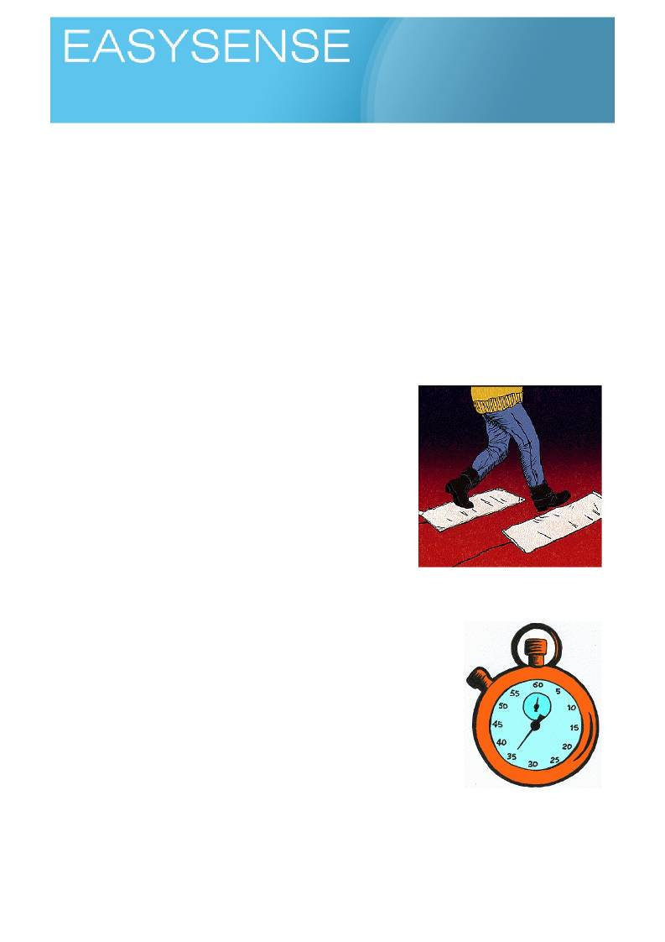
Age 4 - 6

Sensors: Push Switches or Timing Mats Logging mode: Time A to B

Hops and Jumps
A fun activity to introduce timing to children.
The activity uses people power for timing in place of small cars or carts. The process is the same, you start a
clock at one place, A (here) and you stop it at another place, B (over there).
We are not necessarily looking at this as an activity to teach about speed and timing, but an activity to get
the children used to the idea of timing, and how we do it.
Emphasis should be on;
• The idea of a start and finish point.
• The idea of something taking a time to get from here to there.
• The idea of calling here A and there B (abstraction of place, numbers etc. is not very good with this
age group.).
You will need.
A s p a c e f o r l e a p i n g , ju m p i n g , s t e p p i n g h o p p i n g e t c .

1. A datalogger attached to the computer linked to your
interactive whiteboard, projector or other large display.
2. Pair of timing mats.
3. Software in timing mode, time form A to B.
You will need some way of fixing the timing mats to the floor to stop
them moving around. Decorators masking tape is usually enough. You may have finishes to floors that require other methods.
Suggested method.
We are trying to get children to understand the process of starting a
timing clock and stopping it. Then showing the time on screen as a bar, whose size represents the passing of time.

1. Place the timing mats on the floor about a steps distance apart, so you
step off one mat and onto the other. Overlap them slightly if possible (side by side, not on top of each other).
2. Connect the datalogger to the mats, make sure it is understood which
mat is A and which mat is B and why. Perhaps put an A or B sticker on the mats.
3. Ask one student to walk across the mats to check the spacing is
correct - it is important that the children feel ownership of the activity,
involving them in helping the setup is good for this. Adjust the distance
between the mats if necessary.
4. Start the software and do one more check, collecting data on the
screen. Take a few minutes to describe what is being shown and what it means.
5. Clear the data and start the activity proper.
6. Have one student walk forwards step on mat A and then mat B (one foot on each mat). Check the
bar has appeared on screen. If time allows add name to data table.

1

Dataloggers

7. Repeat for as many children as time permits or seems reasonable for the class.
Spend time going through the data, encourage the children to explain what it means.

Repeat the activity, asking children to hop from one map to another.
Does this make any difference to times? Any explanation why?
You should be looking for statements about moving faster, quicker. Speedy comments!

Once you have the basic method in place you can try,
Logging time:

• Jumping from one mat to another.
• Having more space between the mats so you have to take many steps.
The key is to engage the children in the timing activity, to get them to understand how timing takes place.

Follow up activities,
• What is the fastest and slowest animal?
• Get pictures, say where you found out the information.
• Collect some information and pictures about fast cars, fast runners.
Teaching notes.
Timing mats and timing can create problems for many users.
Most problems come down to the mats being connected to the wrong ports on the datalogger. Do check the
connections.
The other problem can come from the start not being triggered by too light a contact, this will show as a no
result. Simply repeat and make sure a good stamp is used.
If the apparatus and the work is not done frequently it is easy to forget the detail. Rather than become
flustered in front of the class, practice before the lesson and make up some key notes, reminder cards to
help guide you along. Also, involve the class in sorting out difficulties, they will appreciate being asked and it may give a chance for someone unknown to shine.
The data from timing can be shown as the time from A to B or the speed from A to B.
• Time from A to B - the column heights get shorter as the speed between A and B gets quicker. Long
columns are slow journeys, short columns are fast journeys. This may create a conflict, which is
good, as experience may have told them that big columns = more, this at first works the wrong way
round. Good for practice at looking and understanding data.
• Speed from A to B - the column heights get longer as the journey gets faster. The speed is
measured as metres covered in each second. As you get quicker you can cover more meters in a
second so the column gets bigger.
If you have time, measure out a distance on the floor and say you need to cover that distance in 10 seconds,
then increase the distance and say you need to cover that distance in the same time. The idea of having to go faster starts to become more real.
If you have the lines drawn out, turn it round and say if a car driver was moving at this speed in 1 second he
would have covered this distance - it might make some of them realise how little time a driver has to stop.
If you double the number of metres per second you get a very close approximation to speed in MPH, i.e. 15
m/s is 30 MPH.

2

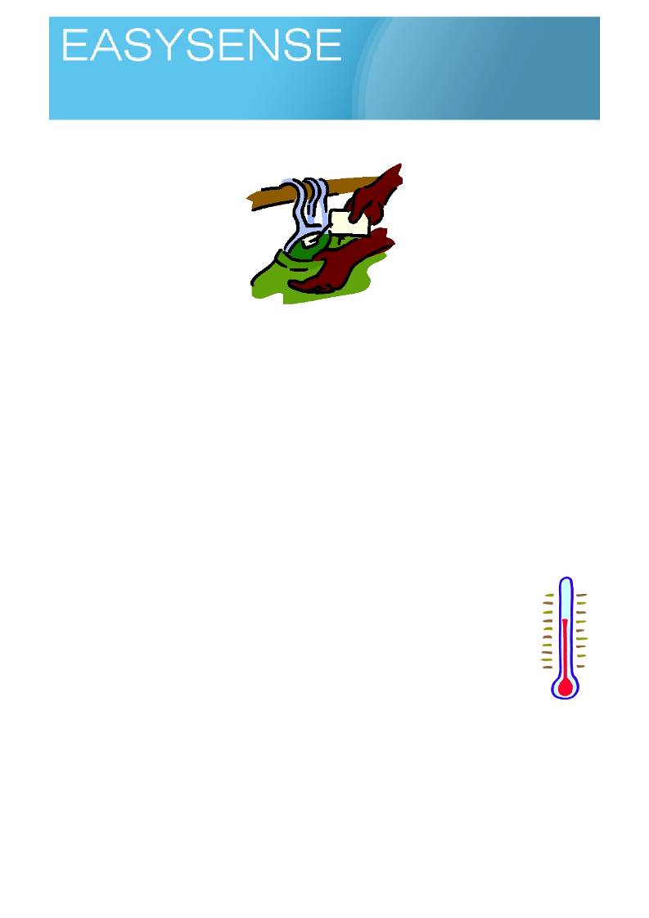
Age 5 - 6

Sensors: Temperature Logging mode: Easylog

What shall I wear today?

We are often told we should wear light coloured clothing or cotton in the summer to keep us cool, but how true is this? How often have you heard people suggesting the opposite? You should wear dark clothing in winter to keep warm! If there is a difference between colours is it really significant? In this activity we take that simple everyday accepted truth and challenge it with a scientific investigation.
Using the principles of science we;
• Decide on evidence not hearsay.
• We test the idea, we don't simply accept it.
• We look for fairness in the tests we do.
• We look for limits on where we can apply our experience.
In the investigation we need to take small pieces of material (cloth, paper, plastic etc) and subject them to
the same amount of heat.
The activity is good for comparing, using data to support an argument, creating an idea to test.
The idea will be something like " pale materials do not get as hot as dark materials". The activity tests the
idea to see if it is true or false.
The activity use 2 external temperature sensors and EasyLog.
You will need.
1. A datalogger with at least one external temperature sensor, preferably two connected.
(attached to the computer linked to your interactive whiteboard, projector or other large
display)
2. Corrugated cardboard. 3. Squares of cloth.
4. Desk lamp to use as a heat source (not compact energy light, no heat!)
Suggested method.
The idea of the experiment is to use the desk light as a heat source. The heat from the lamp will heat up the
sensors which are protected from direct heat by the cardboard and or cloth. Corrugated cardboard should be chosen that will let the sensors slip down into the corrugations.
There are two parts to the lesson,
Activity one - uses corrugated cardboard to establish a testing protocol and see what happens without cloth
present.
Activity two - uses pieces of cloth to shield the sensors. Some of the more alert students will note that not
all the cloth is the same, colour is not only variable that should be controlled.

1
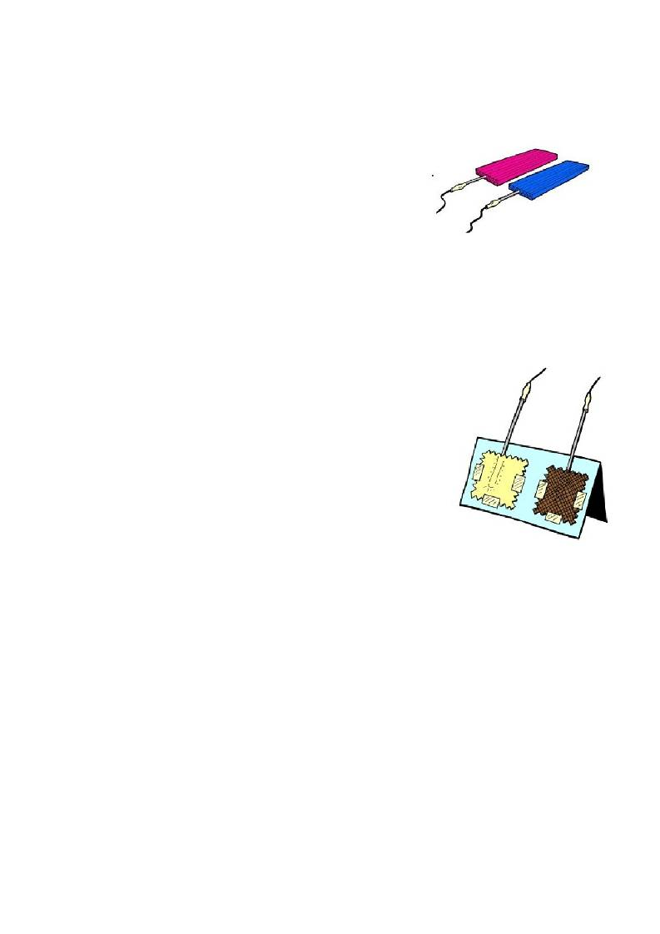
Logging time:
Loggers

Activity 1 Using the cardboard.
1. Slip the sensor down the corrugations into the cardboard. Make a mark on the sensor so it goes in
the same distance in both cases. Make sure the cardboard is the same size for both samples. We are establishing the idea of the fair test.
2. Fasten the samples onto the desk using tape or similar to stop
movement.
3. Start the software. Select Easylog for a continuous recording or
Snapshot if you want to take a reading every 5 minutes.
Snapshot does mean you have to be precise when you take
readings or the rate of heat increase will not form a good pattern.
4. Decide on an end time.
5. Switch on the lamp, start the recording or take the first snap.
As an alternative you could leave the cardboard in a sunny window to see what happens.
Activity 2 using fabric samples.
This is essentially the same as activity one, but allowance has to be made for how the fabric covers the
temperature sensors.
1. Set up the fabric samples with a temperature sensor under the
samples. Select samples to compare that are similar e.g. cotton, one
dark, one light. Not one cotton light coloured, and one woollen dark coloured.
2. Fasten the samples onto the desk using tape or similar to stop
movement.
3. Start the software. Select easylog for a continuous recording or
snapshot if you want to take a reading every 5 minutes. Snapshot does mean you have to be precise when you take readings or the rate of heat increase will not forma good pattern.
4. Decide on an end time.
5. Switch on the lamp, start the recording or take the first snap.
As an alternative you could leave the samples in a sunny window to see what
happens.
Questions.
• Did the samples warm up at the same rate?
• Did any of the samples get any warmer than the others?
• Can you see any patterns?
o Do they explain what you see?
• Which colour clothes would you wear to keep cool or warm?
o Why?
o Where is the evidence (proof)?
Teacher's notes.
This is an activity where you need to be careful and let the results do the work and not anticipate the
answers. It is not unusual to see no difference in the temperature change between samples and certainly not
see a difference between cotton and wool or dark and pale fabrics. The observer needs to be neutral. It is
very tempting to manipulate the results to support your position, resist the pull! Your feelings about the right
clothes for the right place may be correct but the answer may not be in this exercise, perhaps it is the
closeness of the weave stopping draughts getting in!
This is an important concept in science. The observer is neutral. If you don't see what you expect, perhaps
you need to confront and change your expectations not modify the experiment to match what you think. The latter is called bias, not to be encouraged.

2
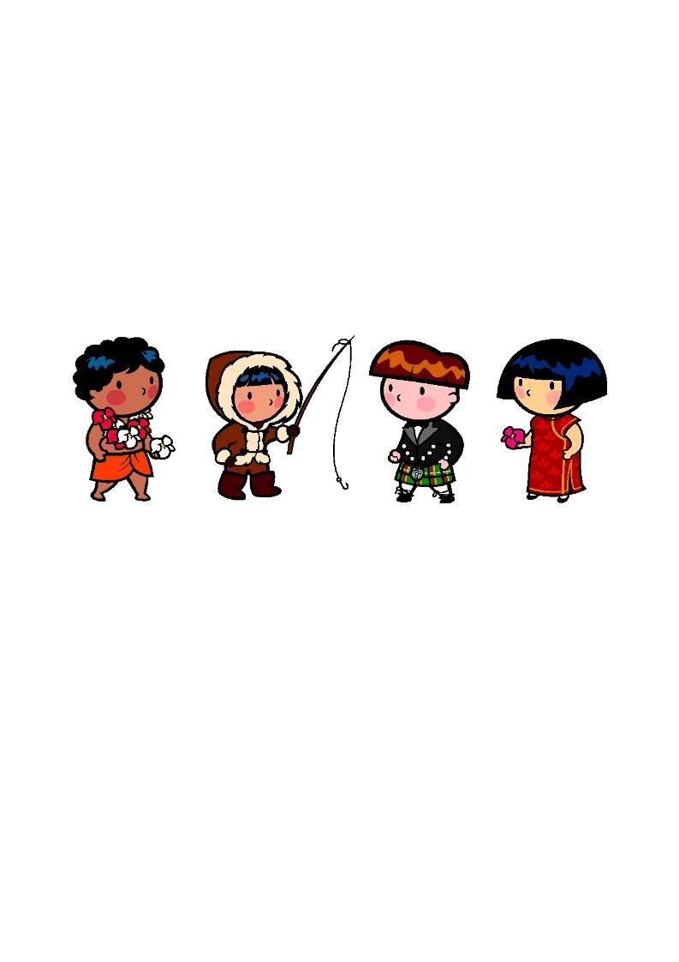
Logging time:
Loggers

The activity is good for getting the thinking caps out! All of you have to work to make sense of the results,
and perhaps that is the purpose, to show that sometimes there is no answer! Whatever answer ou come too there must be evidence to support your position.
Other things to investigate.
• What do people wear in cold and hot countries?
• Do they have a colour they use more?
• Is the colour because of heat or something else (custom)?
• Are there any examples of animals using colour to keep control of heat (do you get pale coloured
animals in hot places?).
• What do you choose to keep warm?
o What's special about it that keeps you warm?
o Would the colour make any difference?

3
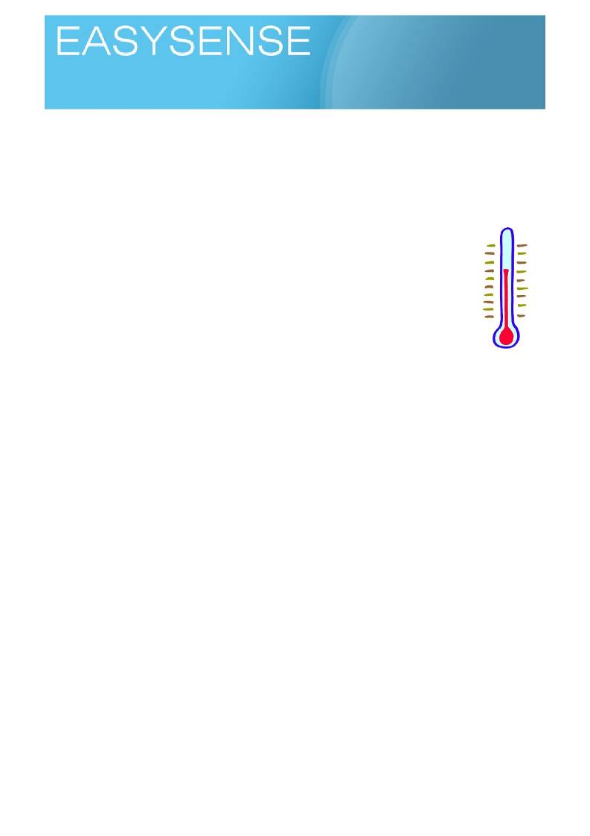
Age 4 - 6

Sensors: Temperature Logging mode: Meters

Are your hands warmer than mine
Learning outcomes.
• Comparing.
• Fair test
• Data logging.
This is best as a whiteboard activity.
You will need
1. A datalogger with a two external temperature sensors connected (attached to the
computer linked to your interactive whiteboard, projector or other large display)
2. Software showing the product of the logger as line graphs.
3. Cup of cold water (to cool temperature sensors after each test)
Suggested method.
1. Start the software and test everything is working. Use a student to hold onto a sensor
to check the display line or bars are up and down on the screen.
2. Dip the sensors in the cold water (why do we do this?).
3. Organise two of the children for the test.
4. Give a sensor to each child, remind them they should not touch the tip of the sensors, yet! 5. Start the software and leave it running for a few moments.
6. Ask the children to hold onto the tip of the sensor after you count to….
7. Keep recording until the temperature looks as if it is not rising any more or create a cut off of 5
minutes maximum.
8. Select Overlay in the software and get another pair to run the race!
Use the data collected to extract any observations from the class, things to tease out of them are;
• Which went up quicker
• What was the highest temperature?
• How do you know (looking for numbers to justify answer)?
• Why did the temperature stop going up (we have a fixed temperature and you cannot get
hotter than the thing you are touching!).
• What was the difference between the sensors?
• What was the difference between the start and finish, lowest and highest etc (practice of
differences, subtracting)
Teacher's notes
The idea of this activity was to encourage the children to look at the data and look for similarities and
differences.
Get the children in learning pairs or groups to talk and pick two things that are really different and make a list
of what is different. They should use linked statements, for example "thing one is red and thing 2 is blue". If
you pick a feature you should always say what is and how it is different, never assume that saying it is blue is enough.
Once they have done a differences list. pick two things that are similar and write out how they are the same
and how they are different.

1
Logging time:
Loggers

This is good activity to introduce the data logger to a class (or teacher). It is an activity that can in reality be
used across a wide range of age groups as a refresher for data logging or as an introductory activity, possibly even as an ice breaker lesson at the beginning of new year or class.
Two temperature sensors are used, and two children are selected. The data collected is shown appearing
live on the screen. This adds tremendously to the learning experience and makes the link between data, graphs and times really well.
The exercise is as much about gaining familiarity with data logging and sensors as it is about any science we
might discover.
While the activity is simple the follow on work can become complex:
1. Early years - use as a simple comparison exercise.
2. Middle years - use to explore line graphs and the idea of time based data.
3. Later years - looking for patterns in data, does gender affect the final temperature? Does everyone
have the same temperature?

2
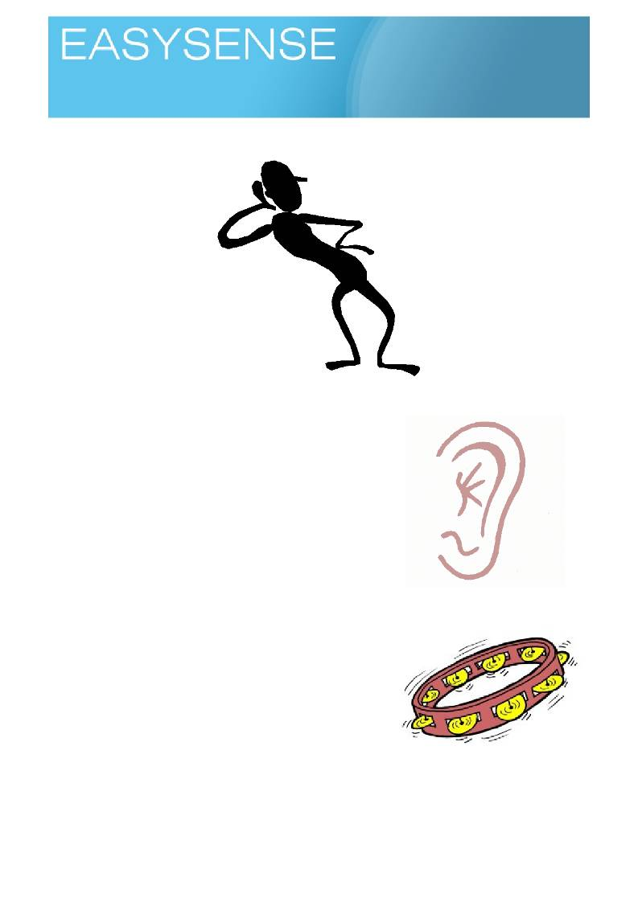
Age 8 - 10

Sensors: Sound Logging mode: Snapshot

Making Ears

This activity uses the skills learnt using the logger to study sound.
This activity is uses a simple idea, a constant sound source will be tested at a set distance to see who can
capture most noise!
Questions we can explore are things like,
• Do big ears collect a lot of noise?
• Does the shape of the ear make any difference?
• Do all animals with big ears hear well?
• Are ears only for hearing?
As a class there is bound to be experience of animals and ears, some
of them may know that ears are used for things other than collecting
noises (Elephant ears and desert fox ears are used for cooling, horse and cat ears for communication). What about insects and Dolphins do
they have ears? Where are they?
The activity encourages and should be used to encourage "iterative"
design and research. Iterative design is the process of using information from a previous design to create improvements in the next design.
You will need
1. A datalogger with a sound sensor (attached to the computer
linked to your interactive whiteboard, projector or other large
display)
2. Software showing the product of the logger as pictograms
and bar charts.
3. Sound maker.
4. String or a tape to measure distance.
5. Sticky tape, paper clips, glue card etc to make ears. 6. Picture library of ears.

1
Logging time:
Loggers

Suggested method.
Before Datalogging.
Ask the children to look for the resources library and find out about ears. Look for shapes of ears, animals
with and without ears, even use digital camers ot take pictures of each others ears.
In learning pairs or groups ask the children to talk about and think of ideas of what ears are used for. Ask
them to link their ideas to picture (hand drawn) of an example ear.
Datalogging
The data to be collected is a simple noise level. Using meters or snapshot to show evidence will be perfect.
The activity lends itself to be a whiteboard activity with shared results. You need a constant sound to stop
people waiting for the noisiest bit before recording. Competition is a great motivator, but it does tend to
create skulduggery!
1. With the datalogger attached to a PC use the software to show the output of the datalogger on the
whiteboard or large screen as numeric meters, pictograms or bars.
2. Use the logger to test the sound maker and find the normal value. You may want to consider some
way of fixing the logger and sound maker in place to keep distance and direction constant.
3. Use a tape to define the test distance and the place of the logger to noise maker. 4. Slip the ear over the sensor and re test.
5. At this point it will become apparent that you need to record the data, swap to Snapshot and then
you can record the data for each set of ears and compare to the fair test.
Questions.
1. Why did you make your ear that shape?
2. Did how you placed it on the sensor make a difference?
3. Did what you made the ear from make a difference?
a. If you made the same ear from different materials would it make a difference.
4. What made you think of your ear shape?
Extensions
You have collected numbers in the activity, use them to,
1. Practice number lines and big numbers (the sound values will be big numbers).
2. Use number lines to find differences (e.g. how much did the ear change the noise measured). 3. Does the stuff you made the ear from make a difference?. 4. Talk about why this is a fair test.
5. What happens if you use
a. a louder noise,
b. a different noise?
6. What happens if you make "false ears" for yourself - do you hear more, more from a direction…..

Related activities.

• What do animals use ears for apart from listening?
• Which animal has the biggest ears?
• Hearing aids and hearing trumpets?
• What about inside out ears? Something to make sound less?
• Can you really hear through a wall with a cup?

Science background.
What we call ears on people are really the ear flaps or pinnae. The ear is deep inside the skull. They are not
normally evenly placed on the head or have the same shape on either side, this is to give us stereo hearing and help with direction.
Many animals do not have ears (pinnae) while others have ears that can be moved around (does anyone in
the class waggle their ears? We do have a little bit of control left).
The ears are not only used to collect sounds but can be used to;

2
Logging time:
Loggers

• Help cool the animal - elephant ears cover up the earhole (look for it in pictures), so they can't be for
collecting noises!
• Show how the animal feels - horses, apparently, have very sophisticated language of ears. Your pet
cat flattens ears to show anger and pricks them up to show interest.
• Find the direction of something - bats ears.
• Signal sex to other animals - white spots on tiger ears show it is a male.

The ear (pinna) catches sounds and directs them into the ear canal (ear hole) where they can be heard by the ear proper and sent to the brain to be made into something we can understand.
You can hear the effect of extending the ears by cupping hands around them and changing the shape of the
extra ear and its position. It can make a big difference but usually at the expense of a wide hearing field. It's the equivalent of using binoculars or a telescope for the eyes.
When you are younger, your hearing range is much wider than as an adult. You hear much higher
frequencies of sound when you are younger. Loud noises that you "feel" will probably damage your hearing.
The ringing in you ears after exposure to loud noises is a sign of damage. Once you loose hearing it does
not come back. There is evidence to suggest that males and females hear different types of sound - females
detect more high pitch sound than males. What about the mosquito units used near shops to distract young
people form gathering?
One of the demonstration units working for the Royal National Institute for Deaf people has sound sensors in
a model head. You place earphones from an MP3 player on your head and turn the volume to how you like
it. You then transfer the earphones to the model head (without resetting the volume). It then shows if you are listening too loud. You could try a similar idea using the sound sensor on the logger, just place the earphone next to the sensor after listening and see the sound level.
Advice is, if you can't hear the world around you through the headphones you have it too loud!

3
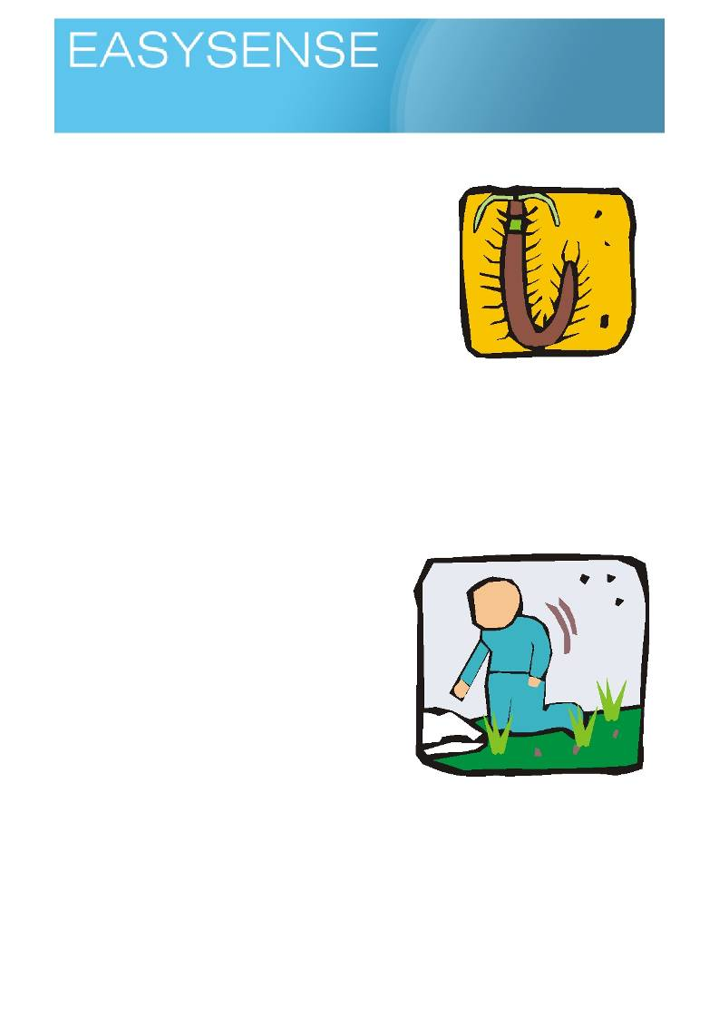
Age 7 - 9

Sensors: Temperature, Light Logging mode: Snapshot or Easylog

Bug Alert
This is a longer term study of an environment. For most schools and
children the visit to a site to observe and take measurements will take
place within a school day, and this will be fine for the curriculum
needs. Some schools may have access to a range of environments close at hand and will want to consider a longer study.
Information collected by a datalogger can be one more piece of
evidence when describing a site. It is unlikely that the datalogger will
reveal any large differences, but connected to the observed information it may complete the story.
You will need.
1. datalogger.
a. External temperature sensor.
b. Protective coat for the datalogger, waterproof - large plastic bag or modified food container.

Suggested method.
You will need to decide what is you want to measure. It is easy to fall into the trap of recoding everything the
datalogger can record without thinking about if it will tell us anything. Sound is unlikely to be factor, temperature could be significant.
The external temperature sensor can be used to measure soil temperature, creepy crawlies like a bit of
warmth as much as we do! A warmer soil could well indicate a more insect friendly area. Light can help us understand why there is higher temperature.
1. Take the datalogger to the study site.
2. After a bit of wildlife observation select a site to
measure that appears to have things within it. Move
away from the paths or short grass, this is like a dessert, a most animal unfriendly space.
3. Once the datalogger and sensors are set up, start
Easylog. Make sure when you complete the protection
for the datalogger you have not effectively disabled
the built in sensors (ended up with light sensor in the
dark end of the bag!).
4. On return to the datalogger, stop the recording. 5. Take the datalogger back to the class room and
connect it to a PC.
Hint. If it has been a cold damp time for the datalogger, let it
warm up for time before trying to access the data.
6. Download the collected data.
Using the data.
You will have to "work" the data, it is very unlikely it will show anything without interpretation.
Things to consider,
• Bugs don't really like big changes of temperature.
• Bugs don't really like a lot of light (flying ones do, but crawling ones, no!).

1
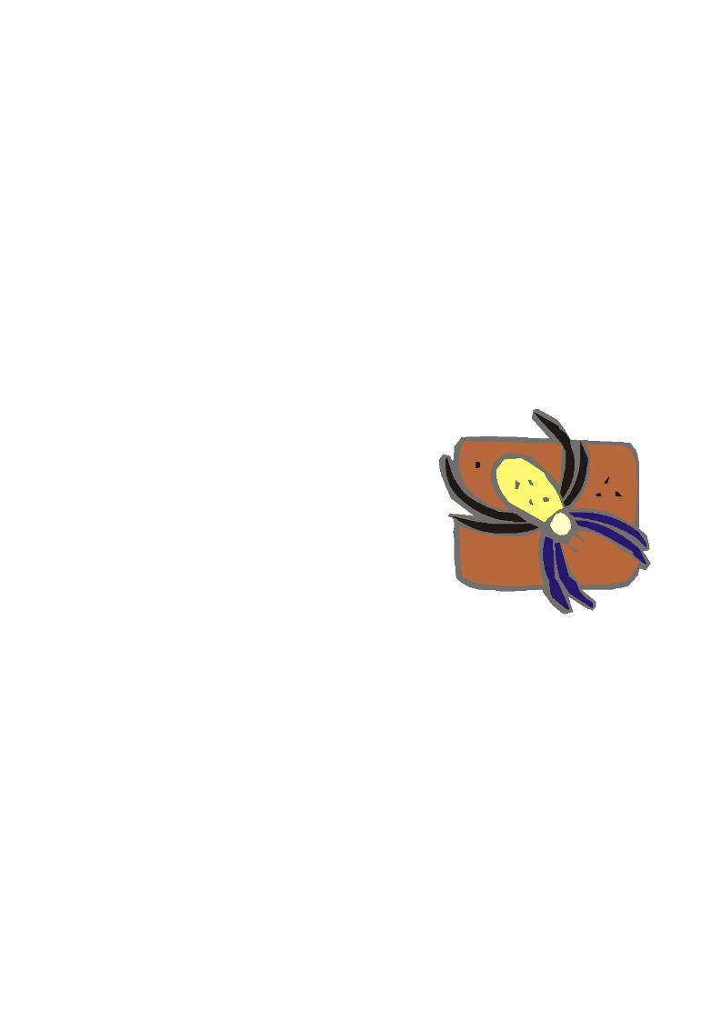
Logging time:
Dataloggers

• It is normal for temperatures to fall at night, and go up in the day. Bugs will be adapted to this or hide
from extremes.
Use your instinct to tell the story,
• if you were a bug, why would this be important to me?
• Get the children to imagine being a bug, a creature that is frightened of being eaten, doesn't like
getting hot, can dry out in the sun etc. Ask them to produce a poster showing and explaining where
they would live.
• Is there anything in the data that looks bug friendly or unfriendly.
Using Snapshot.
You can use the datalogger to snap data at sampling points.
1. Record the temperature under 5 logs or 10 stones.
2. Record the temperature and light at 1 metre intervals as you move away from a tree (a transect) to
collect abiotic evidence to support field observations.
3. Collect data at the same place at defined time intervals e.g. every hour.
4. Collect data when you see something, every time you see an earthworm, measure the soil
temperature.

Science background.
• Spiders have 8 legs
• Insects have 6 legs and 3 body segments
• Crustaceans have lots of legs
• Millipedes and centipedes have one or more
pairs of legs per body segment.
They are all Arthropods, things that have jointed limbs.
Spiders are known to scientists as belonging to family of animals
called Arachnids. The name comes from a Greek tale,
Arachne was a lady who was a weaver. She was very good at
weaving, the best there had ever been. Her work was admired all over ancient Greece. She was so good she boasted her weaving was better than the gods. The gods heard about this and became
very jealous and angry, to show everyone how annoyed they were and how people should be afraid of the
gods they turned her into an animal that spent its whole life spinning - a spider, arachnids are the children of
Arachne!

• What other animals or plants have a story behind their name?

For the teacher - some names from Greek mythology.

Narcissus - daffodils, named after a man who was so vain he loved only himself, he sat by a pool one day and saw his reflection and wasted away looking down at himself. Daffodils are often found "looking down".
He also had a lady admirer who could only repeat what he said (another punishment of the gods), narcissus
ignored her and eventually she faded away until only her voice copying what you say could be heard, her
name Echo!
Cygnets - baby swans, named after a king who mourned after his dead cousin, he stopped talking or
making any noise and was eventually turned into a swan out of pity by the gods (who for some reason could not kill him!), which makes no noise.
Wolf - Lupine, After the boastful human Lycaeon who doubted that Zeus was a god and tried to kill him. As punishment he was turned into a animal that had to kill and rob to live - a wolf.
Hyacinth - A Greek youth called Hyacinthus was accidentally killed by Apollo when he threw a discus, to show his grief Apollo made a new flower from his tears - the hyacinth.

2
Logging time:
Dataloggers

Laurel trees belong to a family of trees called Daphne. She was very beautiful nymph who was being
chased by Apollo through a wood. The other gods fearing that Apollo would do her harm transformed her
into a tree to save and protect her!

You could go for things named after someone, not normally a story but an honour!

• a sea snail - Bufonaria borisbeckeri, (boris becker the tennis player)
• a ground beetle - Agra katewinsletae (Kate winslett actress)
• a dinosaur - Masiakasaurus knopfleri (mark knopfler, musician and singer)
• a wasp named Polemistus Chewbacca (Chewbacca, the large hairy one in star wars)
• a beetle - Agathidium vaderi).(after Darth vader, the nasty black caped one in star wars)
• a lichen - Caloplaca obamae in honour of Barack Obama's support of science.
• slime-mold beetles (Agathidium bushi after George Bush, Agathidium cheneyi after Dick
Cheney and Agathidium rumsfeldi after Donald Rumsfeld)

Teacher's notes.
The use of dataloggers in field work can be very rewarding, it can also be very frustrating. The evidence
collected might not say anything exciting, but that's life - it does not like extremes, it likes things the same.
Remember the datalogger is piece of electronic equipment that has big holes in it to let sensors connect. It is
not going to be waterproof by its very nature. Take care to protect it from water.
If you are leaving the datalogger outside for a period of time you need to protect it from direct water contact
e.g. rain. Don't forget water contact from condensation, wrapping into a plastic bag seems a very good idea
but watch out for how condensation forms on the inside of the bag as it cools down at night.
Temperature sensors look as if they can be thrust into the ground or piles of leaves or whatever. The tubes
are there to protect the thermistor inside the tube from excessive contact with water and corrosive materials, the tube is not designed to be spear! If you want to test soil temperatures use a small "dibber" to make hole first, something like a an old screwdriver, meat skewer or modify an old soil thermometer case.

3
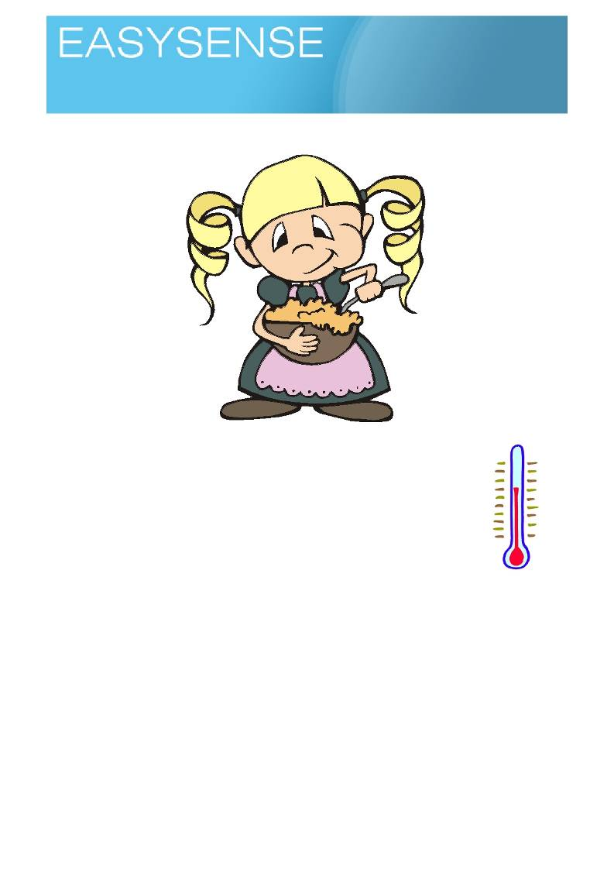
Age 5 - 7

Sensors: Temperature Logging mode: Easylog or Snapshot

Goldilocks

.
You will need.
1. A datalogger with a temperature sensor (attached to the computer linked to your
interactive whiteboard, projector or other large display)
2. Software showing the product of the logger as pictograms and bar charts.
3. Hot porridge (or similar).
4. Spoons. 5. Bowls.
6. Balance, scales (optional)

Suggested method.
Set up the logger and software connected to the whiteboard. Run a quick test with the
software showing meters to show how the software displays temperature and temperature
changes.
Use imagination to describe the activity via the three bears, why do you want to test, make one of the
children one of the bears etc.
Start with only one temperature sensor connected.
The activity has 2 parts,
• Activity one - finding the best temperature by testing.
• Activity two - using the logger and sensors to predict when the best temperature will be reached.

1
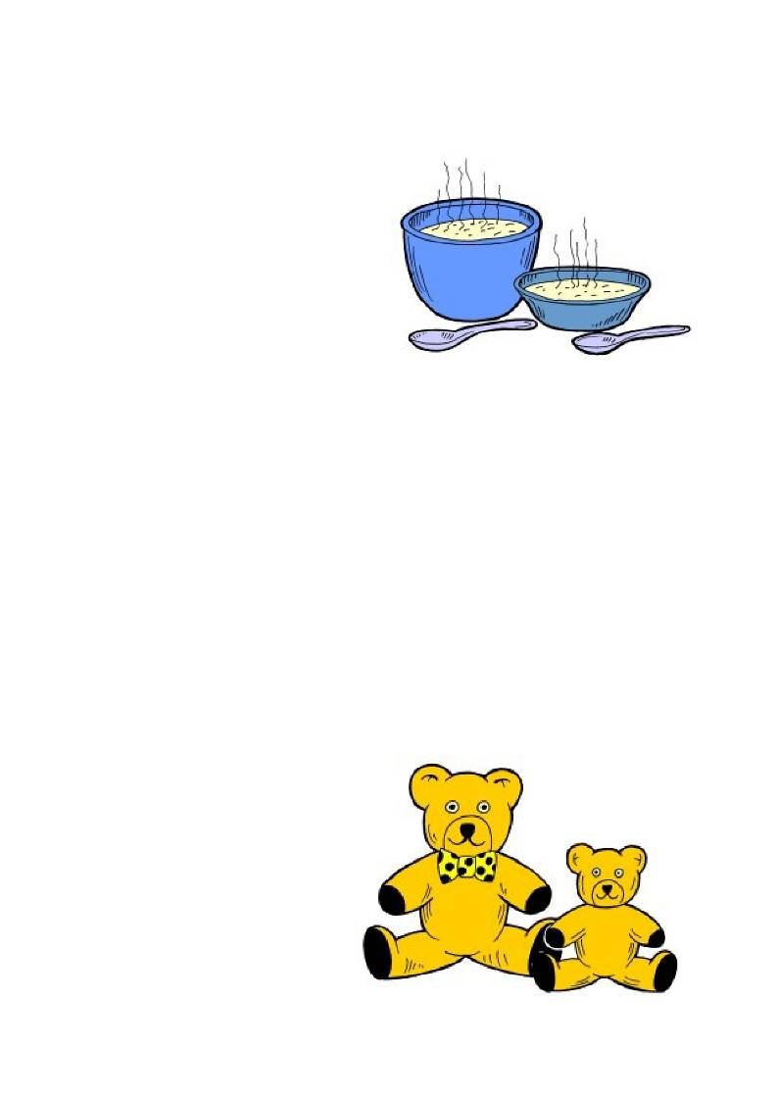
Logging time:
Loggers

Activity one, the test.
1. With the logger and sensors attached and ready make some porridge up.
2. Pour a small amount of porridge into a bowl, perhaps make this an excuse to do some weighing
3. Put one of the temperature sensors into the bowl of porridge, the temperature value will be shown on
screen.
4. Let one of the bears carefully test the
porridge for how hot it is (it could be still
quite hot at this point, remember children
are more sensitive to heat than adults.)
5. Test every 2 - 3 minutes and stop when the
tester says it is the right temperature to eat. Make a note of the temperature.

Note. The activity can take so many turns at this
point, you could be writing down the
temperatures, transferring the temperatures to a
big graph or watching the temperature fall as a
line against time. In all cases you want to find
the number value of the temperature that makes
it right to eat without burning your mouth and lips!

6. Make the connection between the number and the heat.

Activity two, the blind test.
Part two uses the temperature sensor only to test for the right eating temperature. It also uses two porridge
bowls, one with more in than the other. We are testing the validity of the temperature number against the reality of sensation, and also looking how more takes longer or less to change.
1. Fill two bowls with porridge, one bowl with one unit of porridge and the other with two units (twice as
much).
2. Place a temperature sensor into each bowl.
3. Record the temperature at 2 - 3 minute intervals until one bowl reaches the agreed good to eat
temperature.
4. Test the temperature by having a bear take a sample. Are both bowls ready to eat? Is it good to eat?

Questions.
1. When do you think the porridge will be ready to eat - prediction. Ask the children to talk with their
learning partners and decide the correct eating temperature. When they think they have and idea mark it on the graph or temperature scale of the graph.
2. How long did it take before the porridge was ready to eat?
3. How did you know it was ready to eat?
4. What temperature was it?
5. How much hotter was daddy bears porridge than baby bears? (daddy bears porridge was the most
porridge )
6. Why do you think that baby bears porridge cooled faster?

Extension.
1. Bring out a bowl of porridge out, this
one has come from the house. How
long ago had it been made? Ask the
children to go back to learning
partners and groups to talk about How
could you work it out and produce an
answer. Write the answer onto a piece
of paper and have the answers
collected and pinned onto an ideas
board
2. There is the possibility of some project
type work to come from this activity.
3. What is porridge?
a. Where does it come from.

2
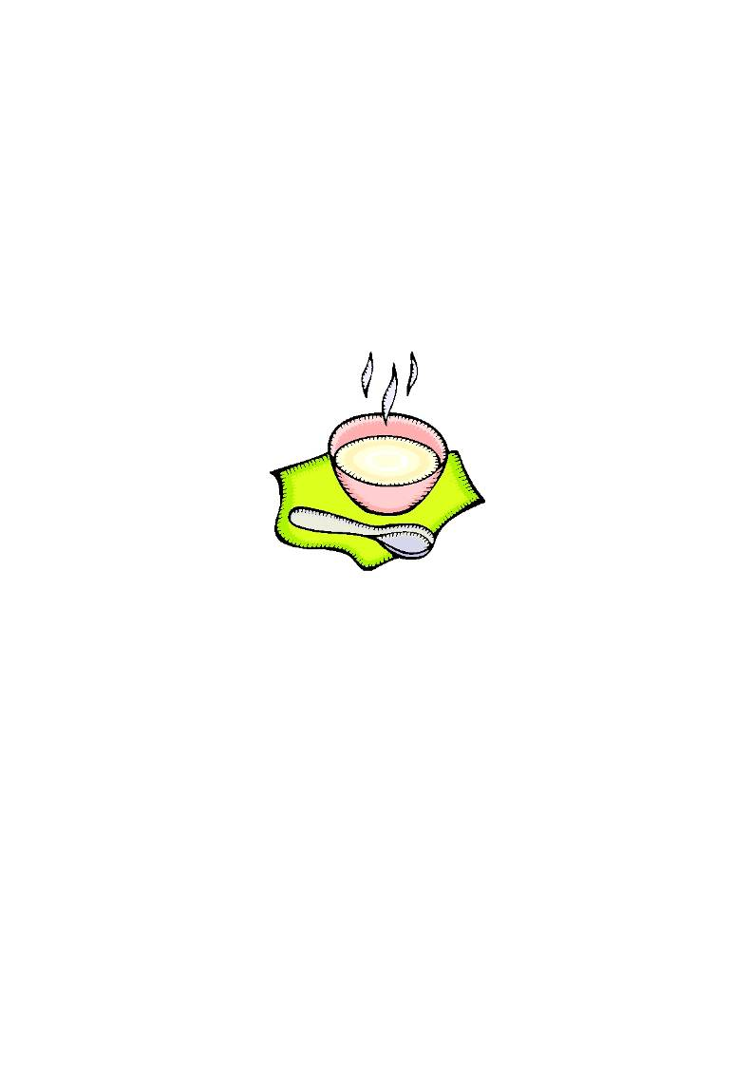
Logging time:
Loggers

b. Who eats it.
c. Why was it eaten?
4. How do I make porridge?
5. What do people use in other countries for breakfast?
6. What words do they use to describe breakfast and the breakfast foods?
7. Where did Goldilocks the story come from?
8. What are bears?
a. Where do they live?
b. Did we ever have bears in this country?
c. How rare are they?
d. Do we look after them well?
e. Why do we call the toy bears Teddy bears.

Teacher's notes.
The activity lends itself to being integrated with the telling of the Goldilocks story. You will have to make
allowance for a missing adult bear (On a business trip, driving the lorry to Scotland, out shopping etc.) as the
logger only has 2 external temperature sensors. There is potentially a lot of interactivity between the
experiment and the children if a real food stuff is used. With regard to how the food can be prepared the simplest method is to go for an instant hot food such as custard, porridge or an instant noodle snack.
Porridge matches the story better than custard.
The food needs to be thick to be authentic but not too thick, the flow of heat through thick, gloopy porridge or
custard is poor and the effect of the different mass of food will not be seen.
For a more interactive story telling form, use "pudding bowls" to hold the porridge. For a more scientific
version use plastic beakers (preferably as would be seen in a lab, not drinking beakers borrowed from the canteen!).
The activity can make use of the screen on the logger to see the results. Working in this way lends itself to
including a lot of chidren in the collection of the data and would allow a graph board to be used to plot the data as it is collected - helping to reinforce graphing skills.
Alternatively make use of the interactive whiteboard software to show the temperature changes. Make marks
on the screen to show the best porridge temperature and even have the target value written on screen.
The whole activity is divided into two sections, the first section is to find the best temperature for eating the
porridge. The second section uses this information to determine the best porridge eating time.
When children are testing the same food, you need to make sure each bear has their own spoon

3
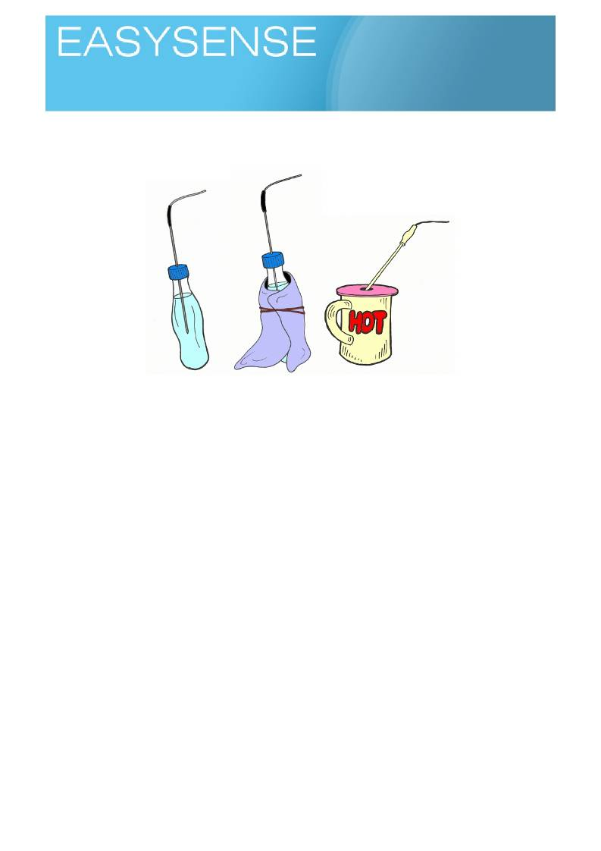
Age 7 - 9

Sensors: Temperature Logging mode: Easylog

Keeping warm

You will need.
1. A datalogger with two external temperature sensors attached (attached to the computer linked to
your interactive whiteboard, projector or other large display)
2. Software showing the product of the logger as pictograms and bar charts. 3. Hot water, kettle.
4. Insulating things, cloth, blanket, bubble wrap etc. 5. Same shape and sized bottles, jars, beakers.
Suggested method.
The simple aim of the activity is to stop some hot water from cooling down by as long as possible.
Carbonated drinks bottles are good for the activity, they are a fixed size, shape and convenient to get hold
of. Do watch out for the melting point, often only slightly more than 60C will melt the bottles.
1. Set up the logger to have two external temperature sensors connected. One will test the unprotected
bottle and the other the wrapped up one.
2. Prepare the two bottles, one to be unprotected and one to have cosy coat. 3. Fill the two bottles with the same volume of hot water (same temperature.)
4. Place the temperature sensor into each bottle and secure the lead / sensors (you may find it
convenient to make a hole in the screw on cap if it is still present).
5. Click on start to collect the temperature data.
6. Watch for few minutes, then ask for prediction about where temperature will be in 5 and 10 minutes.
Use the interactive software to mark or draw on the screen where you think the temperature will be.
If you use Overlay you can repeat the activity with bottles in different coats. You should be able to have the
uncoated bottle only used once. Once you have data from it, it becomes the reference or standard for all the other tests.

1

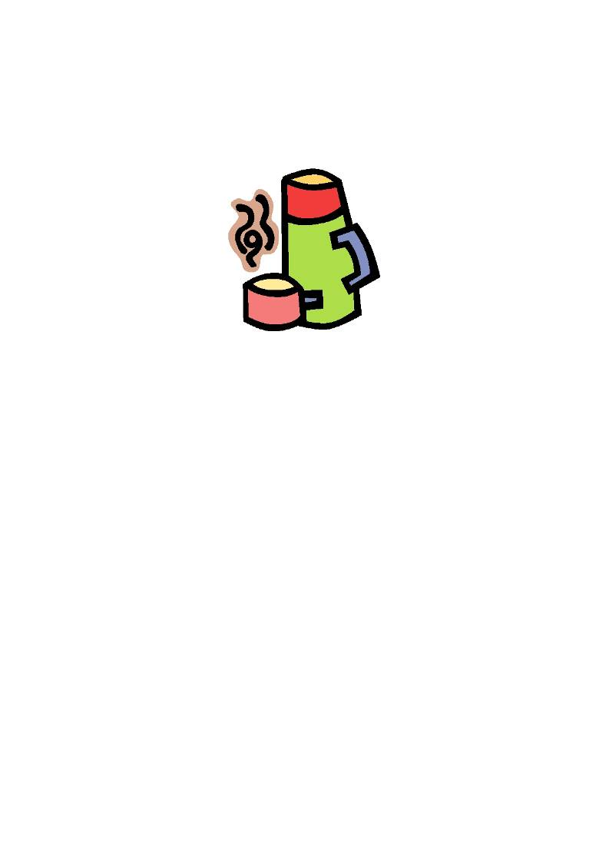
Loggers

Questions.
1. Which container stayed hottest for longest?
2. Did the coat make a difference?
3. If you used more than one coat which one was best?
4. Can you see any similarity between coats that had the some keep warm times?
Logging time:

Teaching notes.
The activity looks at how heat is lost and introduces the idea of insulators and conductors.
The activity can also be used to introduce the idea of modelling, the testing of a theory using a very similar
apparatus to that which will eventually be used. In this activity the beakers could easily be models of houses, people or penguins! The aim is for children to think about the sort of materials they use to keep them warm in winter and to design the experiment to test their ideas.
What may need a bit of work at, is the idea that keeping something from cooling down is the same as
stopping something from warming up.
Most students experience is that a warm coat keeps them warm and cosy, they would not agree that wearing
a coat in the summer would keep them cool! The problem is that the body is good little heater and keeps providing heat, we don't follow the rules! Unlike the hot bottle we are using in the system we keep adding heat to the system, the bottle is constantly losing heat from the system.
Any things that you are going to use to stop getting cold need to be the same size and shape (fair test)
Try to use water as hot as you are able, cooling depends upon a temperature difference, the greater the
difference the quicker the heat will be lost. If you start with luke warm water the different in heat between the
room and the water could be so small that it takes far too long for the heat loss to become visible.
If you have access to one, a vacuum flask is a good comparison, as are the insulated cups you can get for
coffee.
If you are feeling brave try foil with the shiny side in to the heat! We are always told that a shiny surface
reflects heat.
Although it is suggested to use Easylog, snapshot can work as an alternative data collection method. With
snapshot you would need to collect a sample (snap) at set time intervals. This method of collection can be good for time management, fixed period data collection. For some learners it may be an easier method to
understand. You need to decide if it is the mathematical and graphing skills that are the teaching point or the science of cooling and also the abilities of the class.

2

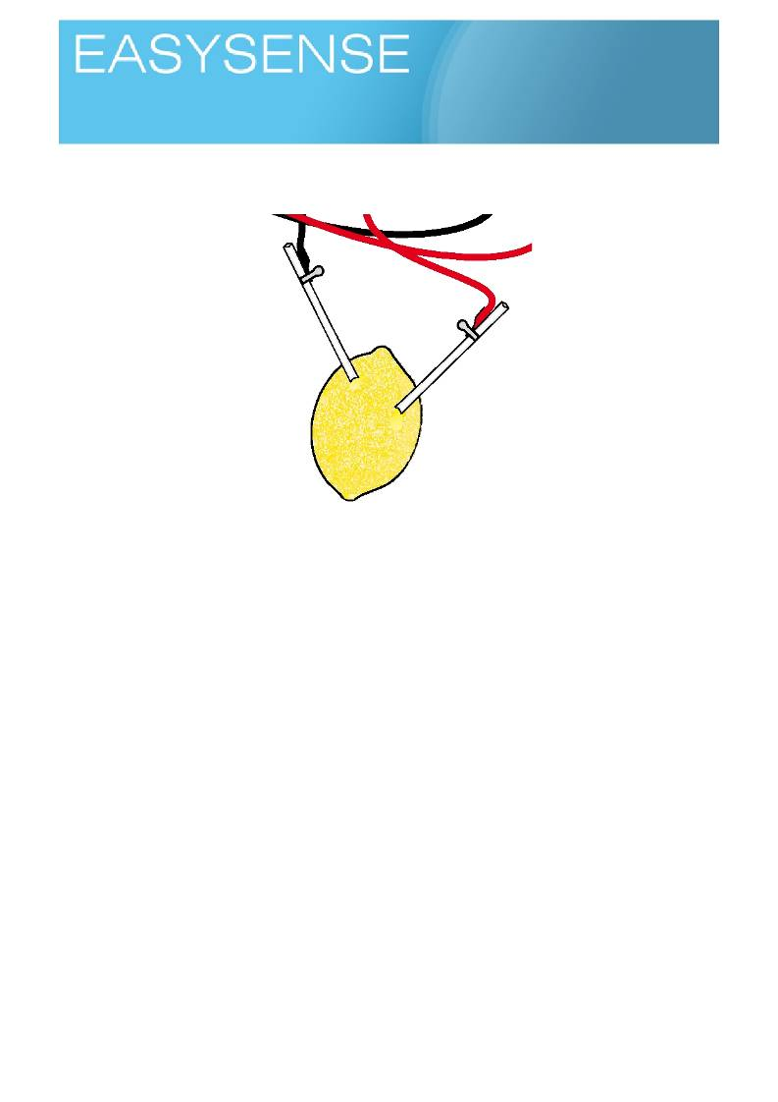
Age 9 - 11
Activities
Sensors: Light Logging mode: Snapshot

.
Fruity volts

Learning experiences covered.
• Recording data.
• Tables.
• Grouping and setting.

You will need.
• A datalogger with a voltage sensor (attached to the computer linked to your interactive whiteboard,
projector or other large display)
• Software showing the product of the logger as a numeric display.
Suggested method.
• Connect the datalogger, open the software and select the meters, numeric display.
• Use a sharpened pencil with about 1 -2 cm of exposed pencil lead. Push the exposed lead into the
fruit to pierce the skin and enter the flesh of the fruit.
• Push a piece of metal into the fruit to about the same depth as the pencil. If using a citrus fruit
imagine the segments inside and try to get the pencil lead and metal into the same segment.
• Connect the metal to the Red voltage lead and the pencil lead to the black voltage lead. You should
get a voltage of about 1.2v to 1.6v. If voltage reads zero swap the leads around and retest.
• When you get a voltage reading, make a note of it and the metal used.
• Swap the metal and see what the voltage is.
• If the metal is something like a nail, push it further into the flesh to see if the voltage changes.

1
Logging time:
Loggers

Teacher's notes
Pencil lead works best for this activity, the graphite it contains does not affect the voltage you get. Using two
metals to pierce into the fruit will give conflicting results.
Pencil lead is a thicker lead to used than the uncoated leads for propelling, clutch type pencils and will be
stronger.
For the metal you need to use bare metal, shape is not important (you can test this as an extension), The
metal needs to pierce into the flesh of the fruit. Suggestions would be paperclips (steel), Iron nails, Zinc coated nails, copper wire, ring pulls (aluminium). In fact try anything! As long as the metal has a surface clean of any oil, grease, lacquer, paint etc.
You should find that each metal has its own voltage. You could use it as a simple metal identifier!
If you try apples, pears, potatoes, carrots you should get the same voltage but they may be a bit fussier and
voltages may wobble around as the juice inside does not flow around the metal or pencil lead as well.
Link several fruits together, metal of one fruit connected to the pencil lead of the second fruit. You should be
able to double the voltage.
You might get a voltage from cola in a can, connect the can to the red lead and dip a pencil lead into the
liquid, take care to not get the crocodile clip in the cola. If you don't get a voltage, swap the leads, if you still
don't get a voltage it may be that the can has been coated with a lacquer to stop the acidic cola dissolving the can! Use glass, pencil lead and coin dipped into the cola.
Science stuff.
What we are making is simple cell. One of the characteristics of cells is that it only produces a set voltage.
The voltage made is determined by the metal used. The position of the metal in the periodic able will be a
predictor of voltage produced. In later science they will use a similar test to identify the reactivity series, a
measure of how likely metals are to react. The more volts produce the more reactive the metal will be (be brave, try a piece of gold not gold plate!).
The voltage is produce by freeing electrons up to move around. The acidity of the fruit helps electrons free
themselves of the metal and move producing electricity. Potential for a fruit freshness or ripeness meter!
Pencil lead is mixture of graphite and clay, the graphite conducts electricity but does not release electrons.
Metals release electrons when they come into contact with acids, they also react with acids to produce
hydrogen - the bubbles on the metal may interfere with electricity production.
Cola contains an acid in the form of phosphoric acid - the quantity will depend on the cola used. Cola will
clean metal and dissolve teeth but only if you use long exposure, a long time over the contact with your mouth when drinking. Cola is not that damaging to teeth, probably fresh orange juice is more damaging.
Try brown sauce! It also contains acid as vinegar.

2
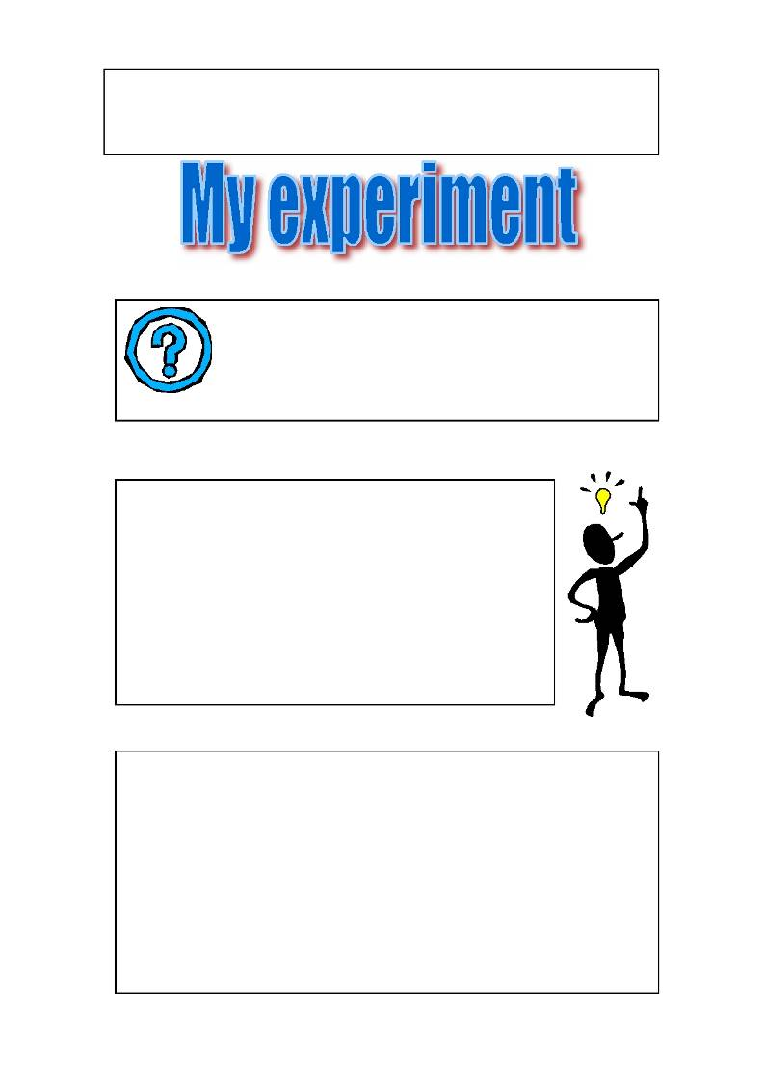
Name: ……………………………………………………………..………..

Class:………………..………………. Date………….……………

What am I trying to do?

Prediction. What do I think my experiment will
show?

What did I use in the experiment? Write and draw.
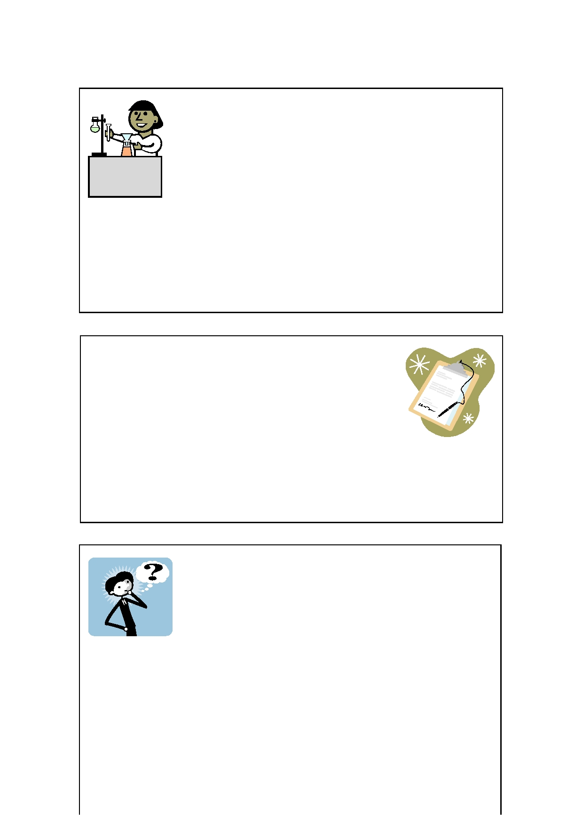
Method (what did I do?)Write and draw.

Results (what did happen?) Write and draw.

Conclusion Why do I think this happened?
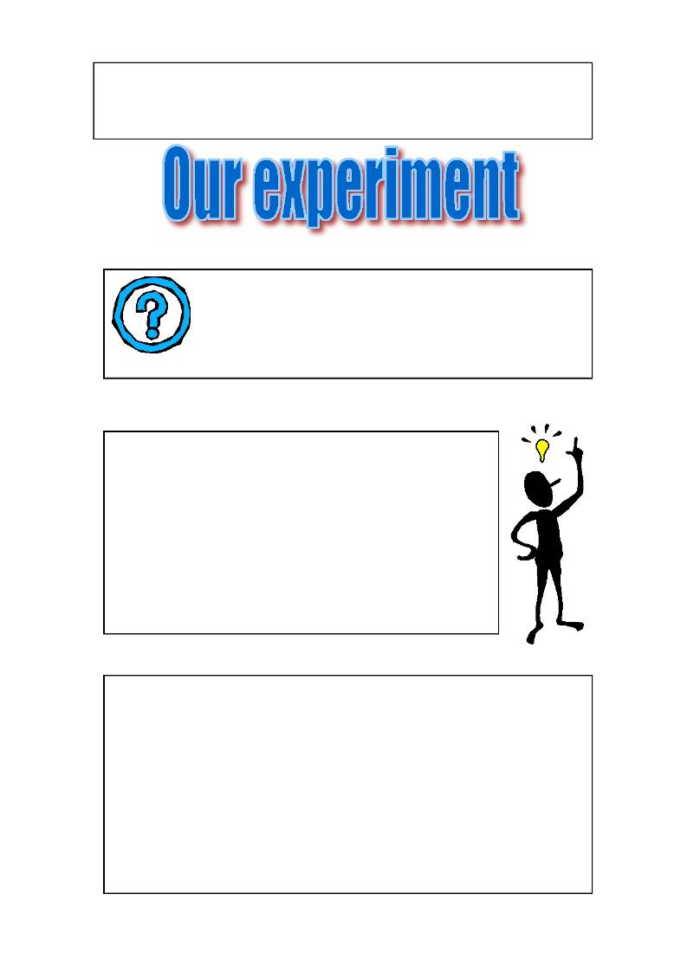
Names: …………………………………………………………..………..

Class:………………..………………. Date………….……………

What are we trying to do?

Prediction. What do we think our experiment will
show?

What did we use in the experiment? Write and draw.
Method (what did we do?)Write and draw.

Results (what did happen?) Write and draw.

Conclusion Why do we think this happened?

